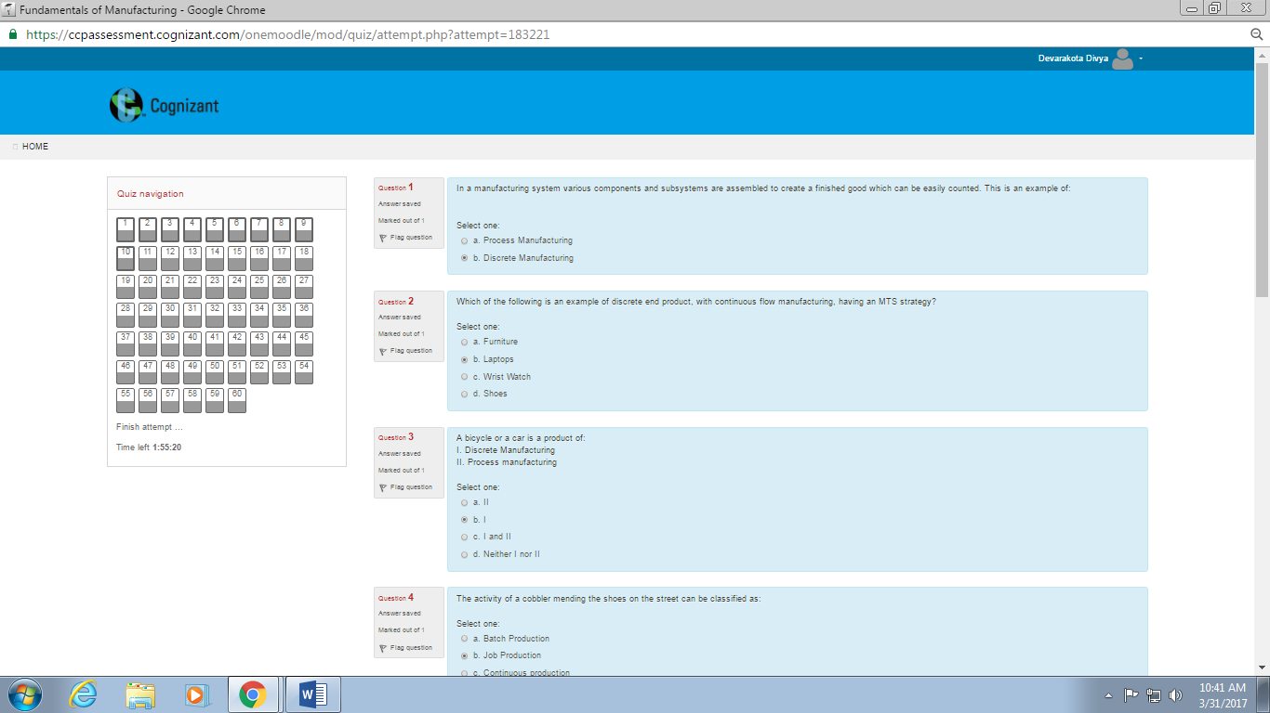

1. In a manufacturing

2. Which of the following is an example

3. A bicycle or a car

4. The activity of a cobbler

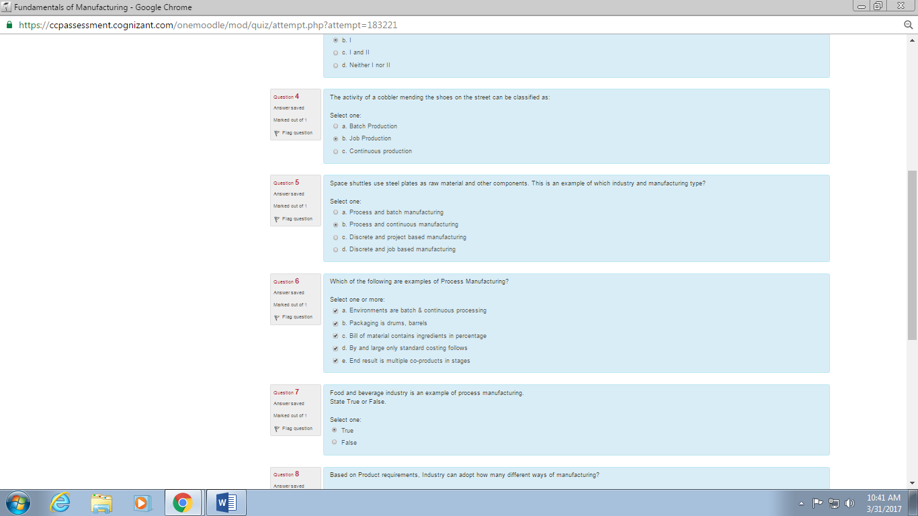

5. Space shuttles use steel

6. Which of the following are examples

7. Food and beverage indistry

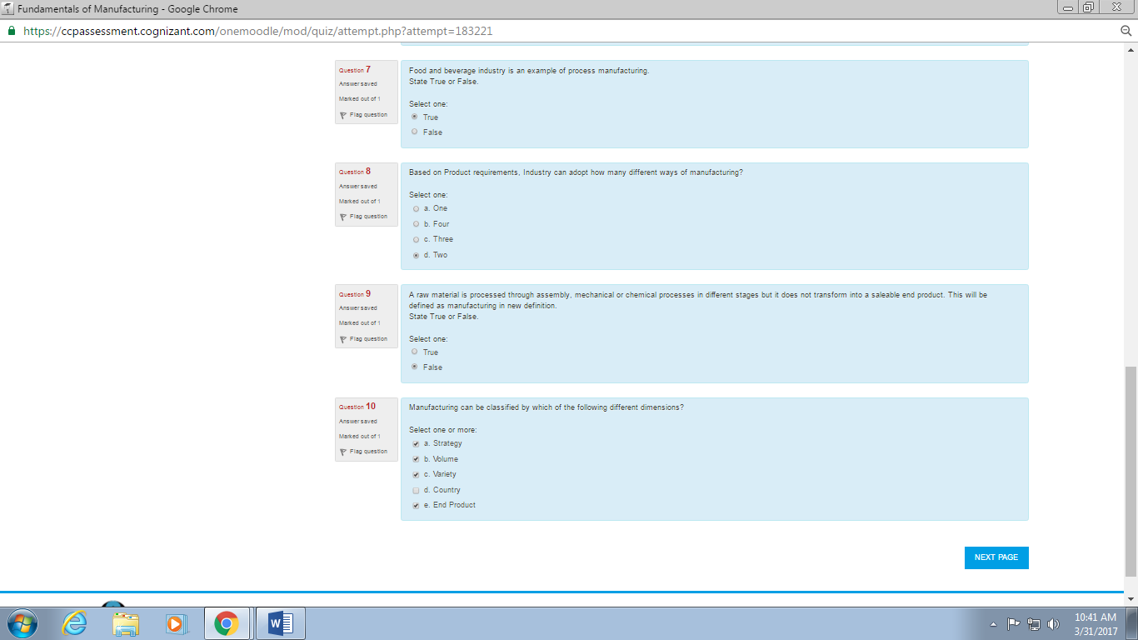

8. Based on product requirements

9. A raw material is processed

10. Manufacturing can be classified

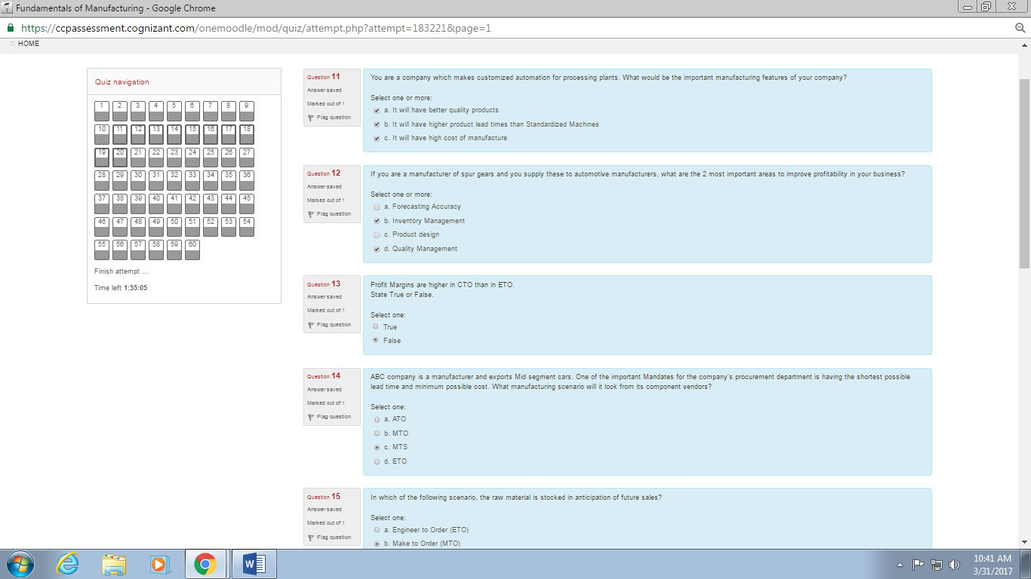

11. You are a company which makes

12. If you are a manufacturer of

13. Profit margins are higher

14. ABC company is a

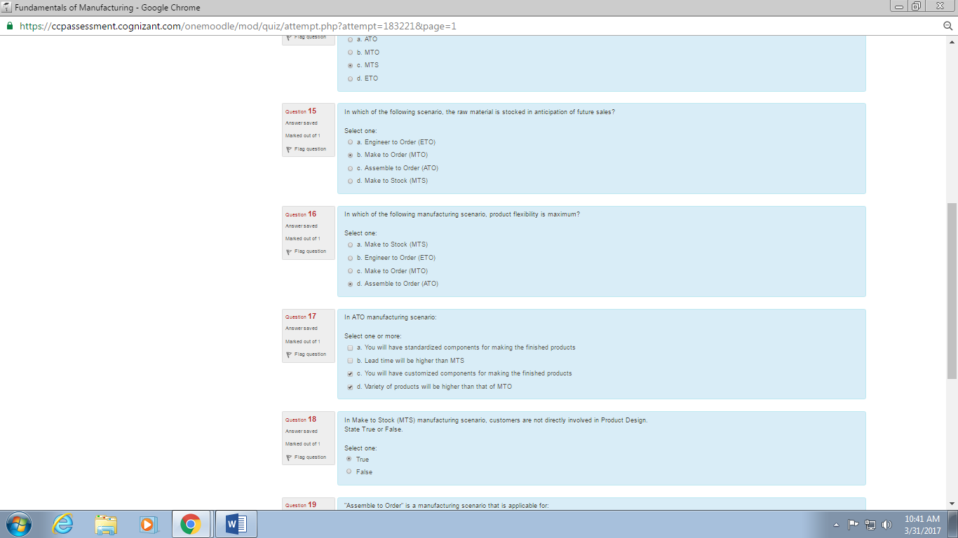

15. In Which of the following scenario

16. In which of the following manufacturing scenario

17. In ATO manufacturing

18. In make to stock (MTS)

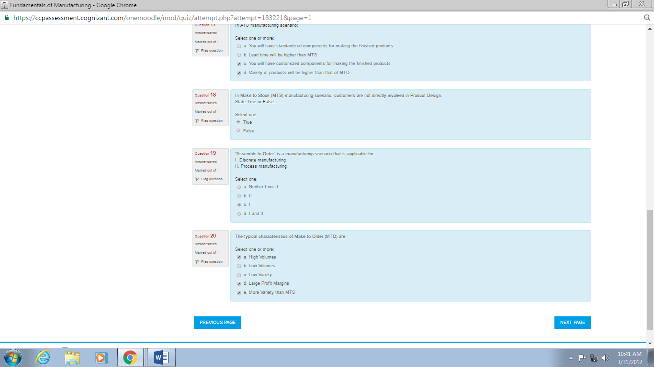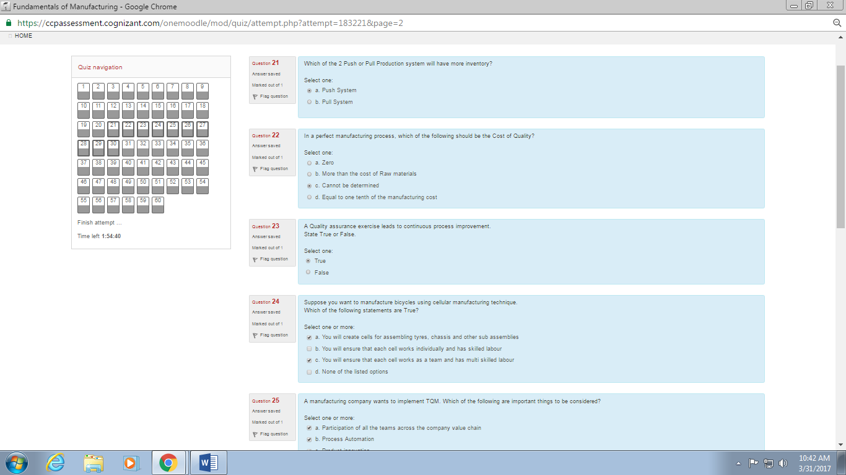

19. “Assemble to order” is a

20. The typical characteristics

21. Which of the 2 push or pull

22. In a perfect manufacturing process

23. A Quality assurance exercise

24. Suppose you want to manufacture bicycles

25. A manufacturing company wants

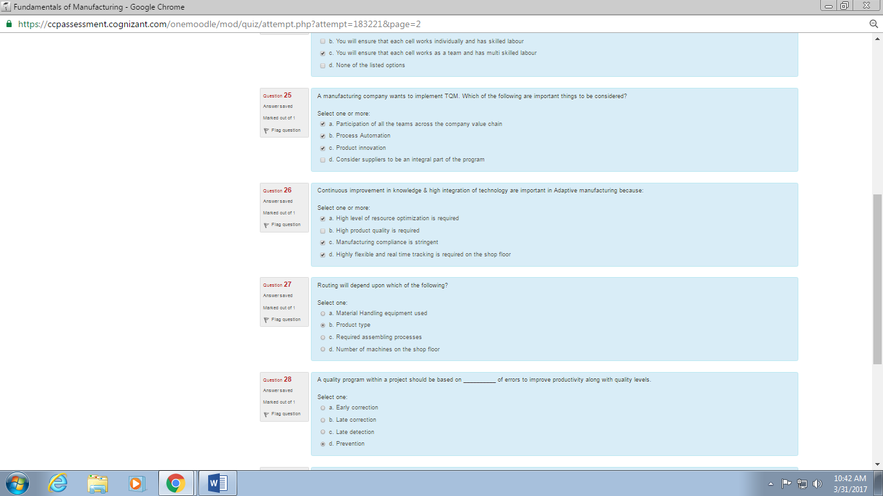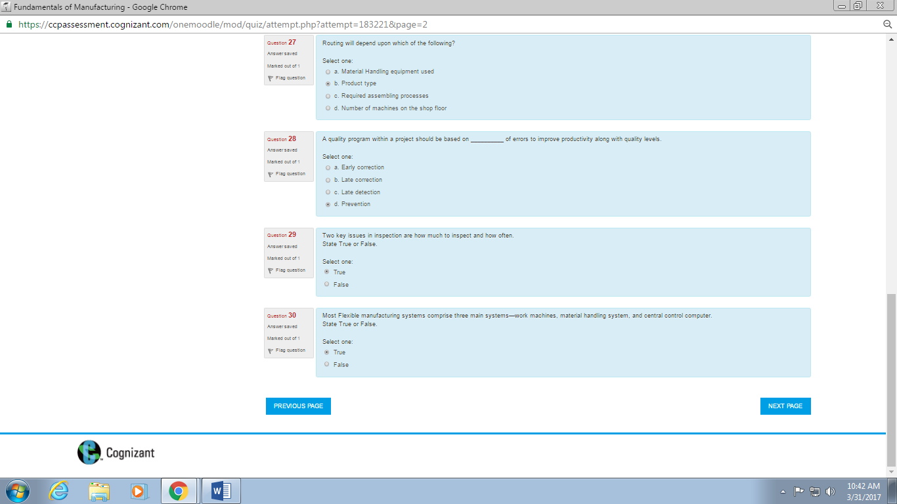

26. Continuous improvement is knowledge

27. Routing will depend

28. A quality program

29. Two key issues in

30. Most flexible manufacturing

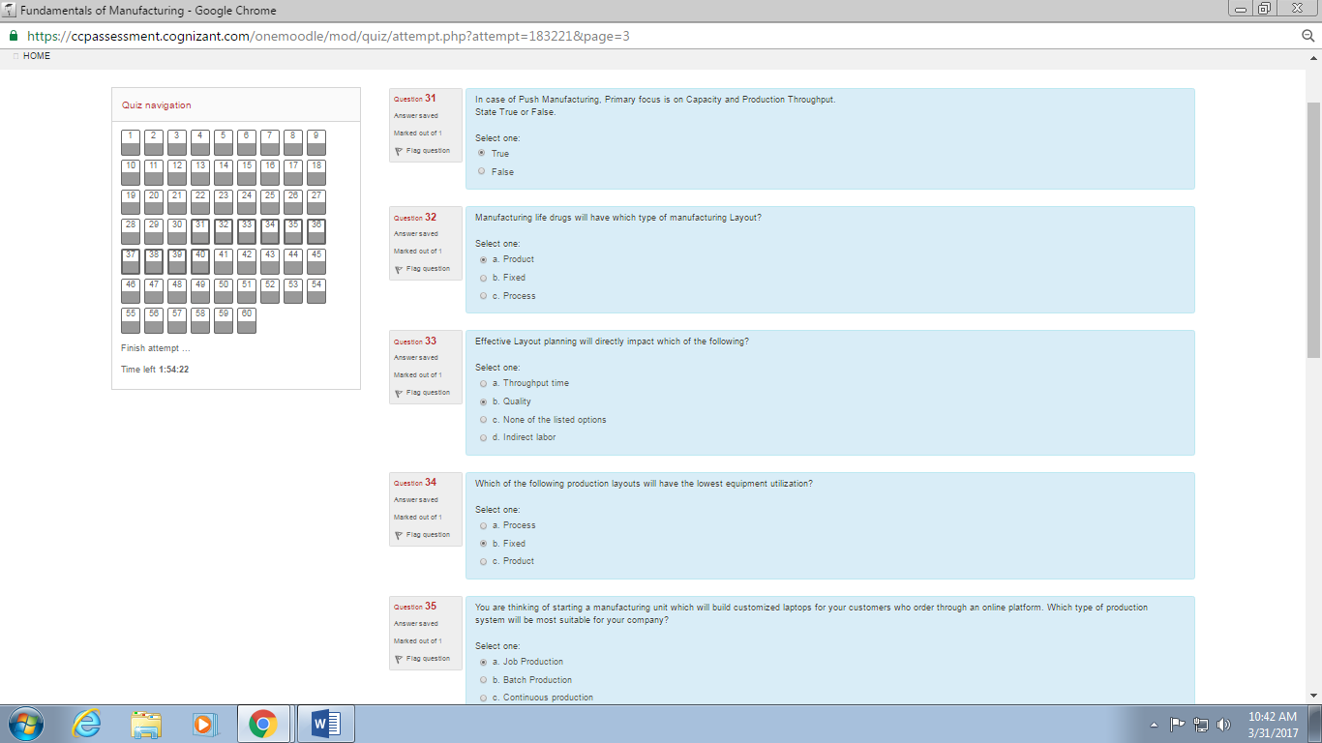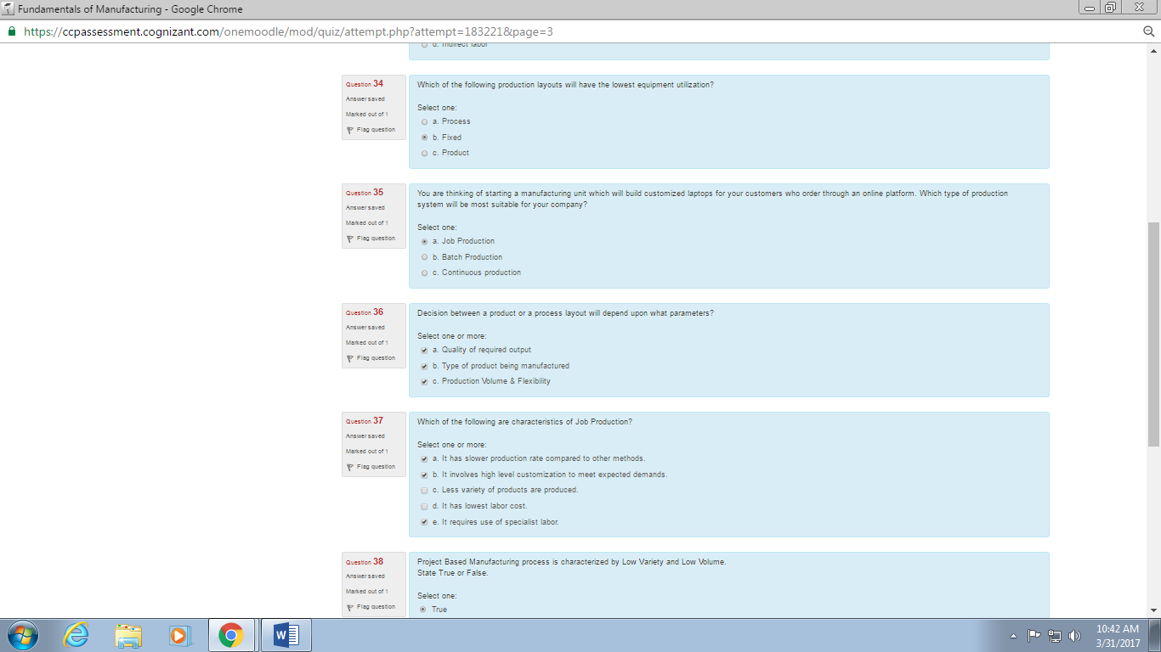

31. In case of push manufacturing

32. Manufacturing life drugs

33. Effective layout planning

34. Which of the following production layouts

35. You are thinking of starting a manufacturing unit

36. Decision between a product or a process

37. Which of the following are characteristics of job production

38. Project based manufacturing process

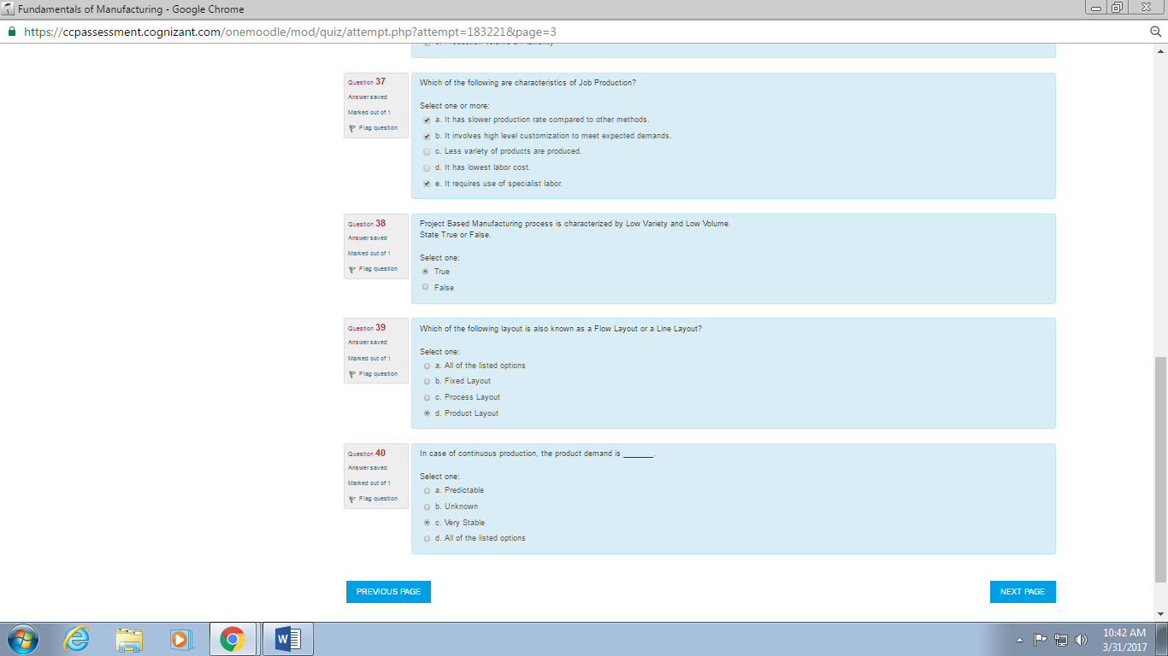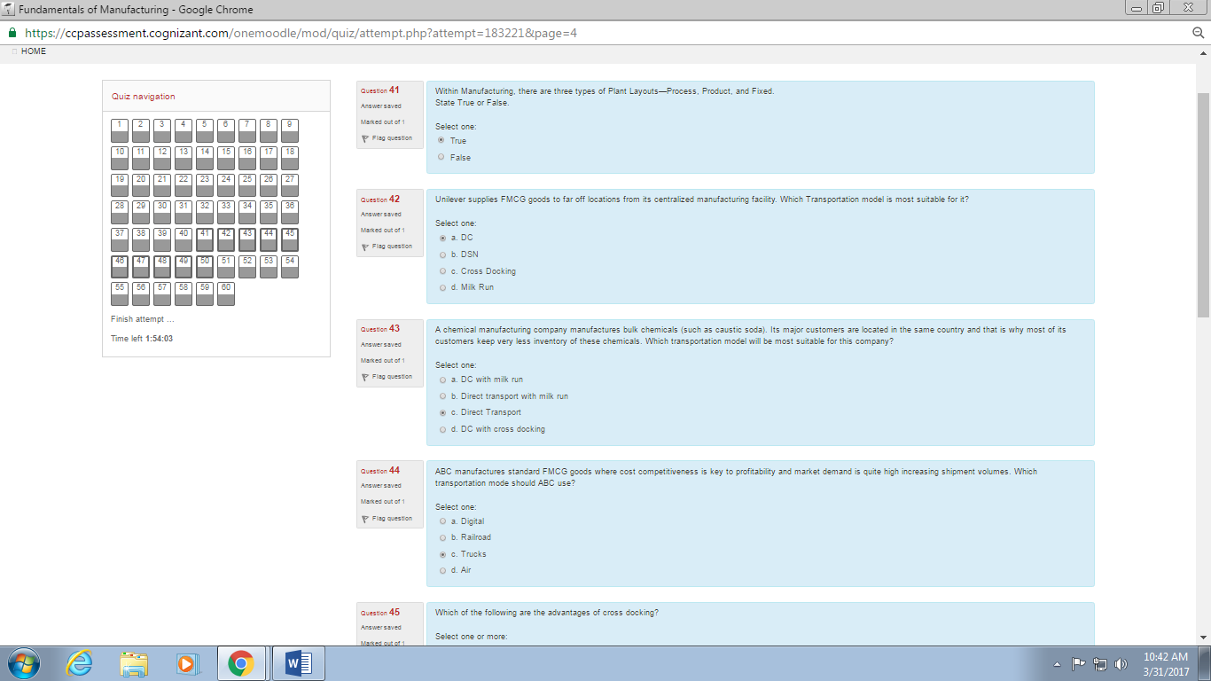

39. Which of the following layout is

40. In case of continuous production

41. Within manufacturing, there are three

42. unilever supplies

43. A chemical manufacturing company

44. ABC manufactures standard FMCG

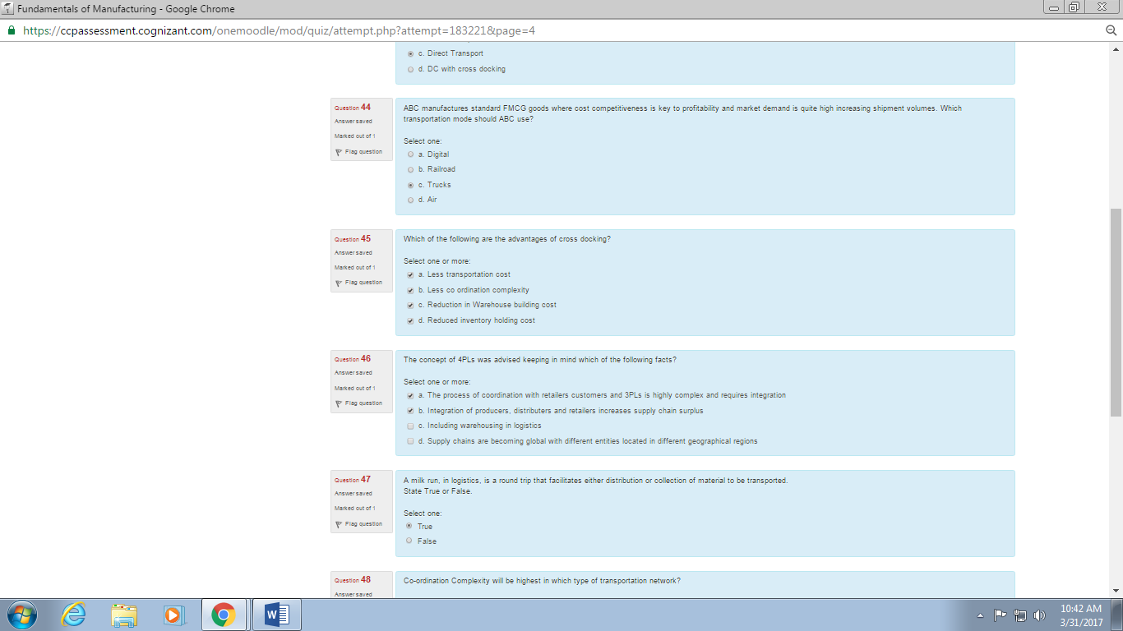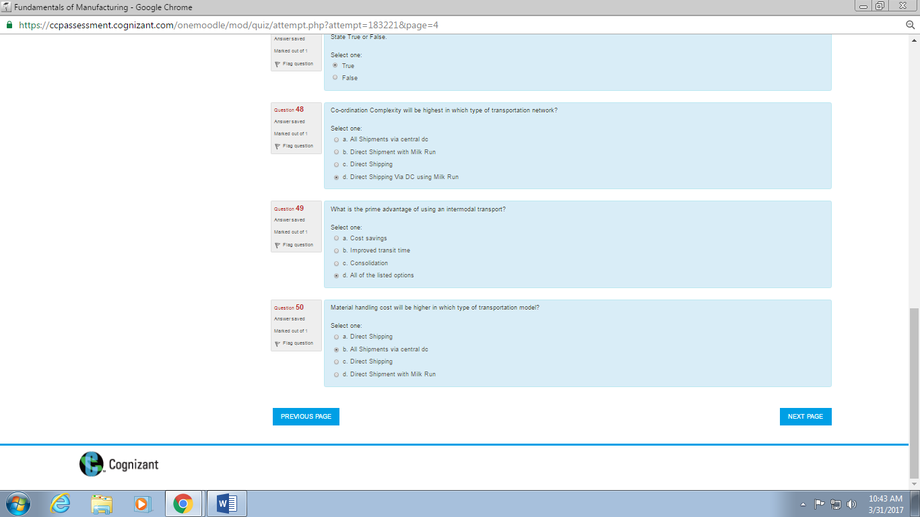

45. which of the following are the advantages of cross docking

46. The concept of 4PLs

47. A milk run

48. Co-ordination complexity

49. what is the prime advantage

50. Material handling cost

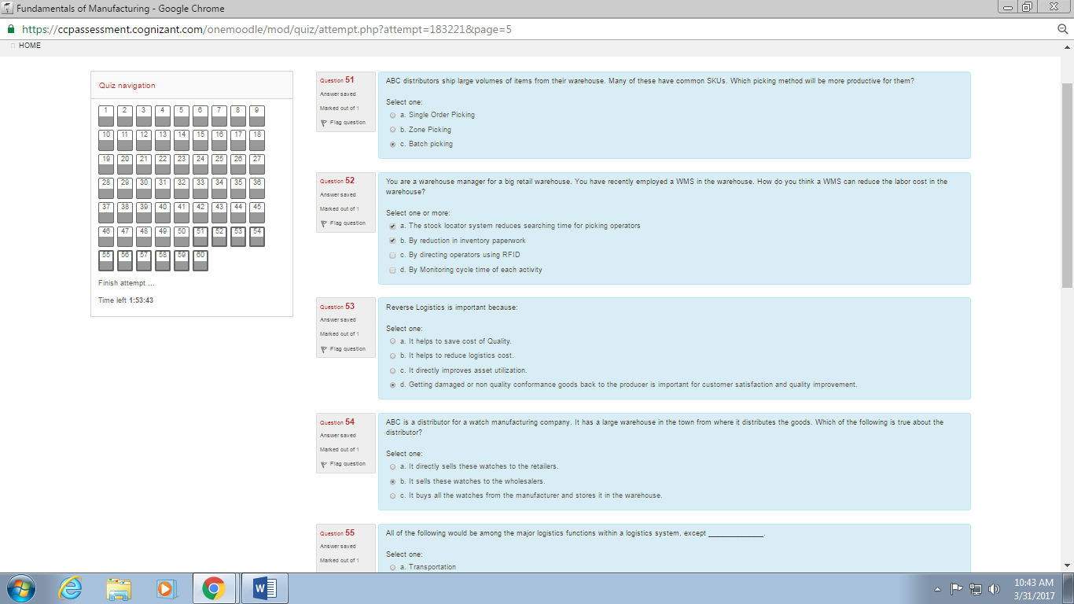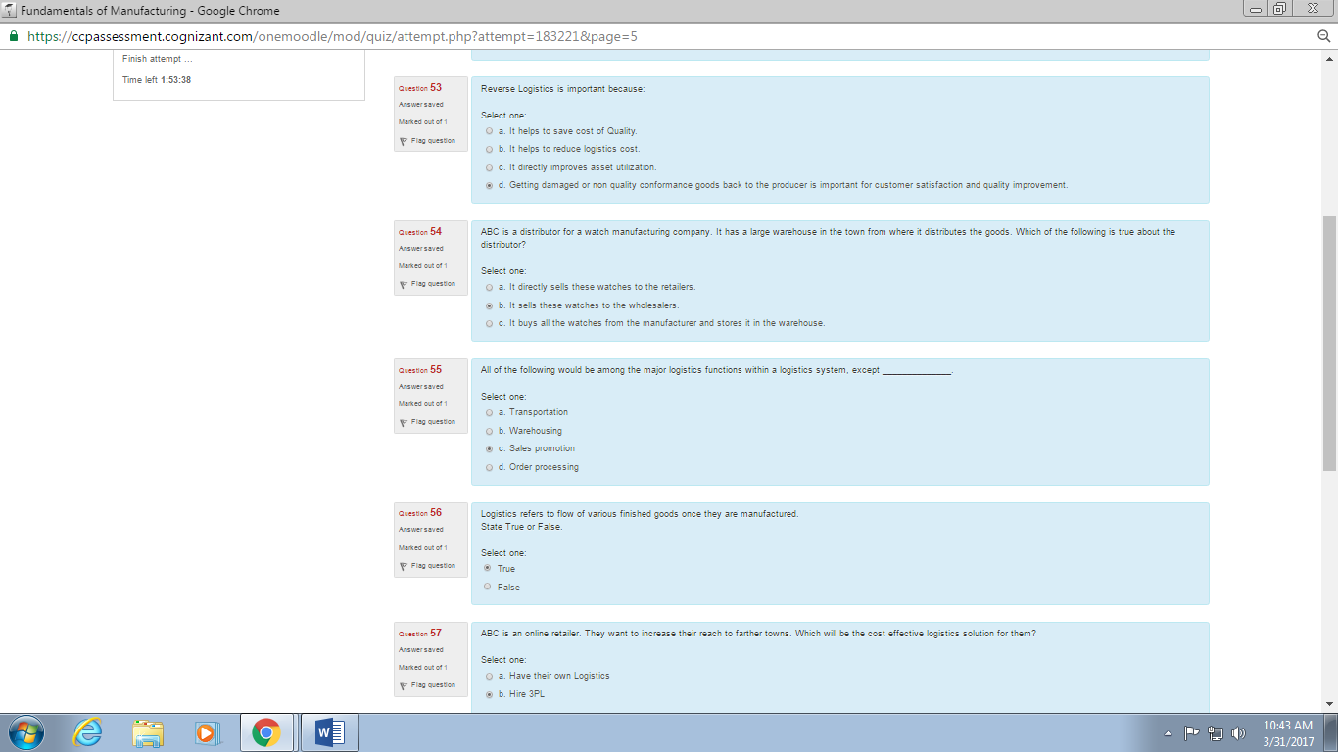

51. ABC distributors ship large

52. You are a warehouse manager

53. Reverse logistics

54. ABC is a distributor for a watch

55. All of the following would be

56. Logistics refers to flow

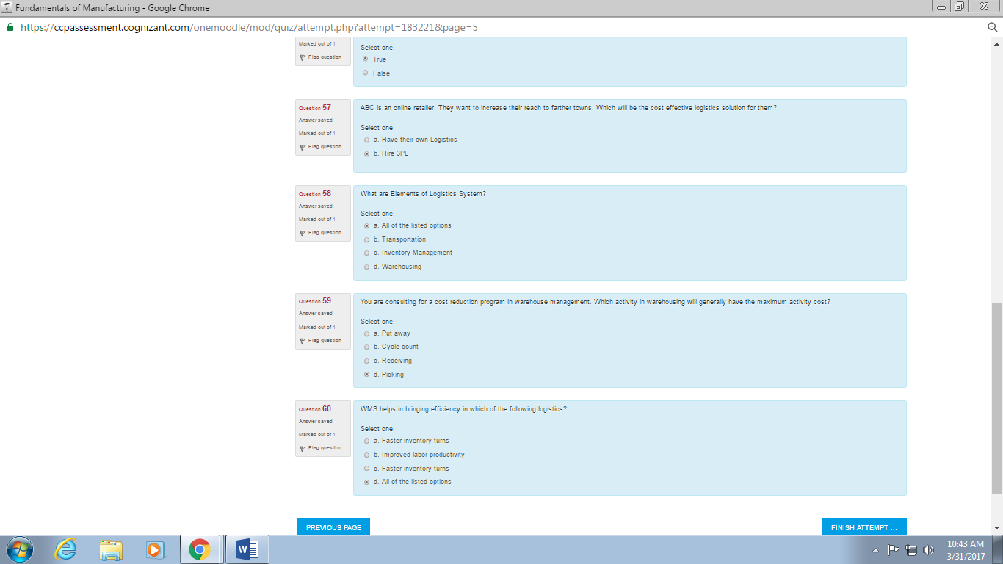

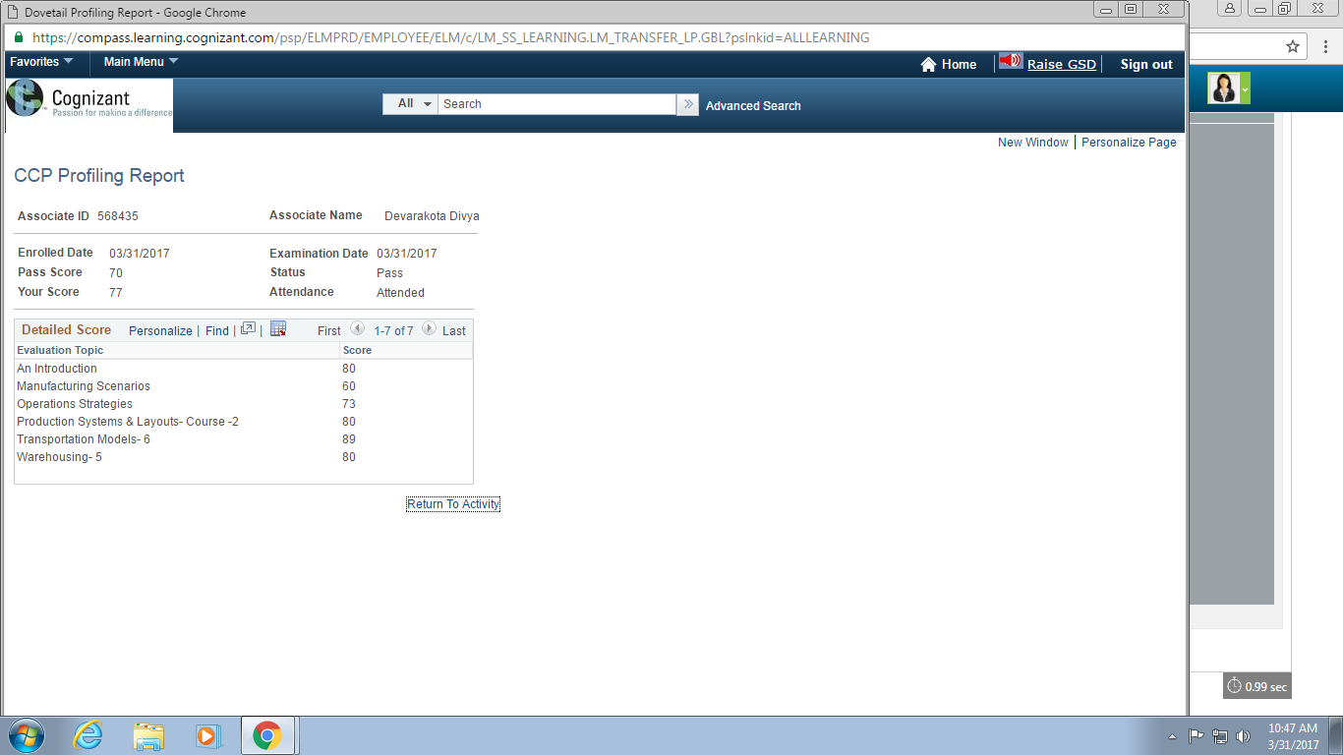

57. ABC is an online retailer

58. What are elements of logistics system

59. You are consulting for a cost reduction

60. WMS helps in bringing

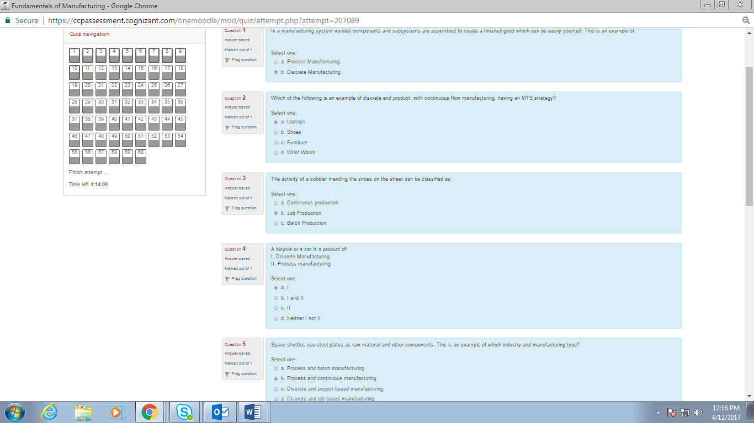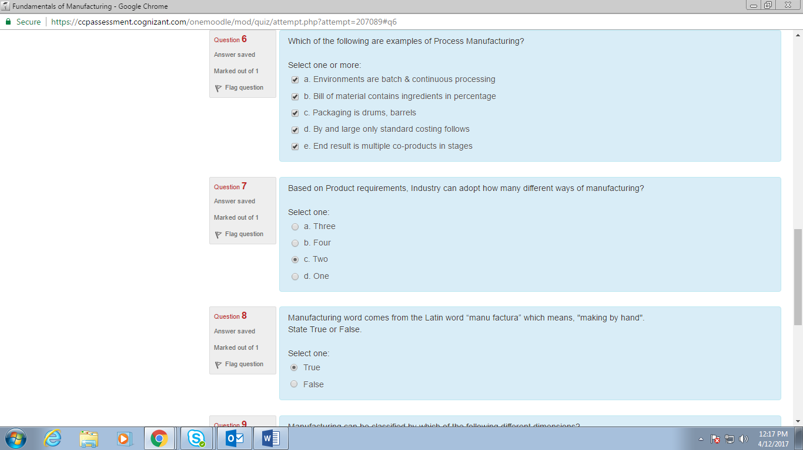

1. In a manufacturing system

2. Which of the following is an example of discrete end product

3. The activity of cobbler

4. A bicycle or a car

5. Space shuttle use

6. Which of the following are examples of process manufacturing

7. Based on product requirement

8. Manufacturing word comes

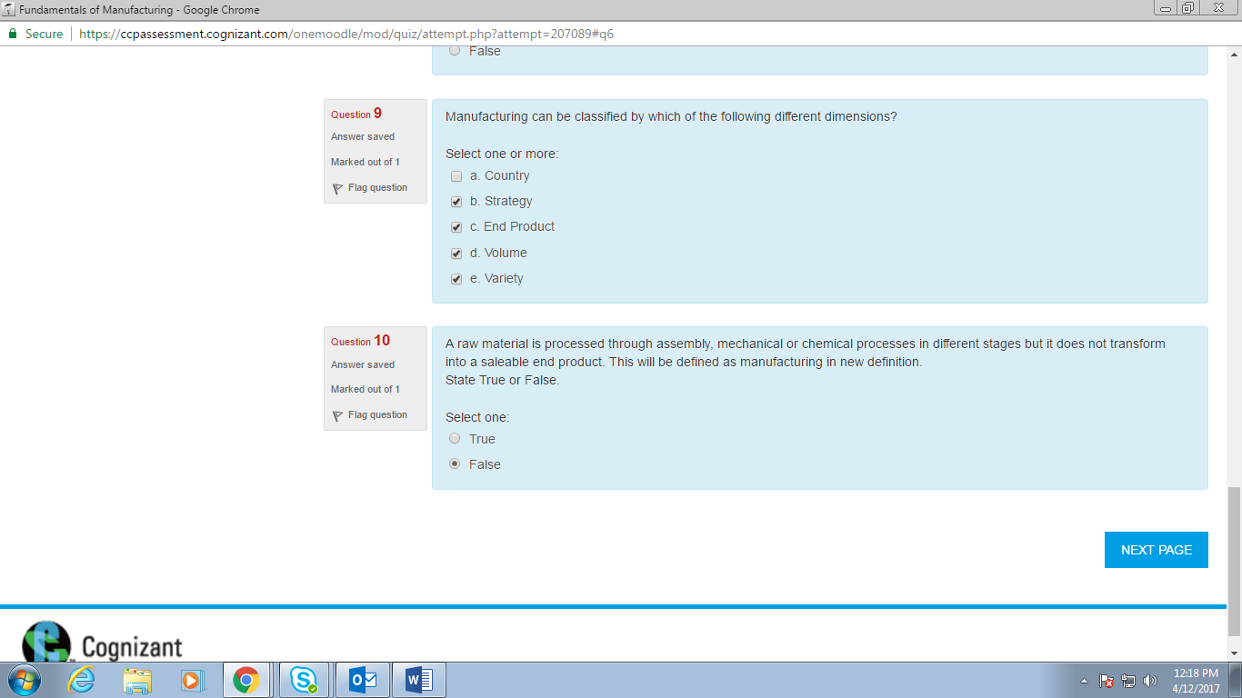

9. Manufacturing can be

10. A raw material is processed

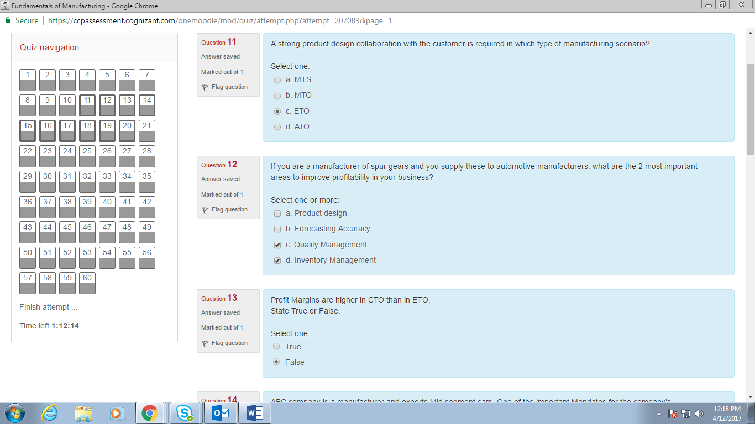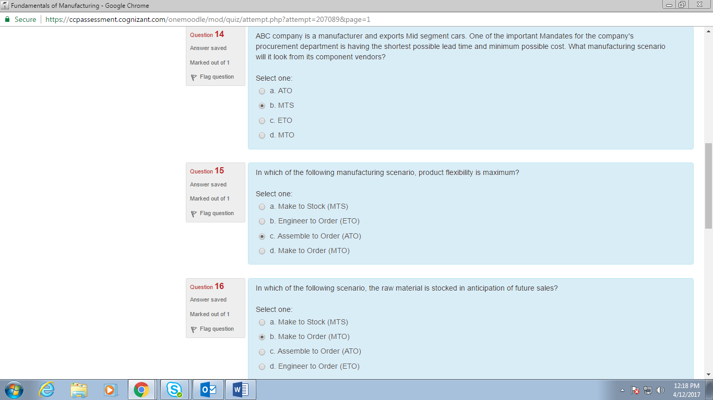

11. A strong product design

12. If you are a manufacturer

13. Profit margins are

14. ABC company is a

15. In which of the following manufacturing scenario

16. In which of the following scenario, the raw material is stocked 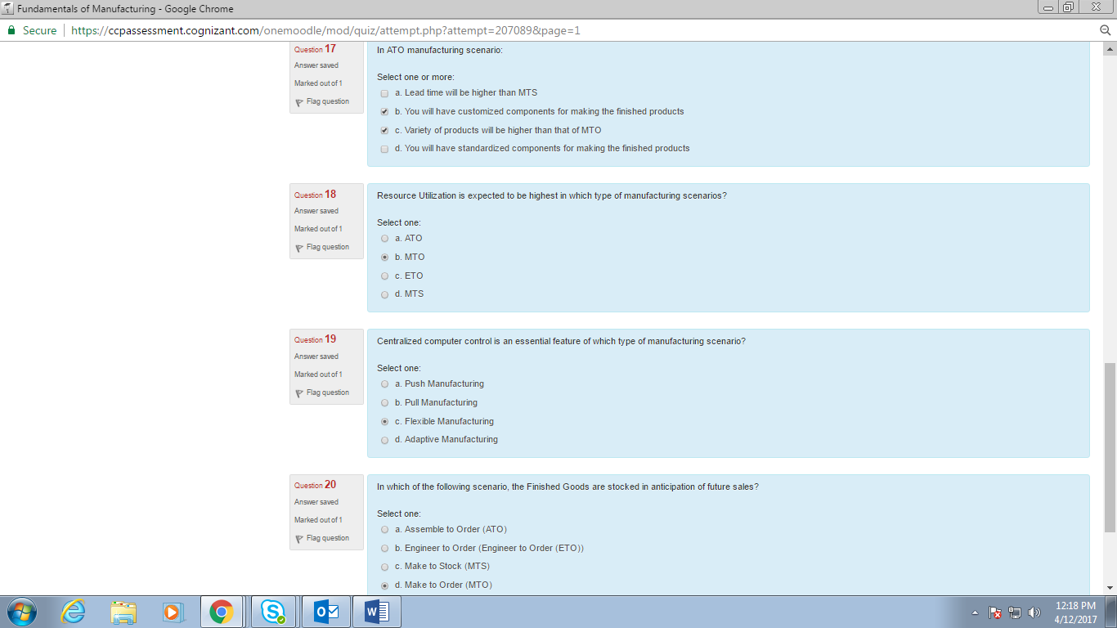

17. In ATO manufacturing

18. Resource utilization

19. Centralized computer

20. In which of the following scenario, the finished goods are stocked

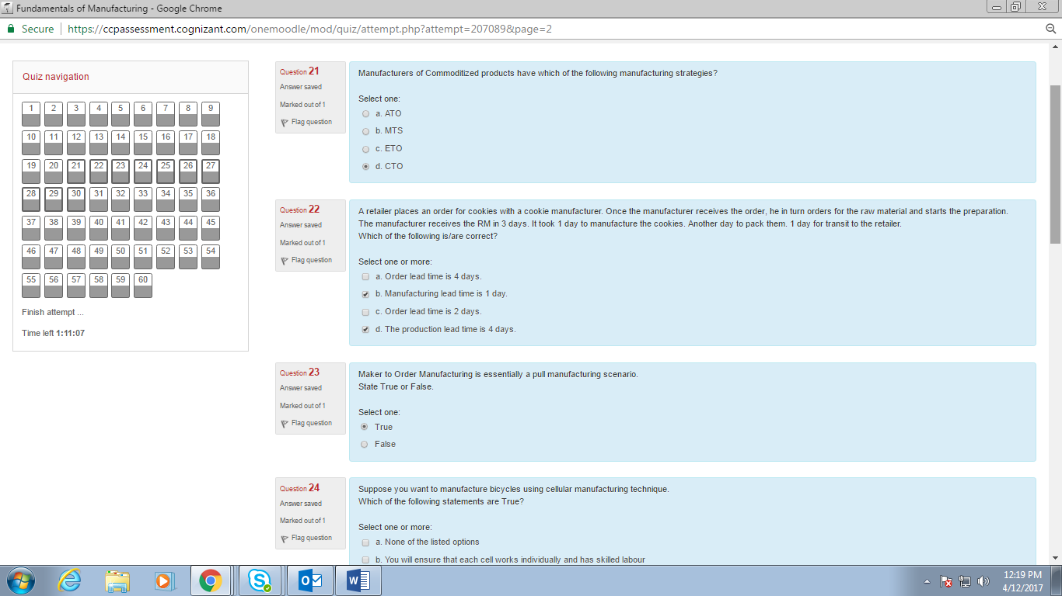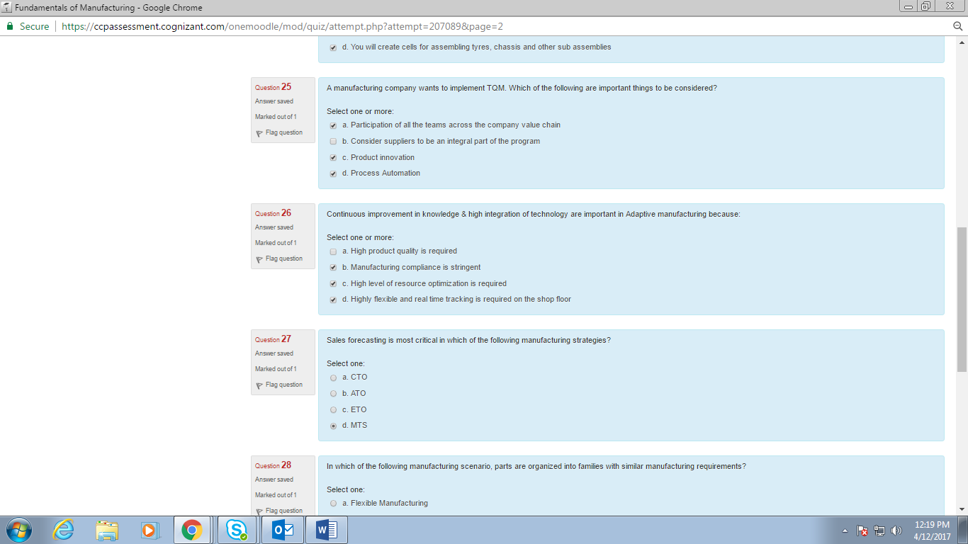

21. Manufacturers of commoditized

22. A retailer places an order

23. Maker to order

24. Suppose you want to manufacture bicycles

25. A manufacturing company want to

26. Continuous improvement

27. Sales forecasting

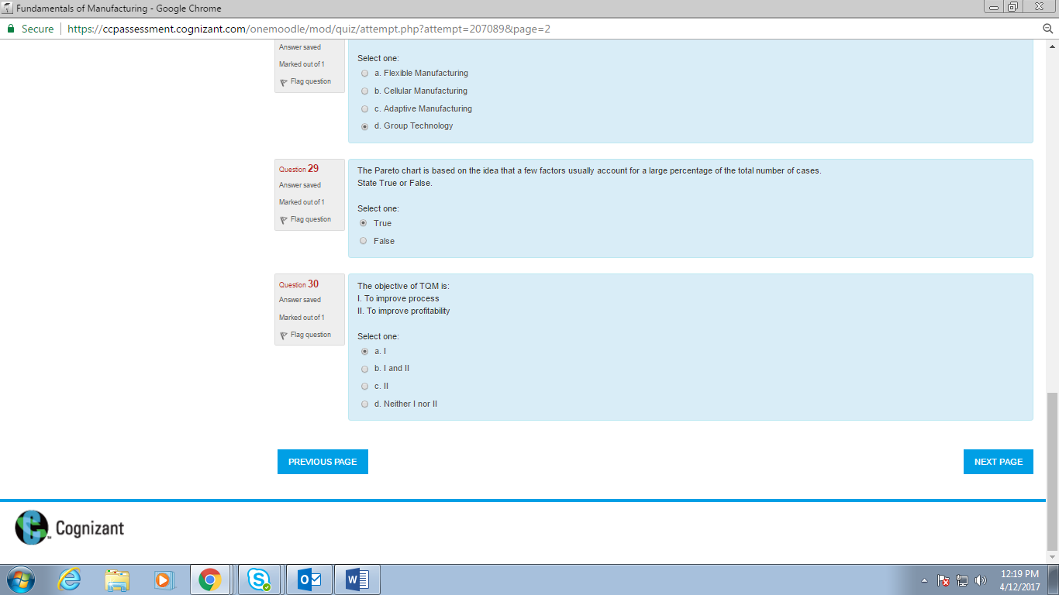

28. In which of the following manufacturing scenario, parts are organized into families

29. The pareto chart

30. The objective of TQM

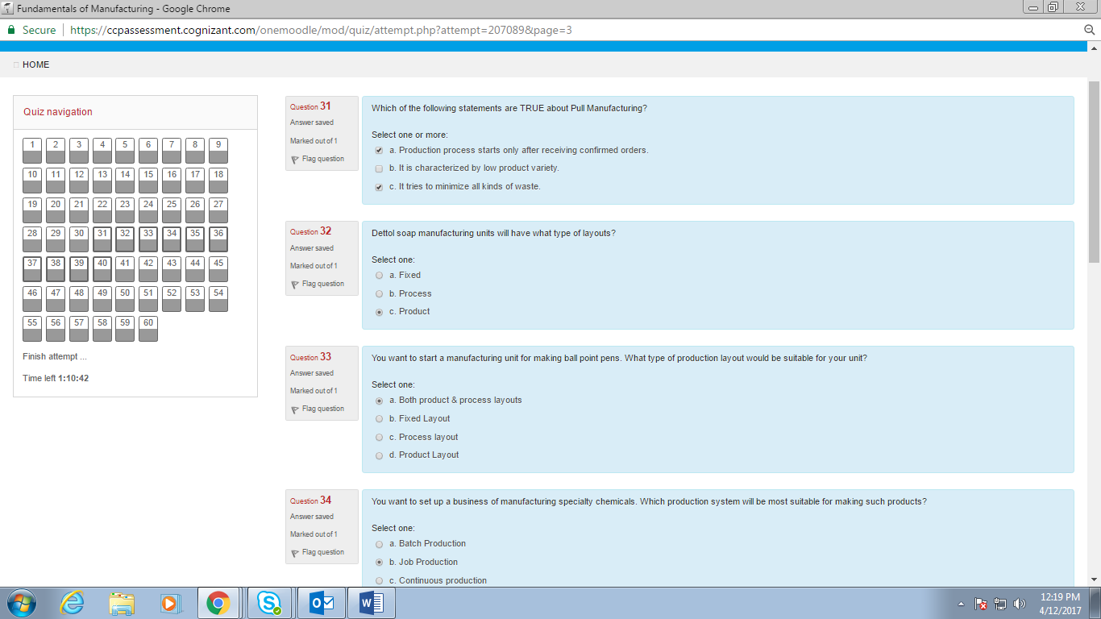

31. Which of the following statements are TRUE about pull manufacturing

32. Dettol soap

33. You want to start a manufacturing

34. You want to set up a business

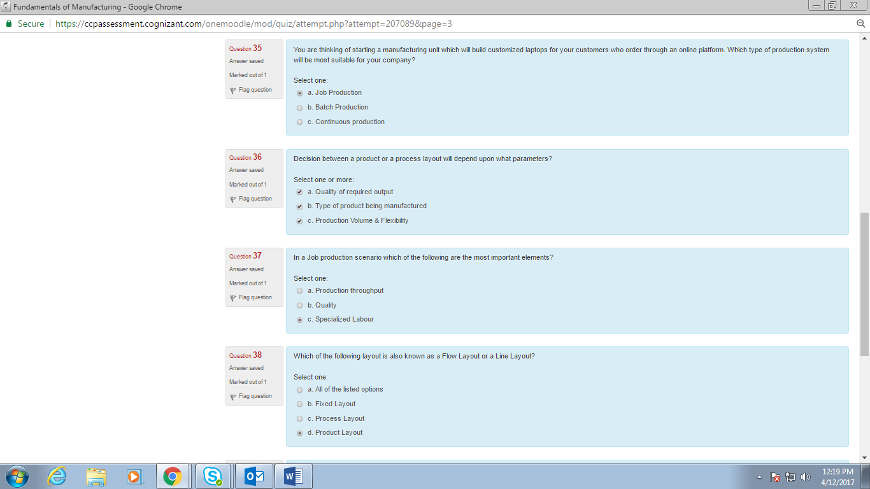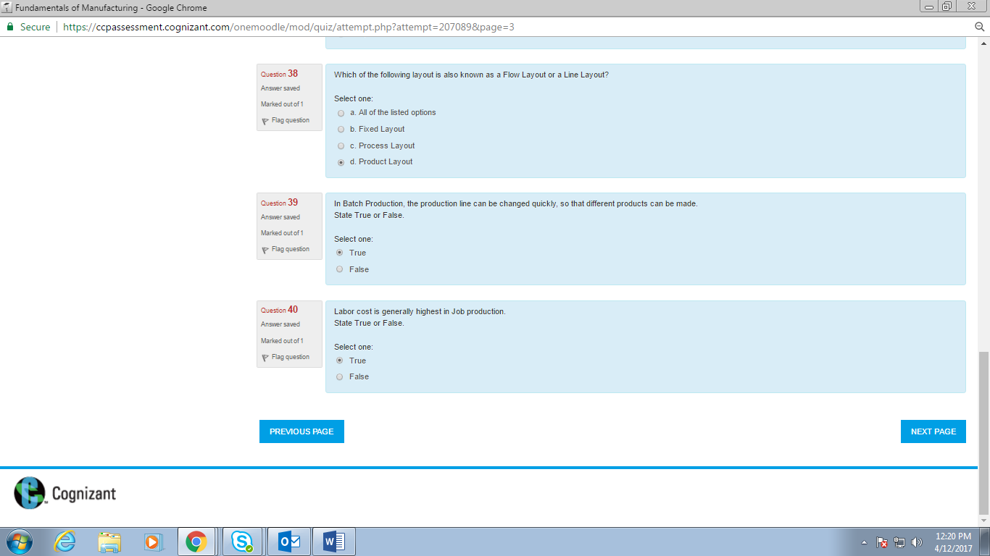

35. You are thinking of starting

36. Decision between a product

37. In a job production

38. Which of the following layout is also

39. In batch production

40. Labor cost

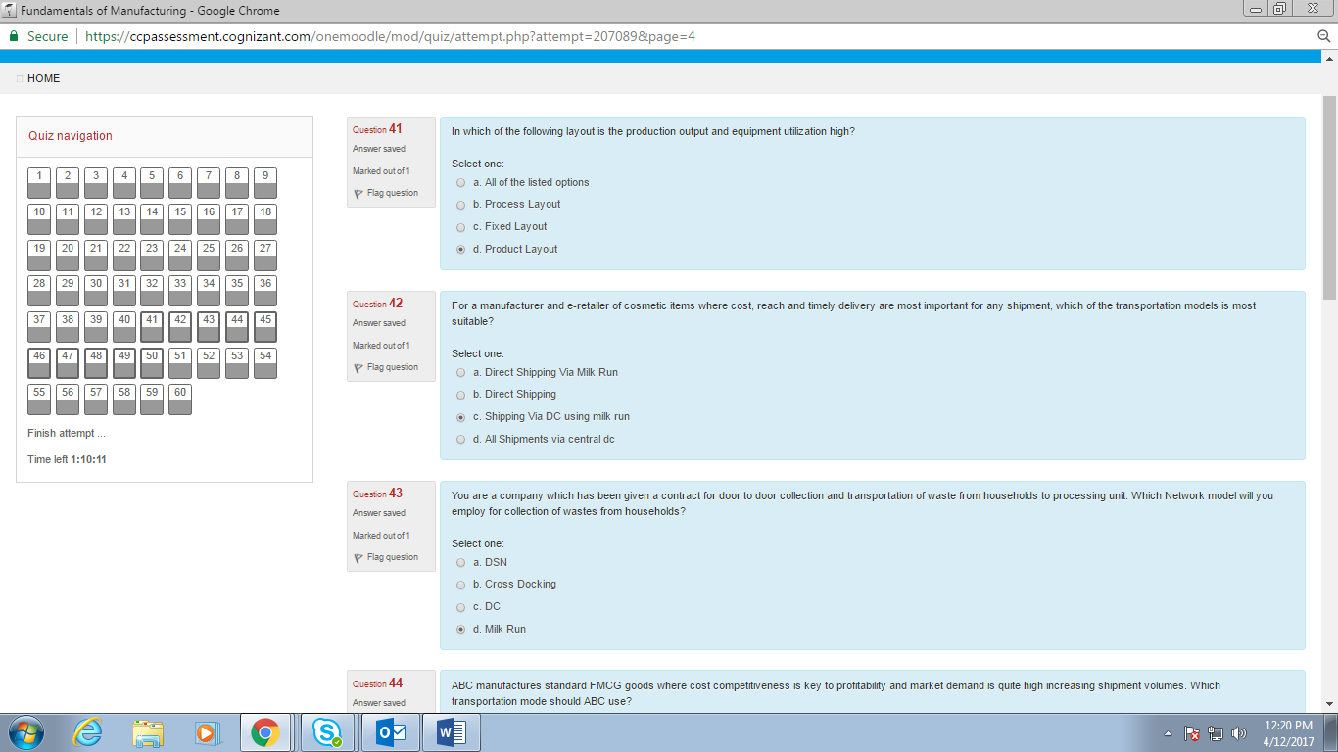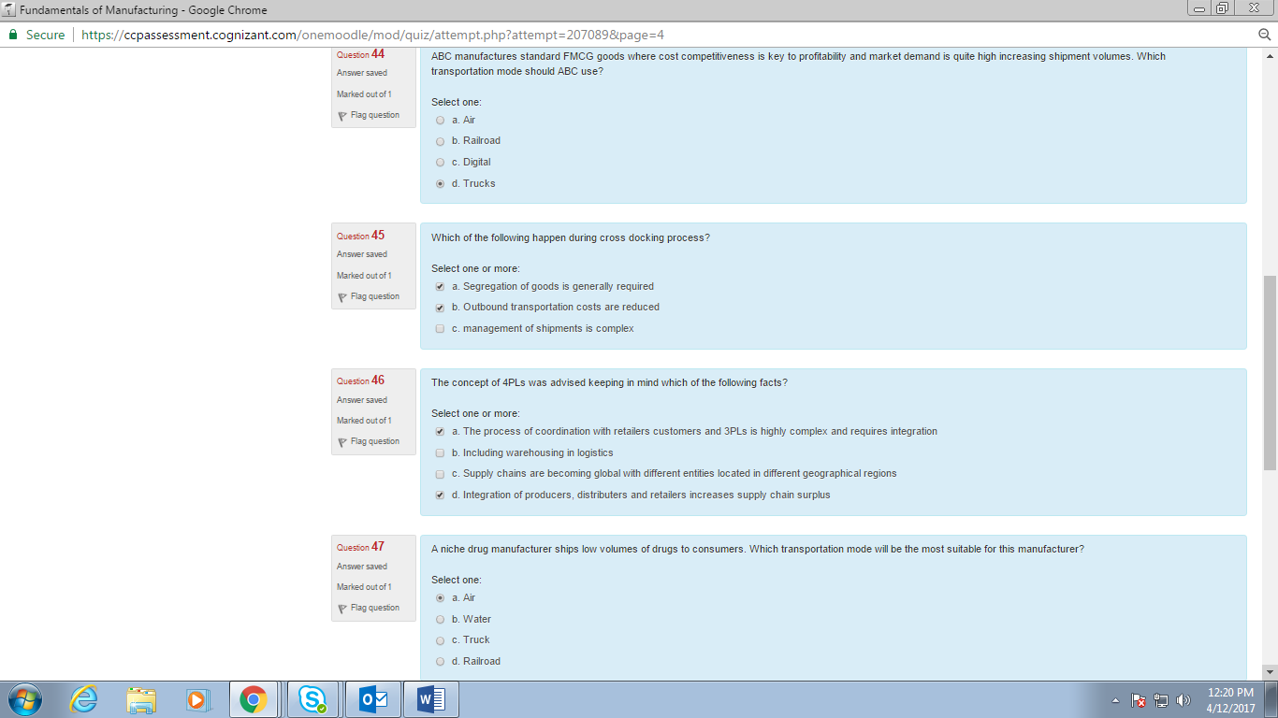

41. In which of the following layout is the production output

42. For a manufacturer and

43. You are a company which has been

44. ABC manufacturers FMCG

45. Which of the following happen during cross docking

46. The concept of 4PLs

47. A niche drug 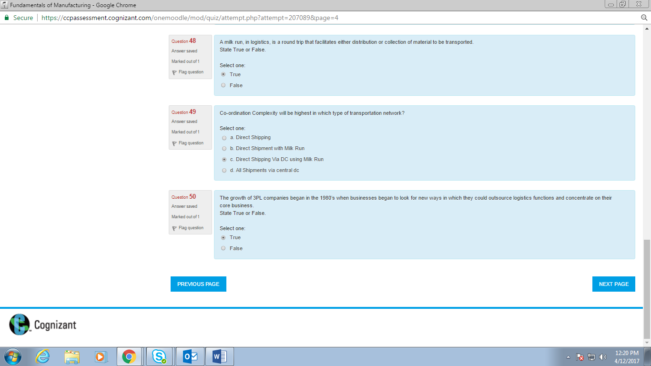

48. A milk run

49. co-ordition complexity

50. The growth of 3PL

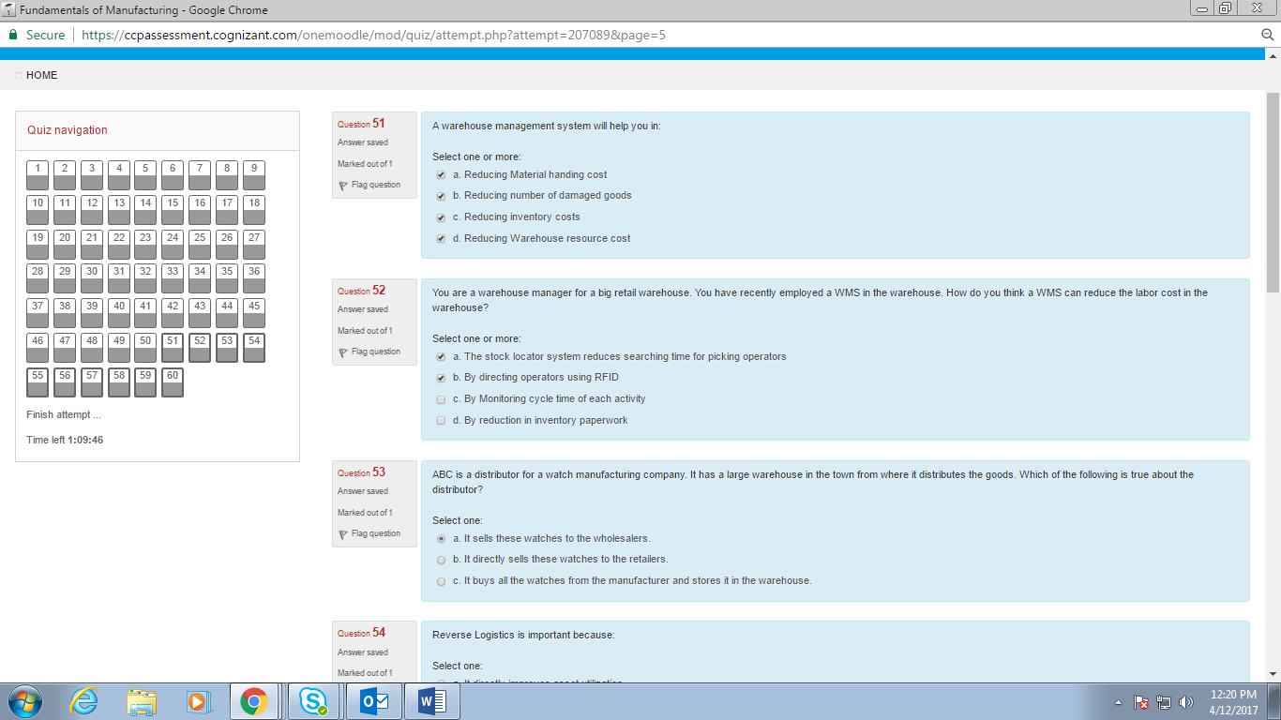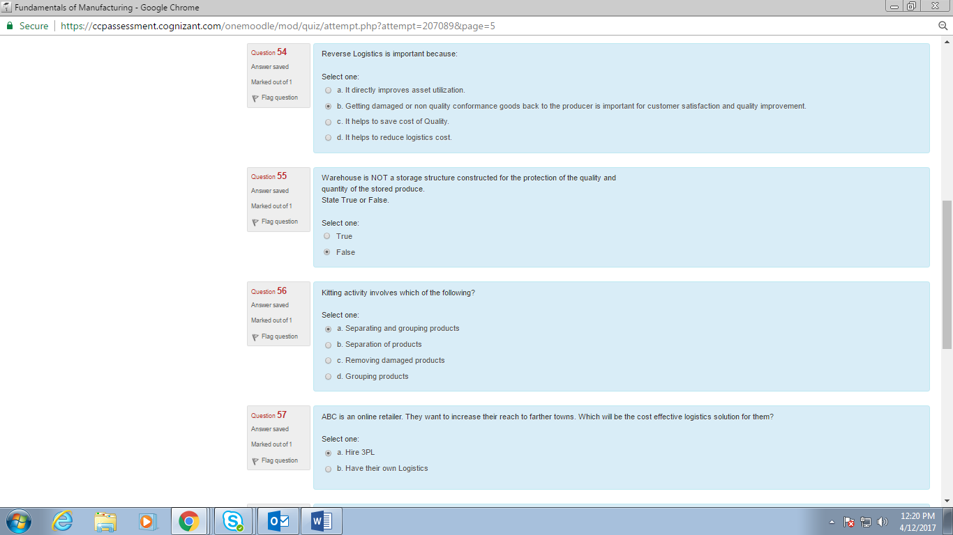

51. A warehouse

52. You are a warehouse manager

53. ABC is a distributor for a watch

54. Reverse logistics

55. Warehouse is not

56. Kitting activity

57. ABC is an online retailer

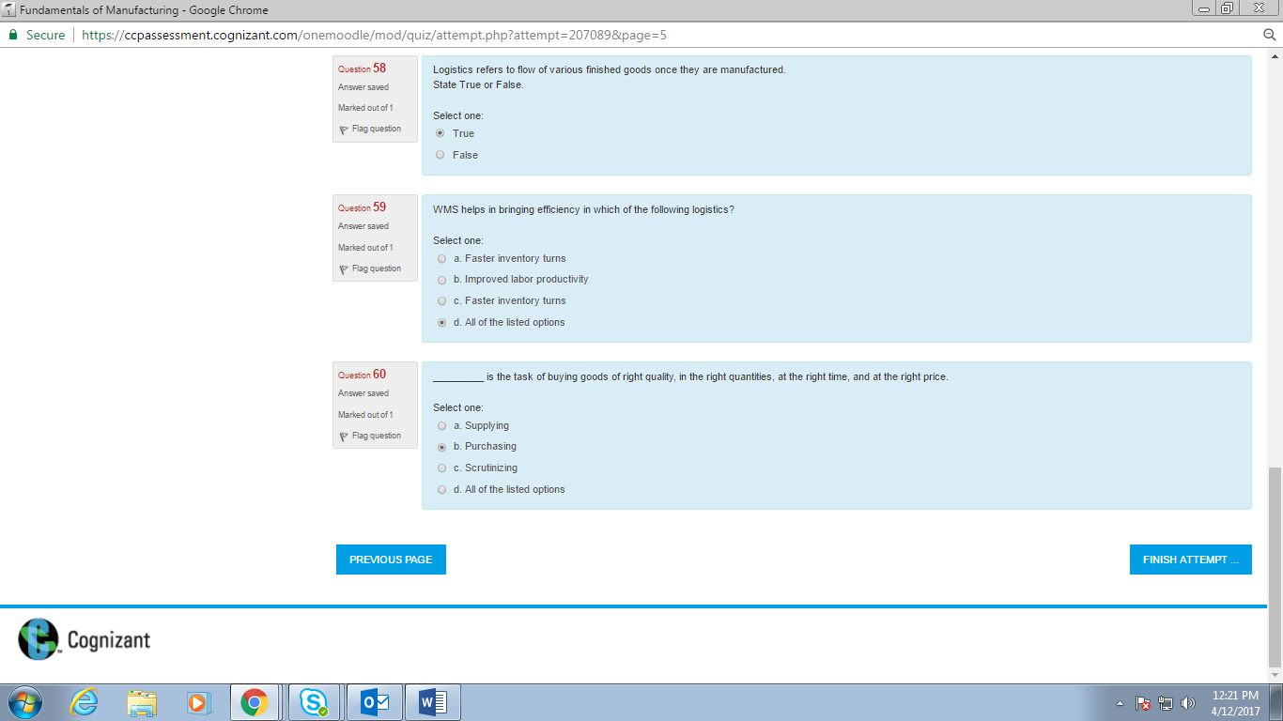

58. Logistics refers to

59. WMS helps

60. is the task of buying goods of right quality

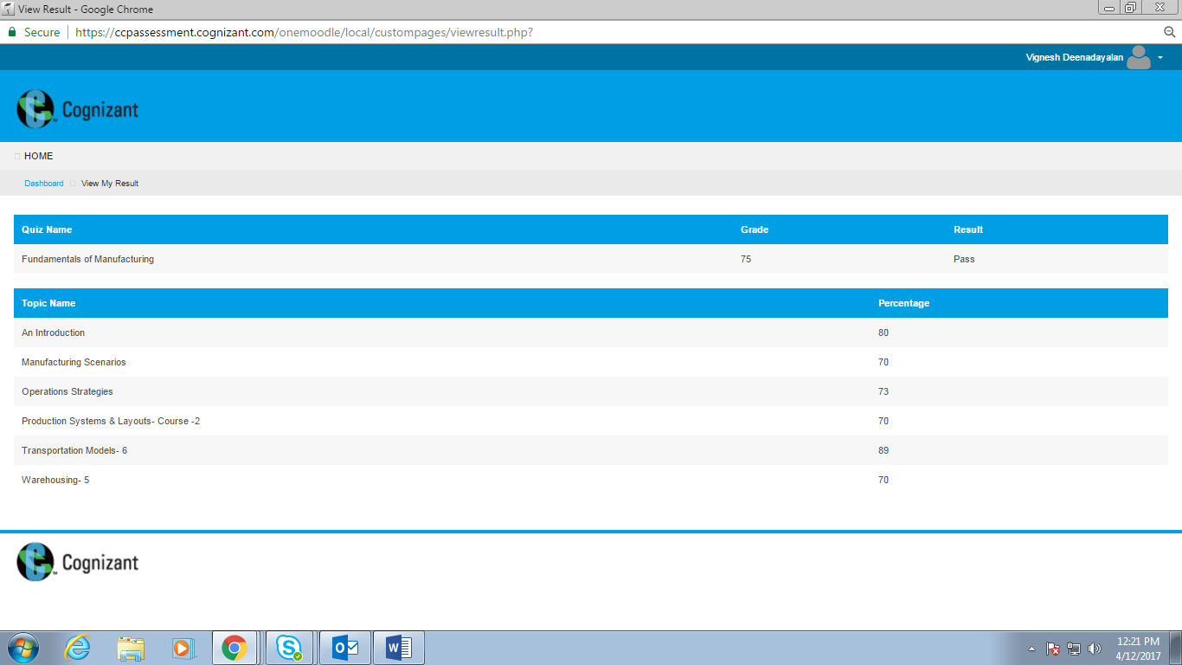

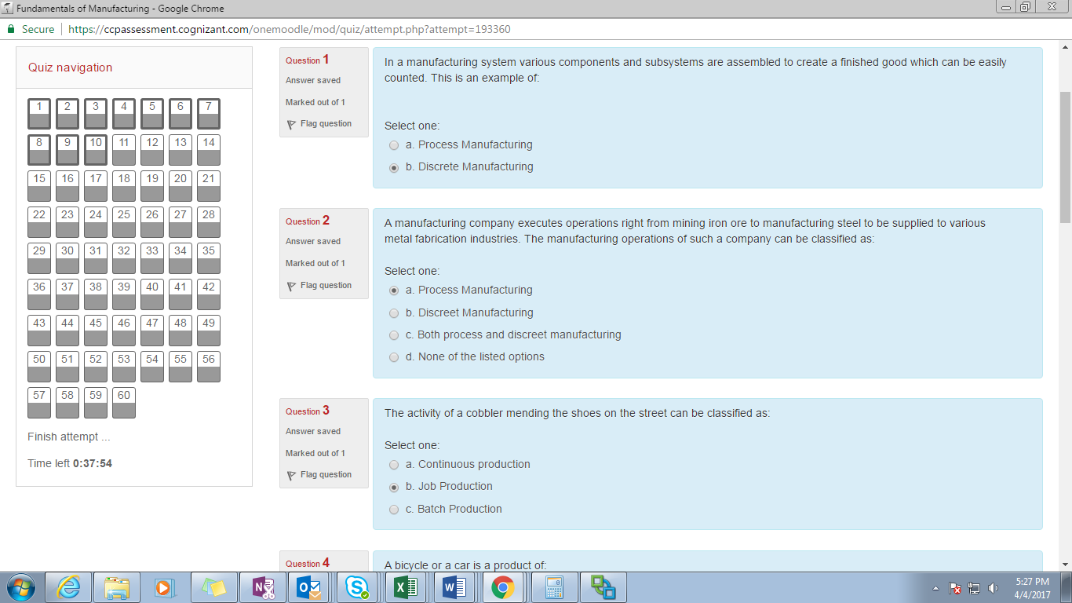

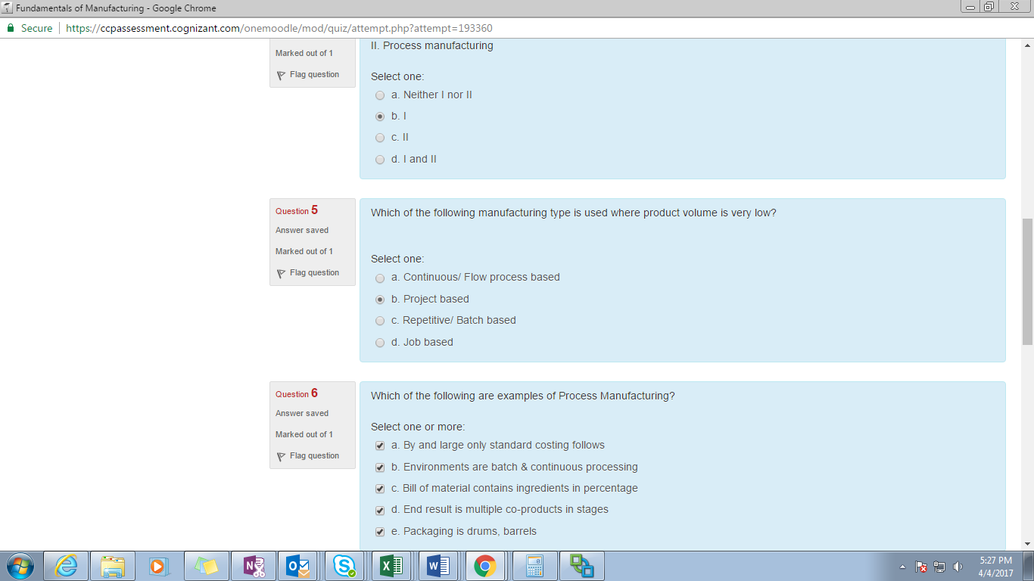

1. In a manufacturing system

2. A manufacturing company executes

3. The activity of a cobbler

4. A bicycle or a car

5. Which of the following manufacturing type is used where product volume is very low

6. Examples of the following are examples of process management

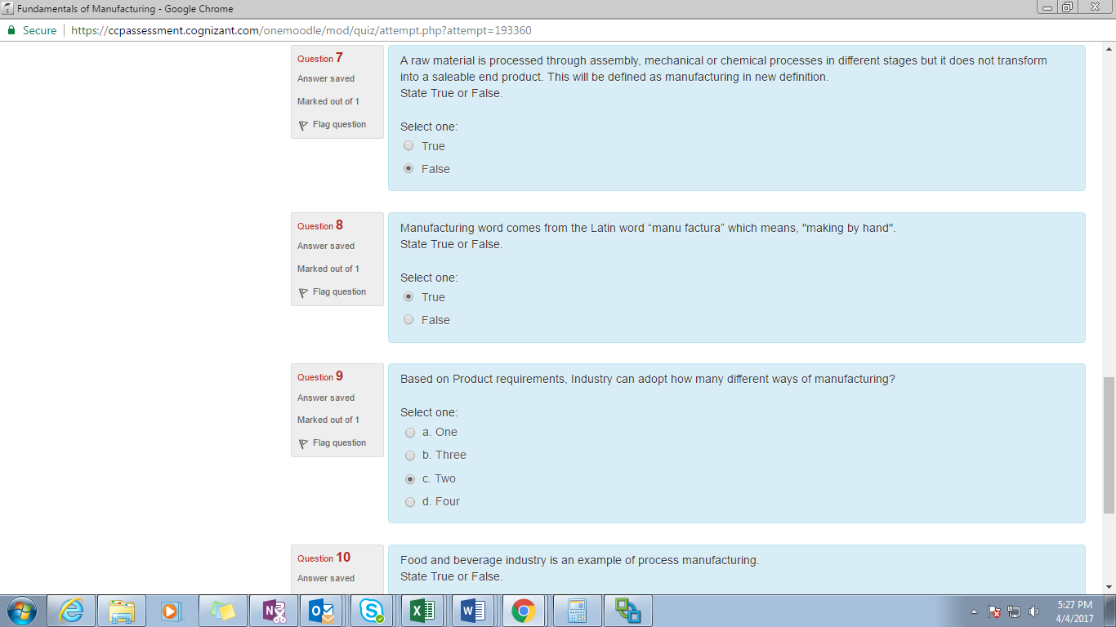

7. A raw material is processed

8. Manufacturing word

9. Based on product requirement

10. Food and beverage

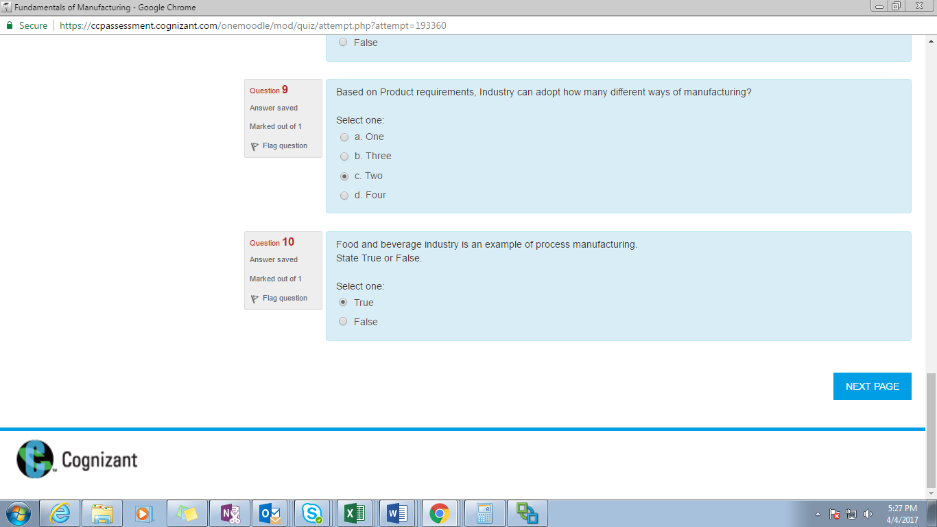

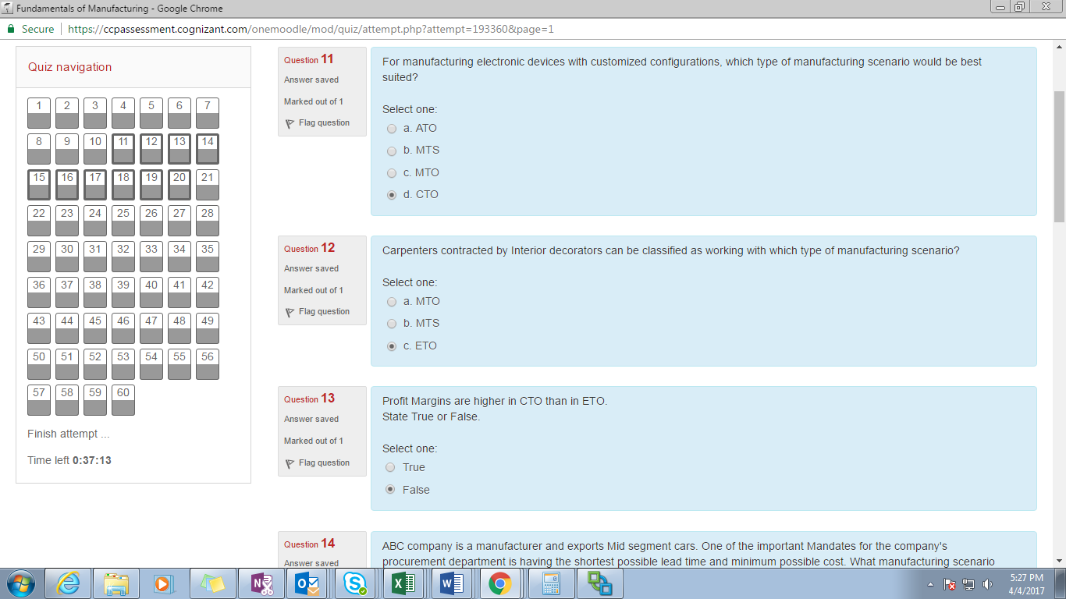

11. For manufacturing electronic devices

12. Carpenters

13. Profit margins

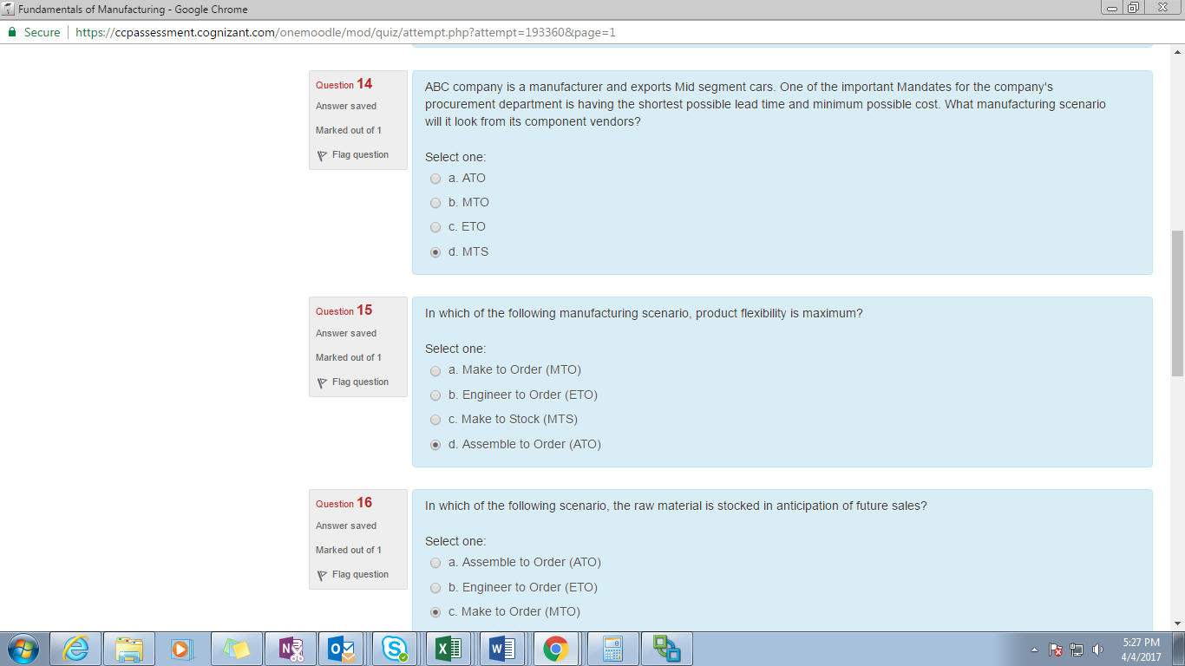

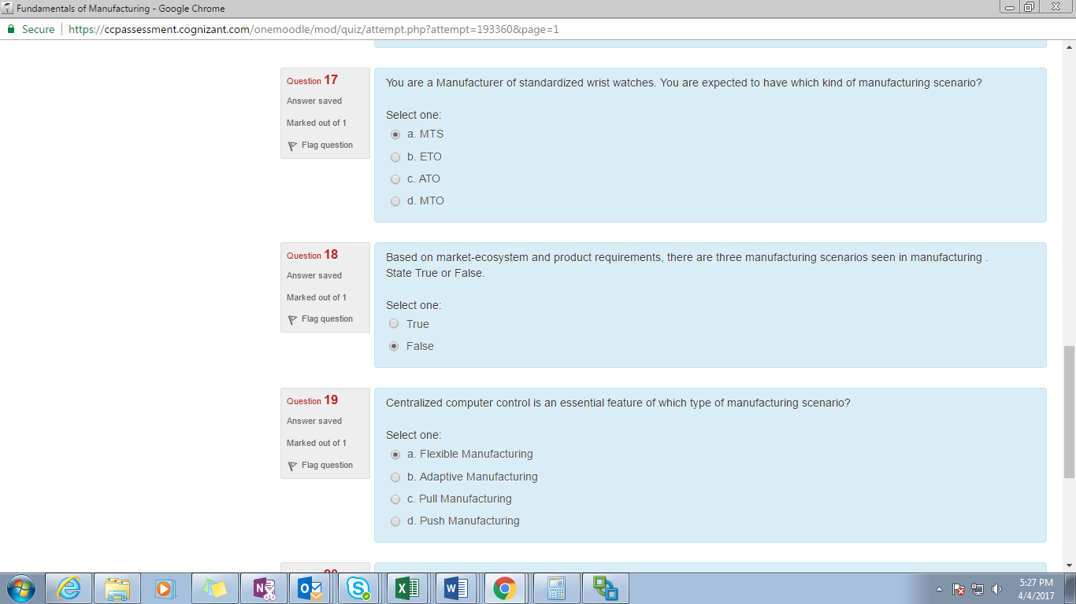

14. ABC company

15. In which of the following manufacturing scenario, product flexibility is maximum

16. In which of the following scenario, the raw materials is stocked

17. You are a manufacturer of standardized wrist watch

18. Based on market-ecosystem

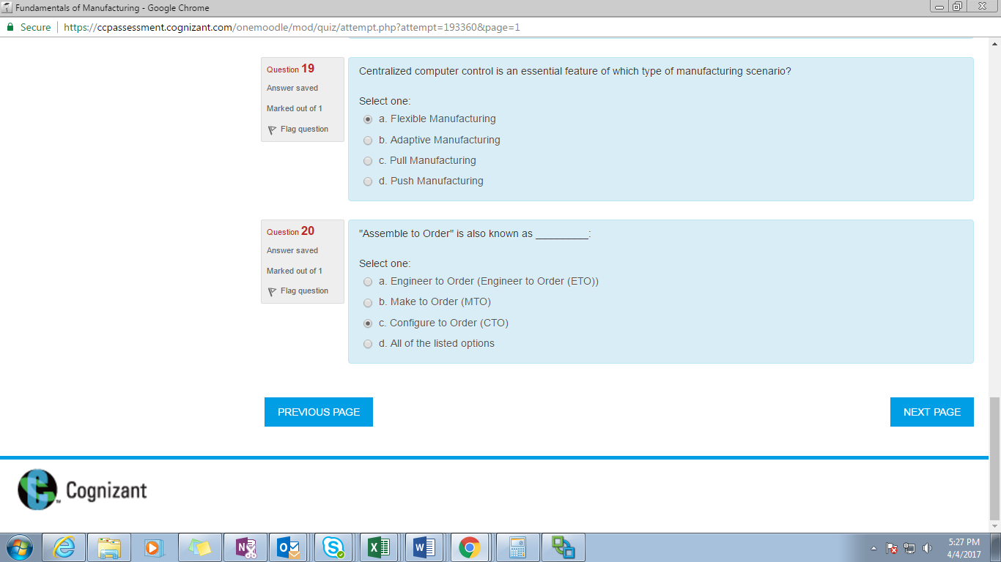

19. Centralized computer

20. Assemble to order

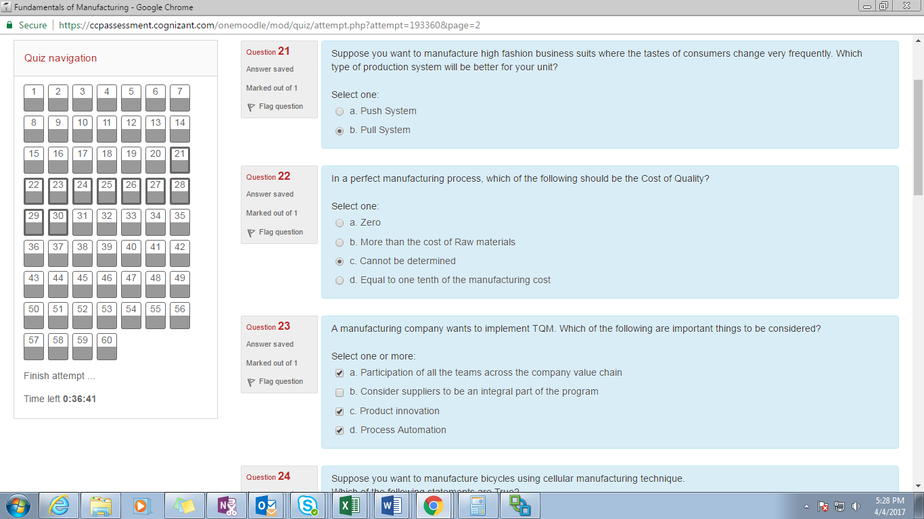

21. Suppose you want to

22. In a perfect manufacturing process

23. A manufacturing company want to implement TQM

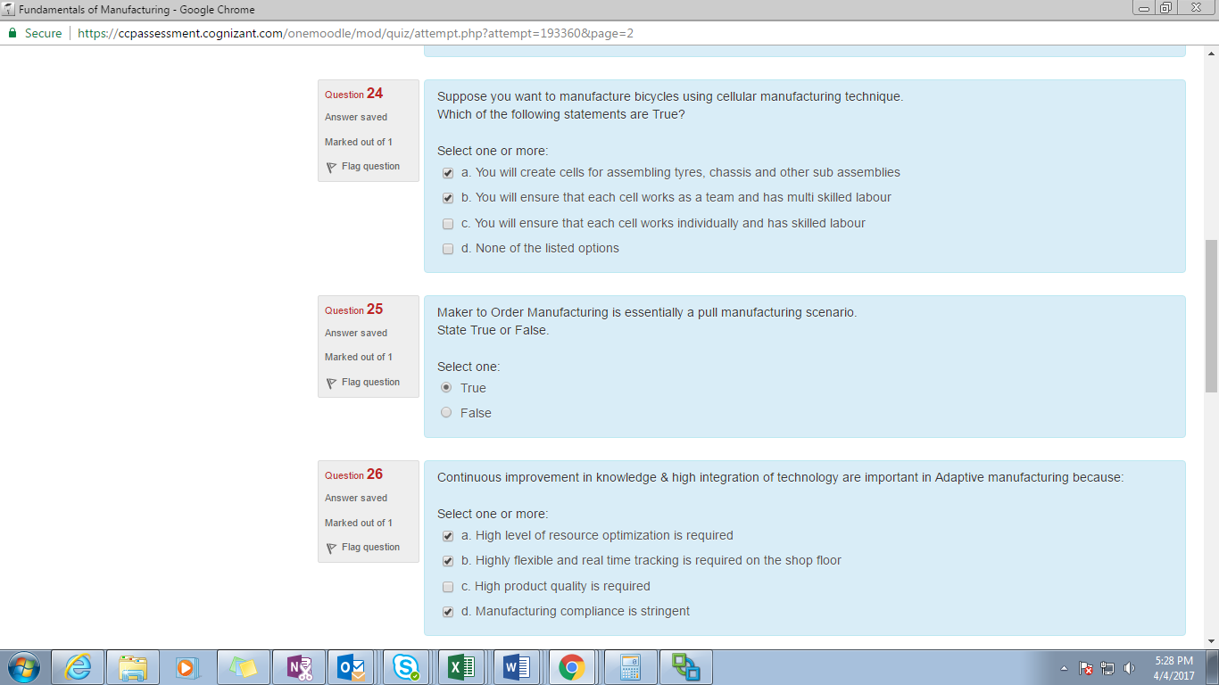

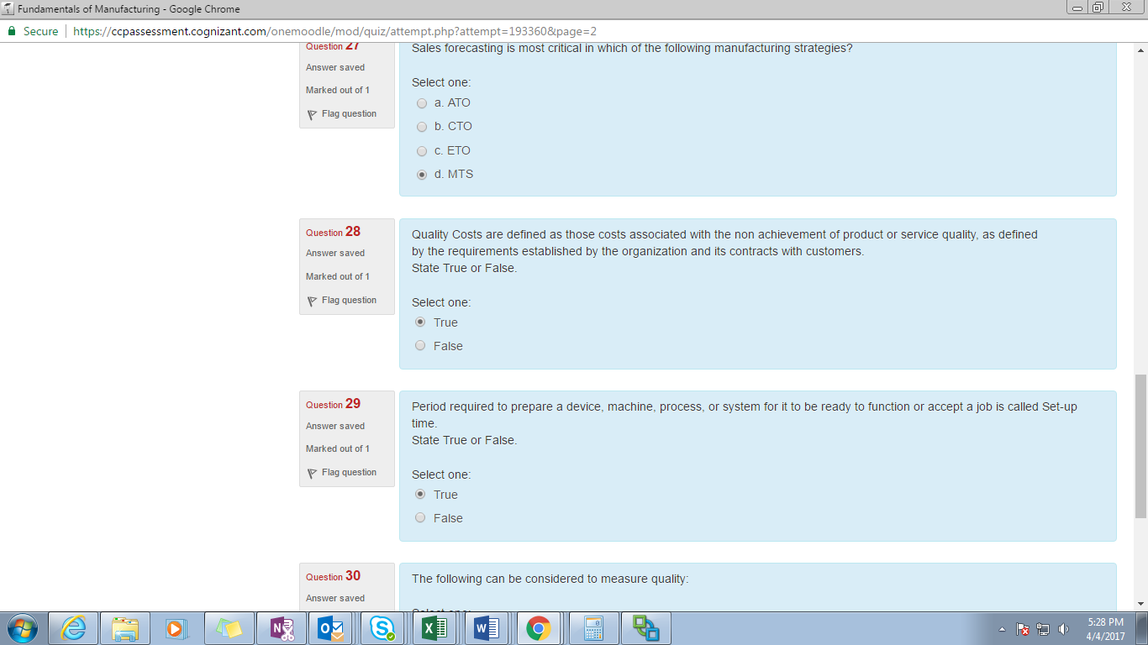

24. Suppose you want to manufacture bicycles

25. Maker to order

26. Continuous improvement

27. Sales forecasting

28. Quality cost

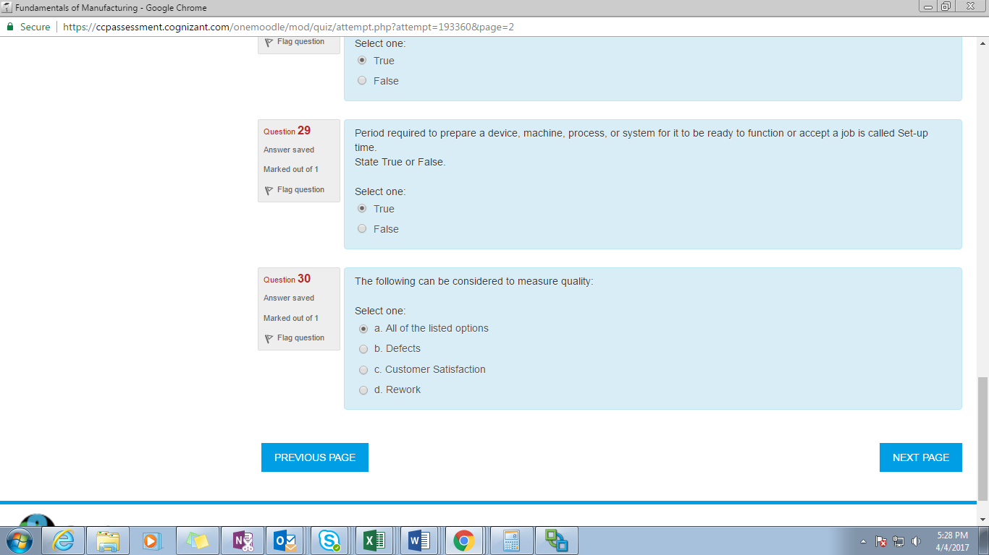

29. Period required to

30. The following can be considered to measure Quality

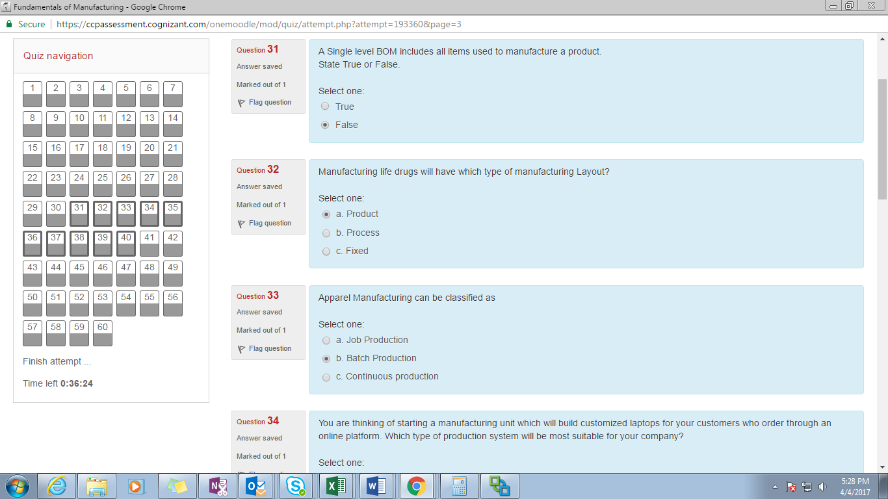

31. A Single level BOM

32. Manufacturing life drugs

33. Apparel manufacturing

34. You are thinking of starting

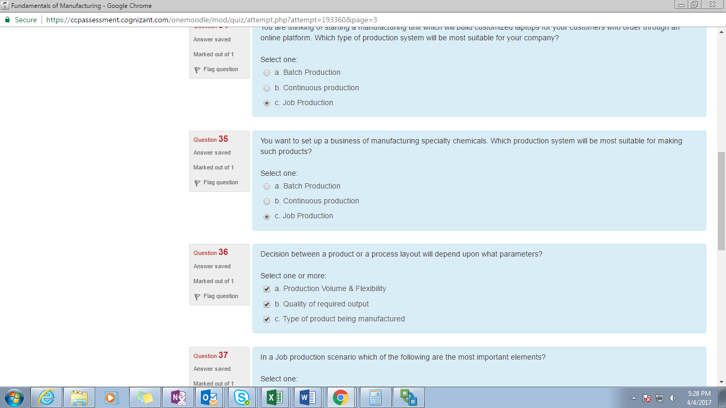

35. You want to set up

36. Decision between

37. In a Job production

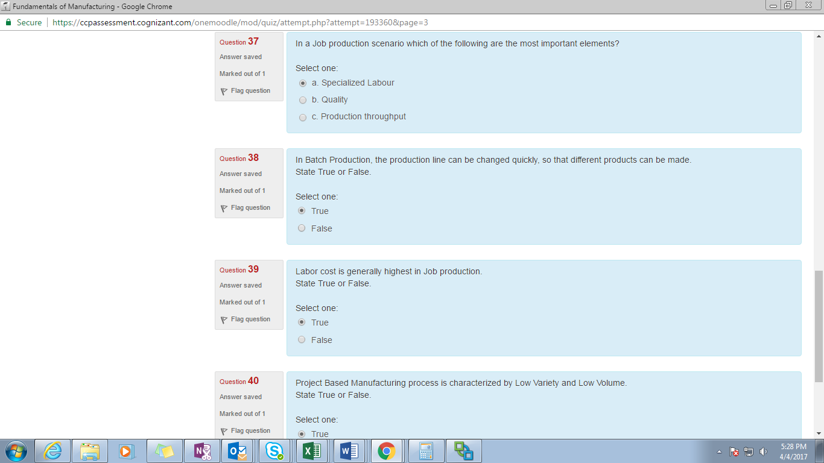

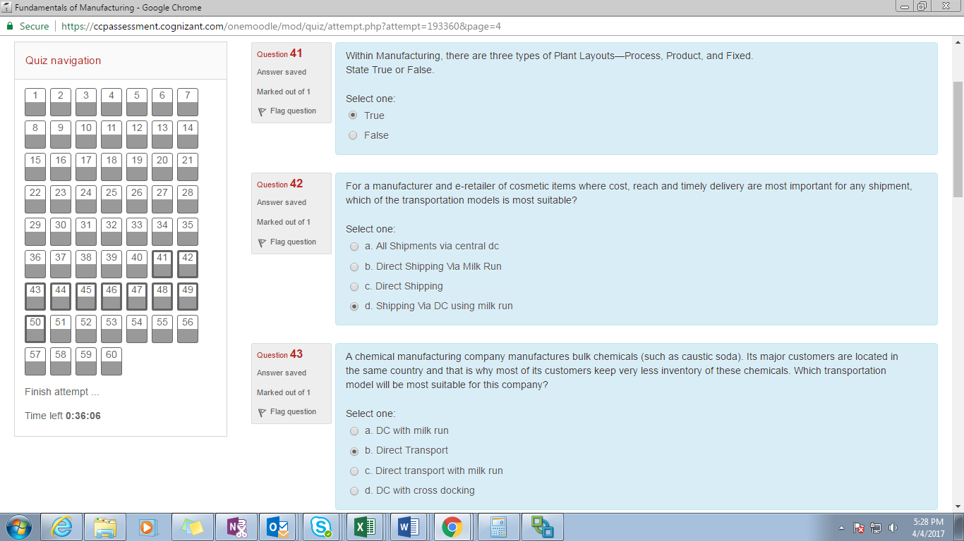

38. In Batch production

39. Labor cost

40. Project based manufacturing

41. Within manufacturing

42. For a manufacturer and e-retailer

43. A chemical manufacturing

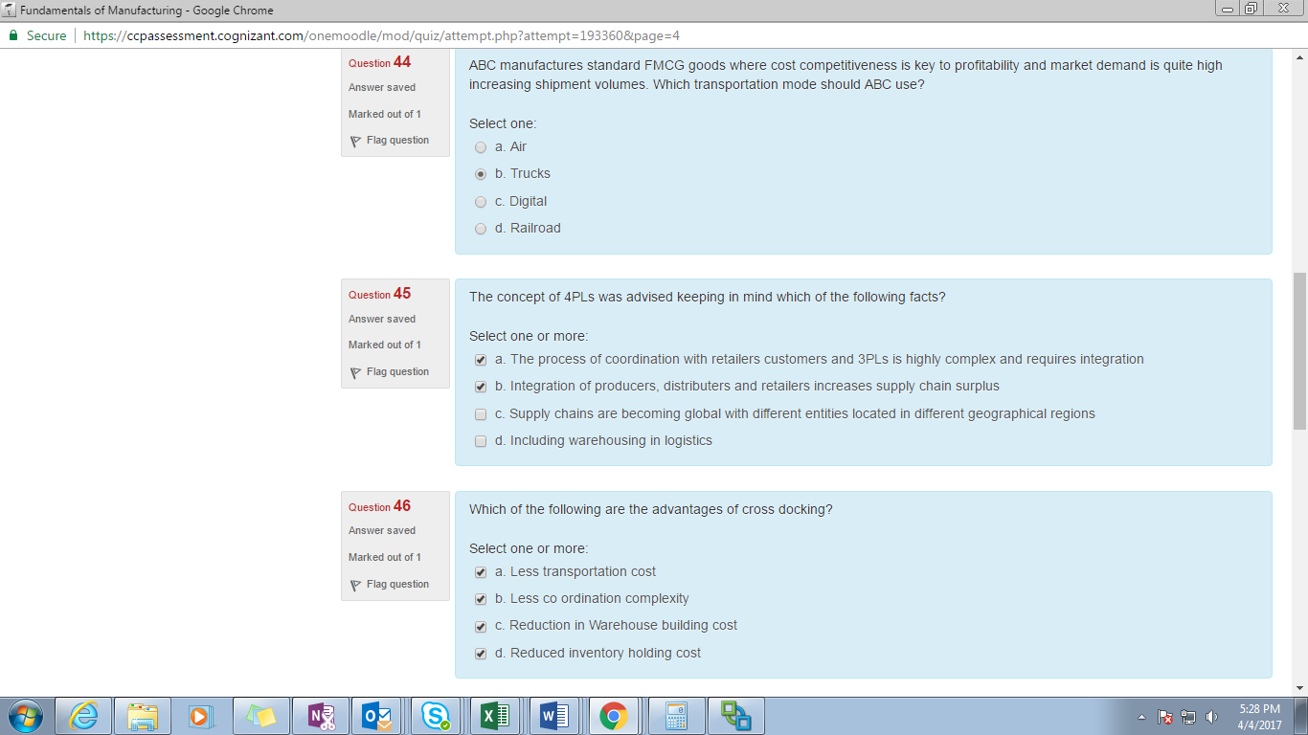

44. ABC manufacturing standard FMCG

45. The concept of 4PLs

46. Which of the following are the advantages of cross ducking

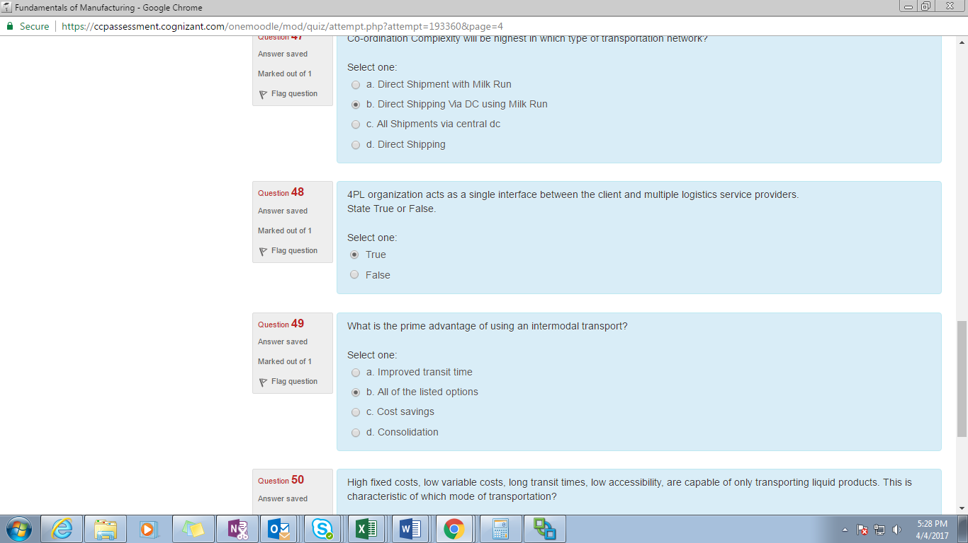

47. Co-ordination complexity

48. 4PL organization

49. What is prime advantage of

50. High fixed costs

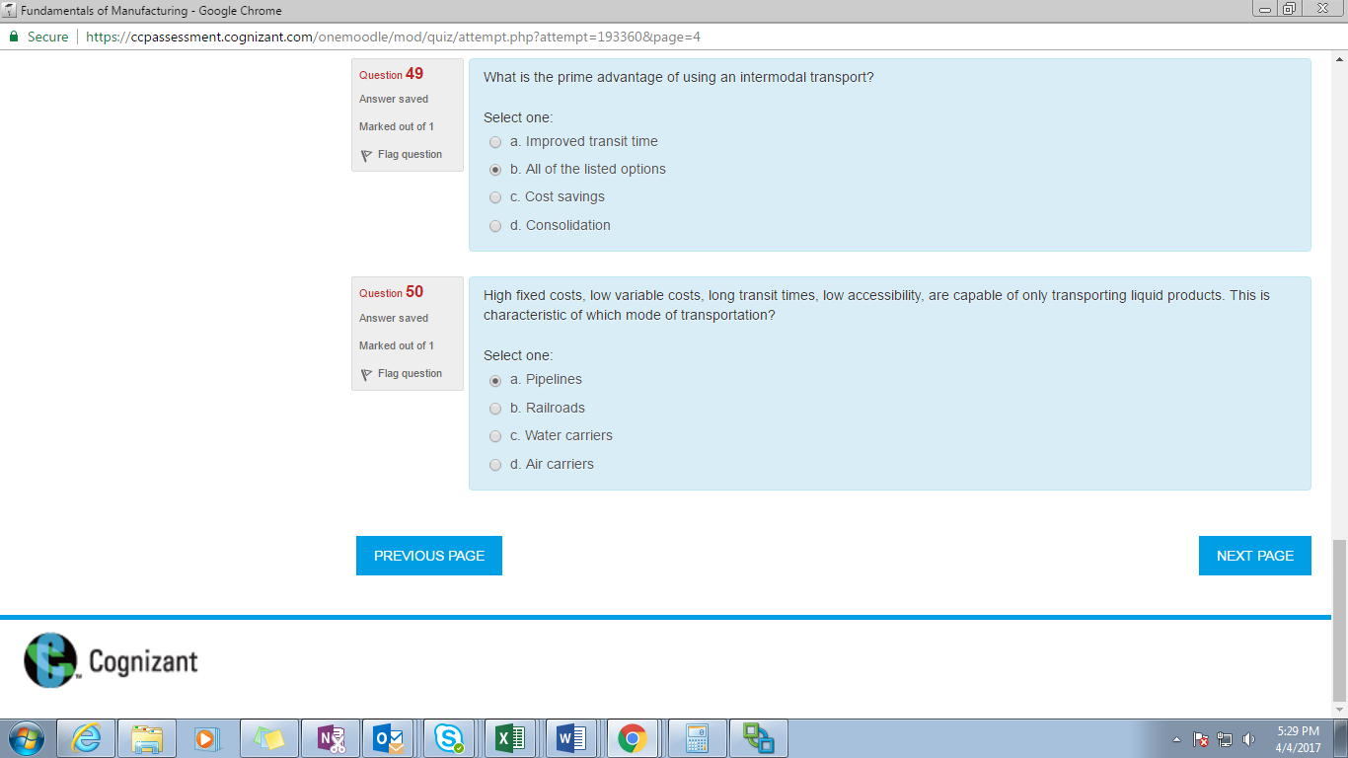

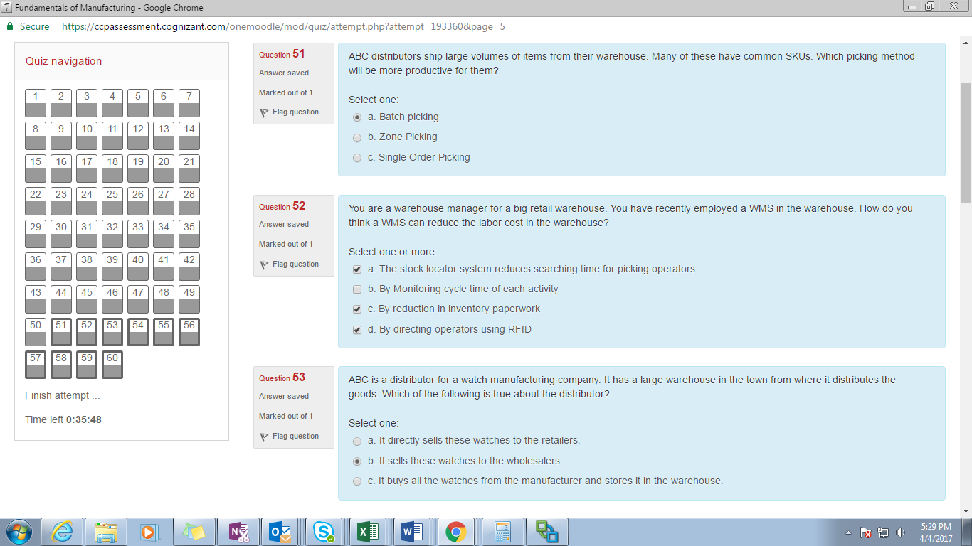

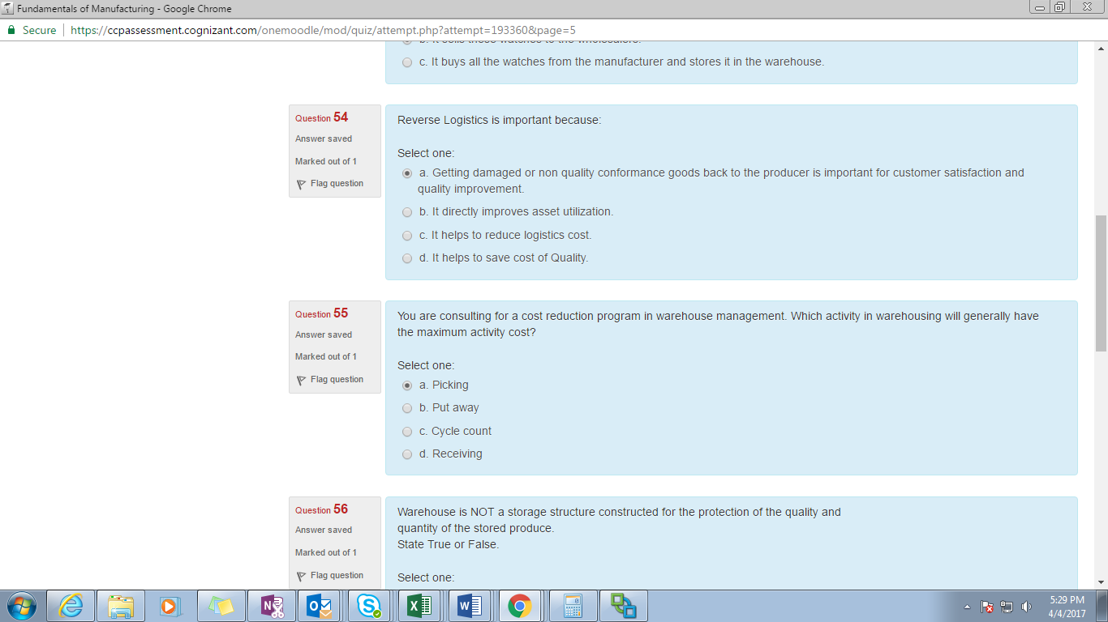

51. ABC distributors

52. You are a warehouse

53. ABC is a distributor for a watch

54. Reverse logistics

55. You are consulting

56. Warehouse is not

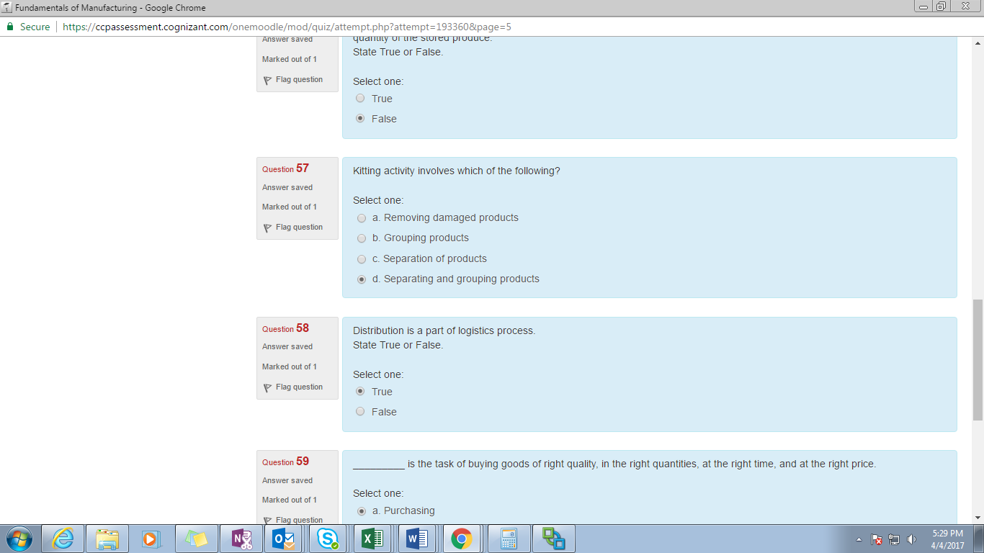

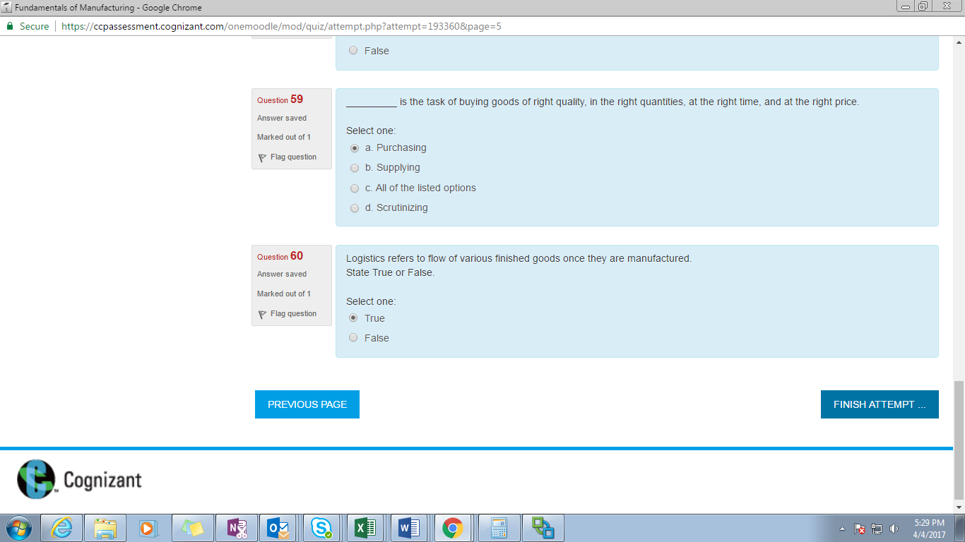

57. Kitting activity

58. Distribution is a part of

59. is the task of buying goods of right quality, in the right

60. Logistics refers to

**Introduction**

* Manufacturing can be classified by which if the following different dimensions *(select one or more)*?

1. Strategy
2. Volume *
3. Variety*
4. End product *
5. Country

* Manufacturing life drugs will have which type of manufacturing layout?

1. Fixed
2. Process
3. **Product**

* Most flexible manufacturing systems comprise three main system-work machines, material handling system, and central control computer – **True**
* A raw material is processed through assembly, mechanical or chemical processes in different stages but it does not transform into a saleable end product this will be defined as manufacturing in new definition. – **False**
* Labor cost is generally highest in job production. State true or false. – **True**
* Space shuttles use Steel plates as raw material and other components. This is an example of which industry and manufacturing type?

1. Process and batch manufacturing
2. **Discrete and project based manufacturing**
3. Process and continuous manufacturing
4. Discrete and job based manufacturing

* Manufacturing word comes from the Latin word “manu factura” which means, “making by hand”. State true or false. – **True**
* In a manufacturing system various components and subsystems are assembled to create a finished good which can be easily counted. This is an example of:

1. Process manufacturing
2. **Discrete manufacturing**

* A chemical manufacturing company manufactures bulk chemicals (such as caustic soda). Its major customers are located in the same country and that is why most of its customers keep very less inventory of these chemicals. Which transportation model will be most suitable for this company?

1. Direct transport with milk run
2. DC with milk run
3. **DC with cross docking**
4. Direct Transport

* Within manufacturing, there are three types of plant layouts – process, product, and fixed – **True**
* Which of the 2 push or pull production system will have more inventory?

1. **Push system**
2. Pull system

* The Pareto chart is based on the idea that a few factors usually account for a large percentage of the total number of cases. State True or False. **True**
* A Manufacturing company executes operations right from mining iron ore to manufacturing Steel to be supplied to various metal fabrication Industries. The manufacturing operations of such a company can be classified as:

1. None of the listed options
2. Both process and discrete manufacturing
3. Discrete manufacturing
4. **Process manufacturing**

* __________ is the task of buying goods of right quantities, at the right time, and at the right price.

1. Supplying
2. All of the listed options
3. Scrutinizing
4. **Purchasing**

* Suppose you want to manufacture bicycles using cellular manufacturing technique. Which if the following statements are true *(Select one or more)*?

1. You will ensure that each cell works as a team and has multi skilled labour
2. **You will create cells for assembling tyres, chassis and other sub assemblies**
3. None of the listed options
4. **You will ensure that each cell works individually and has skilled labour.**

* Food and beverage industry is an example of the process manufacturing. – **true**
* Which of the following are characteristics of Adaptive Manufacturing *(Select one or more)*?

1. **Rapid Production Operation switch such as high volume/low mix and high volume/high mix product loadings**
2. **Need for flexibility with velocity**
3. **High integration of technology into production**
4. A manufacturing cell created for each part family

* A quality assurance exercise leads to continuous process improvement. – **True**
* Postponement will help you to *(Select one or more)*?

1. Have benefits of both pull and push system
2. **Reduce WIP**
3. **Reduce overall production cost**
4. **Improve product quality**

* Based on product requirements industry can adopt how many different ways of manufacturing? – **two**
* Which of the following are examples of Process manufacturing *(Select one or more)*?

1. Environments are batch and continuous processing
2. **End result is multiple co-products in stages**
3. **Packaging is drums, barrels**
4. **Bill of material contains ingredients in percentage**
5. By and large only standard costing follows

* In case of push manufacturing, primary focus is on capacity and production throughput. State true or false. – **True**
* Continuous improvement in knowledge and high integration of technology are important in Adaptive manufacturing because:

1. **High product quality is required**
2. **Manufacturing compliance is stringent**
3. **Highly flexible and real time tracking is required on the shop floor**
4. High level of resource optimization is required

* Which of the following manufacturing type is used where product volume is very low?

1. Repetitive/Batch based
2. Job based
3. Continuous/flow process based
4. **Project based**

* The following can be considered to measure quality:

1. **All of the listed options**
2. Customer satisfaction
3. Rework
4. Defects

* Which of the following is an example of discrete end product, with continuous flow manufacturing, having an MTS strategy?

1. Furniture
2. **Wrist watch**
3. Laptops

* Which of the following are some of the examples of discrete manufacturing?

1. **End result is a destined result and a distinct end product**
2. Stages include mixing, blending, and cracking(process manufacturing)
3. Bill of material contains ingredients in percentage(process manufacturing)
4. **By and large standard and actual costing follows**
5. **Bill of material contains items with quantity in numbers**

* In a manufacturing system raw materials come directly from the earth/natural resources, this is an example of

1. Discrete manufacturing
2. **Process manufacturing**

* Chemical industry is an example of:

1. Discrete Manufacturing
2. **Process Manufacturing**

* A bicycle or a car is a product of:

1. **Discrete manufacturing**
2. Process manufacturing

* Which of the following is false about process manufacturing (*Select one or more*)?

1. Packaging is done in drums and barrels. (process manufacturing)
2. Stages include mixing, blending, cracking. . (process manufacturing)
3. **Bill of materials contain items with quantity in numbers**. . (discrete manufacturing)
4. Process manufacturing generates by-products in addition to wastes. . (process manufacturing)

**Manufacturing Scenarios**

* Which of the following manufacturing scenarios will have the highest lead time and least inventory level?

1. ATO
2. **ETO**
3. MTS
4. MTO

* Make to order manufacturing is essentially a pull manufacturing scenarios. State true or false – **True**
* Groups of business partners assemble to produce, deliver, and support a product is an example of (*select one or more)*

1. Group technology
2. Cellular manufacturing
3. Flexible manufacturing
4. **Adaptive manufacturing**

* In which if the following manufacturing scenario, product flexibility is maximum?

1. Make to order
2. engineer to order
3. make to stock
4. assemble to order

* Resource utilization is expected to be highest in which type of manufacturing scenarios?

1. MTS
2. ATO
3. MTO
4. ETO

* Aircraft manufacturing is an example of which type of manufacturing scenario

1. ATO
2. **MTO**
3. MTS
4. ETO

* In which of the following manufacturing scenario, parts are organized into families with similar manufacturing requirements?

1. Flexible manufacturing
2. Cellular manufacturing
3. **Group technology**
4. Adaptive manufacturing

* In ATO manufacturing scenario (*Select one or more)*:

1. **variety of products will be higher than that of MTO**
2. Lead time will be higher than MTS
3. You will have customized components for making the finished products
4. You will have standardized components for making the finished products

* A strong product design collaboration with the customer is required in which type of manufacturing scenario?

1. MTO
2. MTS
3. **ETO**
4. ATO

* Which of the following statements are TRUE about Pull Manufacturing?

1. **It tries to minimize all kinds of waste**
2. It is characterized by low product variety
3. **Production process starts only after receiving confirmed orders**

* Which of the following manufacturing types is used where product variety is high?

1. Project based
2. Repetitive/Batch based
3. Job based
4. **Continuous/ Flow process based**

* “Assemble to Order” is also known as

1. Make to Order(MTO)
2. Engineer to Order( ETO)
3. **Configure to Order( CTO)**
4. All of the listed options

* Based on market ecosystem and product requirements, there are three manufacturing scenarios seen in manufacturing. State true or false. – **False four**
* High cost of capital is a characteristic of which manufacturing scenario?

1. CTO
2. ETO
3. **MTS**
4. MTO

* Sales forecasting is most critical in which of the following manufacturing strategies?

1. ATO
2. CTO
3. **MTS**
4. ETO

* High cost of capital is a characteristic of which manufacturing scenario? (Not sure. Yet to confirm)

1. ETO
2. **MTS**
3. CTO
4. MTO

* In which of the following scenario, the finished goods are stocked in anticipation of future sales?

1. Make to order (MTO)
2. **Make to stock (MTS)**
3. Assemble to order (ATO)
4. Engineer to order (ETO)

* In which if the following scenario, the raw material is stocked in anticipation of future sales?

1. Engineer to order (ETO)
2. Make to order (MTO)
3. Assemble to Order (ATO)
4. *Make to Stock (MTS***)**

* Manufacturers of Commoditized products have which of the following manufacturing strategies (Not sure. Yet to confirm)

1. ATO
2. ETO
3. CTO
4. **MTS**

* Profit Margins are higher in CTO than in ETO. – **True**
* Standardization in continuous manufacturing enables:

1. Low labor cost
2. **High quality**
3. **Higher throughput**
4. Automation

* ABC is a manufacturer and exports mid segment cars. One of the important mandates for the company’s procurement department is having the shortest possible lead time and minimum possible cost. Which manufacturing scenario will it look from its component vendors?

1. ETO
2. **ATO**
3. MTO
4. MTS

* Carpenters contracted by interior decorates can be classified as working with which type of manufacturing scenario?

1. **MTO**
2. ETO
3. MTS

* In Make to Stock (MTS) manufacturing scenario, customers are not directly involved in Product Design. State true or false. – **false**
* You want to order a laptop from Dell computers, you can go to the website and do a limited customization for your laptop in terms of RAM, Colors, and Processor etc. Which manufacturing system do you expect Dell would be using?

1. ETO
2. MTS
3. MTO
4. **ATO**

**Shortest lead time -- MTS**

**Operation Strategies**

* The growth of 3pl companies began in the 1980’s when businesses began to look for new ways in which they could outsource logistics functions and concentrate on their core business. – **True**
* Which of the following production techniques are used for seasonal products where forecast is difficult *(Select one or more)*?

1. Project based production
2. Continuous production
3. Job production
4. Batch production

* A quality program within a project should be based on ________ of errors to improve productivity along with quality levels.

1. Late correction
2. Late Detection
3. **Prevention**
4. Early Correction

* Zone picking method (*select one or more*):

1. Has more sorting time than that of single order picking.
2. **Is more productive than single order picking but needs more space in the warehouse**
3. **Is less useful when the volume of products to be shipped is very less**
4. Is not suitable for perishable goods

* Batch picking is more productive for higher product volumes because

1. It reduces overall travel time
2. It reduces over all sorting time
3. It improves space utilization
4. **It reduces material handling time**

* Kitting activity involves which of the following?

1. Separation of products
2. **Grouping products**
3. Separating and grouping products
4. Removing damaged products

* A manufacturing company wants to implement TQM. Which of the following are important things to be considered (*Select one or more*)?

1. **Process automation**
2. **Participation of all the teams across the company value chain**
3. **Consider suppliers to be an integral part of the program**
4. Product innovation

* Which of the following can be classified as appraisal cost?

1. **AQL inspection (Quality Audits)**
2. **In line inspection**
3. Cost of employing a statistical process control system
4. Salary of quality manager

* Routing will depend upon which of the following (Radio button) (Not sure. Yet to confirm)

1. *Material Handling Equipment used*
2. **Required Assembling processes**
3. Product Type
4. **Number of machines on the shop floor**

* A raw material is processed through assembly, mechanical or chemical processes in different stages but it does not transform into a saleable end product. This will be defined as manufacturing in new definition. State true or false. – **False**
* Quality Assurance is a reactive approach while quality control is a proactive approach- **False**
* The objective of TQM is:

1. **To improve process**
2. To improve profitability

* Quality costs are defined as those costs associated with the non-achievement of product or service quality, as defined by the requirements established by the organization and its contracts with customers. State true or false. – **True**
* If you are a manufacturer of spur gears and you supply these to Automotive Manufacturers, what are the two most important areas to improve profitability in your business (*select one or more*)?

1. **Quality management**
2. **Forecasting accuracy**
3. **Inventory management**
4. Product design

* A cellular manufacturing technique will be suitable for which of the following products?

1. **O rings which have high volume production**
2. Smaller cycle time with simple construction
   1. Integrated circuit chips manufacturing
3. **Products with smaller cycle time with simple construction**
4. Products with smaller cycle time with complicated construction

**Production Systems & Layouts- Course-2**

* The activity of a cobbler mending shoes on the street can be classified as:

1. Batch Production
2. Job Production
3. **Continuous Production**

* You want to start a manufacturing unit for making ball point pens. What type of production layout would be suitable for the unit?

1. Both Product and process layouts
2. Process layout
3. Fixed layout
4. **Product layout**

* Project Based Manufacturing process is characterized by low variety and low volume – **True**
* Which of the following production layout will have the lowest equipment utilization?

1. Product
2. Process
3. Fixed

* Which of the production layout is the production output and equipment utilization high? (Not sure. Yet to confirm)

1. Product Layout
2. Process Layout
3. Fixed Layout
4. All of the listed options

* Which of the following is also known as a Flow layout or a line layout?

1. **Product layout**
2. All of the listed options
3. Process layout
4. Fixed layout

* You want to set up a business of manufacturing specialty chemicals. Which production system will be most suitable for making such products?

1. Job production
2. **Batch production**
3. Continuous production

* You are thinking of starting a manufacturing unit which will build customized laptops for your customers who order through an online platform. Which type of production system will be most suitable for your company?

1. **Batch production**
2. job production
3. continuous production

* A product layout is flexible for quick changeovers. State true or false. – **False**
* In case of continuous production, the product demand is _______

1. Predictable
2. All of the listed options
3. Unknown
4. **Very Stable**

* A single level BOM includes all items used to manufacture a product. State true or false. – **False**
* A fixed layout is applicable for huge and immovable products. State true or false. – **True**
* Decision between a product or a process layout will depend upon what parameters (*select one or more)*?

1. **Production volume and flexibility**
2. **Type of product being manufactured**
3. **Quality of required output**

In batch production, the production line can be changed quickly, so that different products can be made. State true or false. – **True**

* Line layout is used to manufacture packaged water bottles. – **True**
* Which of the following are characteristics of Job production?

1. **It involves high level customization to meet expected demands**
2. It has lowest labor costs
3. **It requires use of specialist labor**
4. **It has slower production rate compared to other methods**
5. Less variety of products are produced

* Raghav is a vendor who manufactures biscuits for a renowned bakery in the town. Initially he had to manufacture large quantities of biscuits but now people’s tastes are changing and variety is becoming a key to compete in the market. Which type of manufacturing will you recommend to raghav?

1. **Batch production**
2. Job production
3. Continuous production

* BOM file is often called a product structure file or product tree, because it shows how a product is put together. State True or False. **True**

**Transportation models- 6**

* What is the prime advantage of using an intermodal transport?

1. Consolidation
2. **All of the listed options**
3. Cost savings
4. Improved transit time

* **-** 4PL organization acts as a single interface between the client and multiple logistics service providers. – **True**
* Reverse logistics is important because:

1. **it directly improves asset utilization (match)**
2. it helps to reduce logistics cost
3. getting damaged or non-quality conformance goods back to the producer is important for customer satisfaction and quality improvement
4. it helps to save cost of quality

* For a manufacturer and e-retailer of cosmetic items where cost, reach and timely delivery are most important for any shipment, which of the transportation models is most suitable?

1. Direct shipment via milk run
2. All shipments via central dc
3. Direct shipping
4. Shipping via dc using milk run

* High fixed costs, low variable costs, long transit times, low accessibility, are capable of only transporting liquid products. This is characteristic of which mode of transportation?

1. Railroads
2. Air carriers
3. **Pipelines**
4. Water carriers

* All of the following would be among the major logistics functions within a logistics system, except________

1. Order processing
2. Warehousing
3. **Sales promotion**
4. Transportation

* Logistics refers to the flow of various finished goods once they are manufactured. State true or false – **True**
* ABC is an online retailer. They want to increase their reach to farther towns. Which will be the cost effective logistics solution for them?

1. **Hire 3PL**
2. Have their own logistics

* A manufacturing makes a variety of processed food items. The variability in the demand of his supplies is quite high. The manufacturer has to distribute goods to a large number of retailers. Which type of transportation model would he use?

1. Central DC & cross dock
2. Direct shipment with milk run
3. Direct shipping
4. Central DC

* Material handling cost will be higher in which type of transportation model?

1. Direct shipment with milk Run
2. **All shipments via Central DC**
3. Direct shipping
4. Direct shipping

* WMS helps in bringing efficiency in which of the following logistics?

1. Faster inventory turns
2. **All of the listed options**
3. Faster inventory turns
4. Improved labor productivity

* Unilever supplies FMCG goods to far off locations from its centralized manufacturing facility. Which transportation model is most suitable for it?

1. Milk Run
2. Cross Docking
3. **DC**
4. DSN

* 3PL providers are useful because(*Select one or more*):

1. **Logistics is their core competency.**
2. **They have greater IT capabilities**
3. They have reach to their local Geographic areas of operations.
4. Manufacturers have a direct control over 3PLs.

* A niche drug manufacturer ships low volumes of drugs to customers. Which transportation mode will be the most suitable for this manufacturer?

1. AIR
2. Railroad
3. Water
4. Truck

* A retailer places an order for cookies with a cookie manufacturer. Once the manufacturer receives the order, he in turn orders for the raw material and starts the preparation. The manufacturer receives the RM in 3 days. It took 1 day to manufacture the cookies. Another day to pack them. 1 day for transit to the retailer. Which of the following is/are correct?

1. Order lead time is 4 days
2. **The production lead time is 4 days**
3. **Order lead time is 2 days**
4. Manufacturing lead time is 1 day

* What t is/are part of logistics process?

1. Manufacturing
2. **Material procurement**
3. Order processing
4. Invoicing

* You are a company which has been given a contract for door to door collection and transportation of waste from households to Processing Unit. Which network model will u employ for collection of wastes from households?

1. **Milk Run**
2. DC
3. Cross Docking
4. DSN

* What are elements of logistics system?

1. Inventory Management
2. Warehousing
3. **All of the listed options**
4. Transportation

* A large retail chain sells fresh pizzas and packaged meat products. Which of the following is an essential part of the retailer’s logistics process?

1. Own transportation vehicles
2. **A distribution center**
3. A climate controlled warehouse

* Co-ordination complexity will be highest in which type of transportation network?

1. Direct shipment with Milk Run
2. All shipments via central dc
3. Direct shipping
4. **Direct shipping via DC using Milk Run**

* Which of the following are characteristics of the product layout *(Select one or more)*?

1. System is very flexible
2. **Job can be divided into a series of task**
3. **Production volumes are high**
4. Equipment utilization is low
5. **Each item follows same sequence of operations**.

* Distribution is a part of logistics process. State True or False. **True**
* ABC manufactures standard FMCG goods where cost competitiveness is key to profitability and market demand is quite high increasing shipment volumes. Which transportation mode should ABC use?

1. Railroad
2. Digital
3. Air
4. Trucks

* One of the important advantages of having dealers in the supply chain is to:

1. Improve safety while transportation
2. Reduce transportation costs
3. **Increase reach to regional areas**
4. Eliminate wholesalers from the supply chain

**Warehousing-5**

* You are consulting for a cost reduction program in warehouse management. Which activity in warehousing will generally have the maximum activity cost?

1. **Picking**
2. Receiving
3. Cycle count
4. Put away

* A warehouse management system will help you in

1. Reducing warehouse resource cost
2. Reducing inventory costs
3. **Reducing number of damaged goods**
4. **Reducing Material handling costs**

* The concept of 4PLs was advised keeping in mind which of the following facts?

1. Including warehousing in logistics
2. Integration of producers, distributors and retailers increases supply chain surplus
3. Supply chains are becoming global with different entities located in different geographical regions
4. **The process of coordination with retailers customers and 3PLs is highly complex and requires integration**

* You are a warehouse manager for a big retail warehouse. You have recently employed a WMS in the warehouse. How do you think a WMS can reduce the labor cost in the warehouse (*select one or more)*?

1. **By reduction in inventory paperwork**
2. By monitoring cycle time of each Activity
3. **The stock locator system reduces searching time for picking operators**
4. **By directing operators using RFID**

* ABC is a distributor for a watch manufacturing company. It has a large warehouse in the town from where it distributes goods. Which of the following is true about the distributor?

1. It sells these watches to the wholesalers.
2. **It directly sells these watches to the retailers**.
3. It buys all the watches from the manufacturer and stores it in the warehouse.

* ABC distributors ship large volumes of items from their warehouse. Many of these have common SKUs. Which picking method will be more productive for them

1. Single Order picking
2. **Batch picking**
3. Zone picking

* Which of the following happen during cross docking process (*select one or more)*?

1. Management of shipments is complex
2. **Outbound transportation costs are reduced**
3. **Segregation of goods is generally required**

* Warehouse is not a storage structure constructed for the protection of the quality and quantity of the stored produce. State true or false. – **False**

Sales forecasting is difficult in MTS

1. A manufacturing company wants
2. 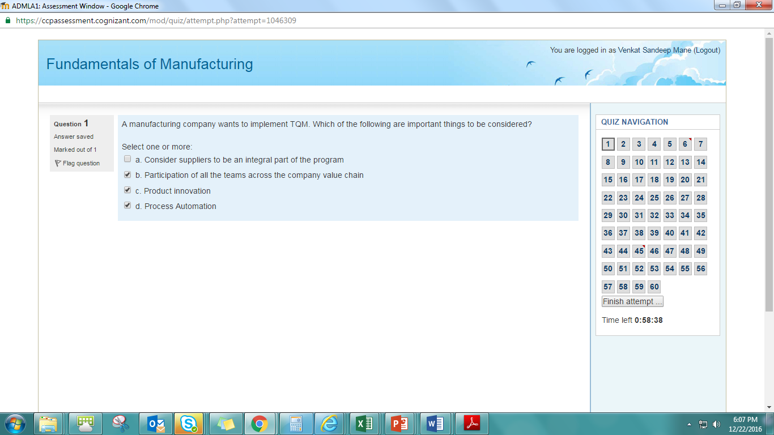ABC company is a manufacturer and exports

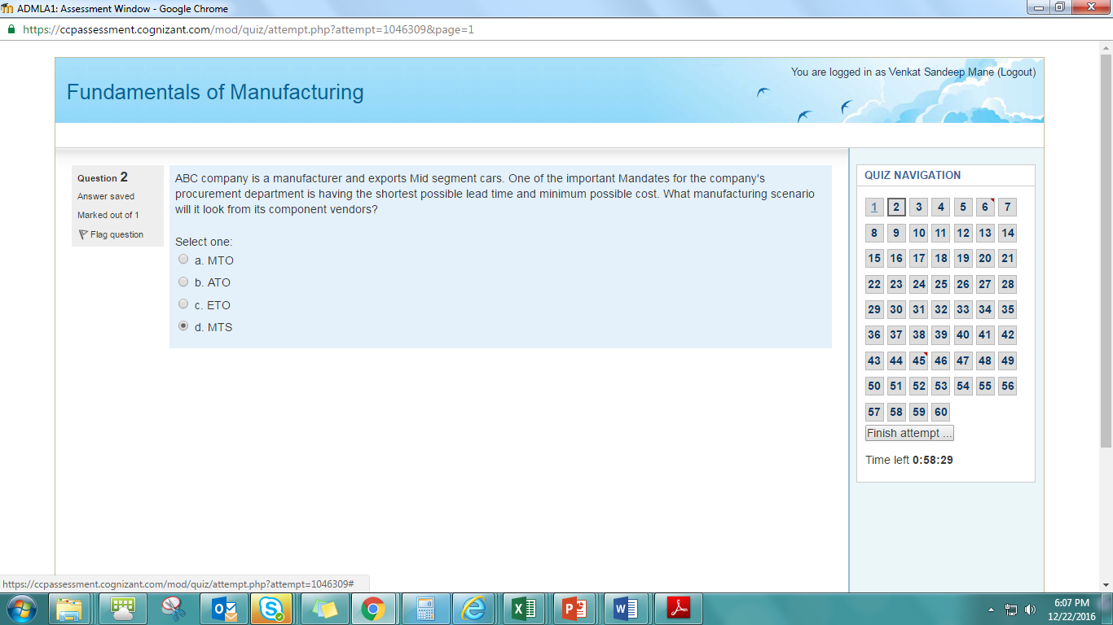

1. Group technology is essential

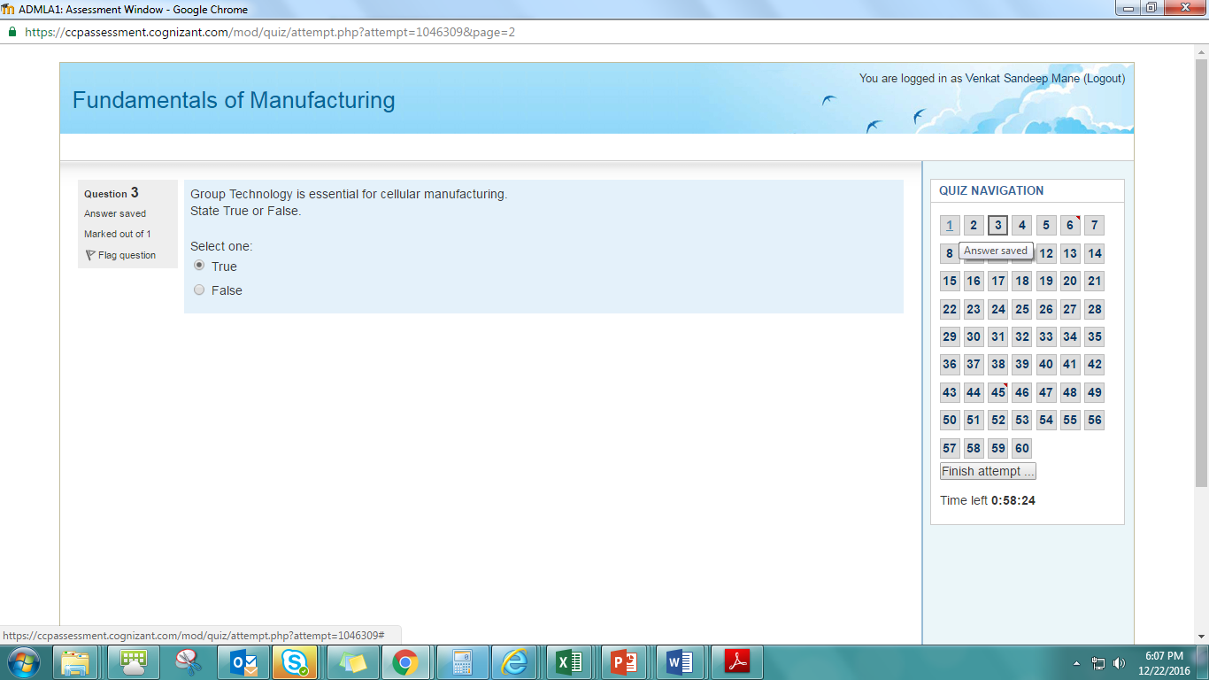

1. You are thinking of starting a manufacturing 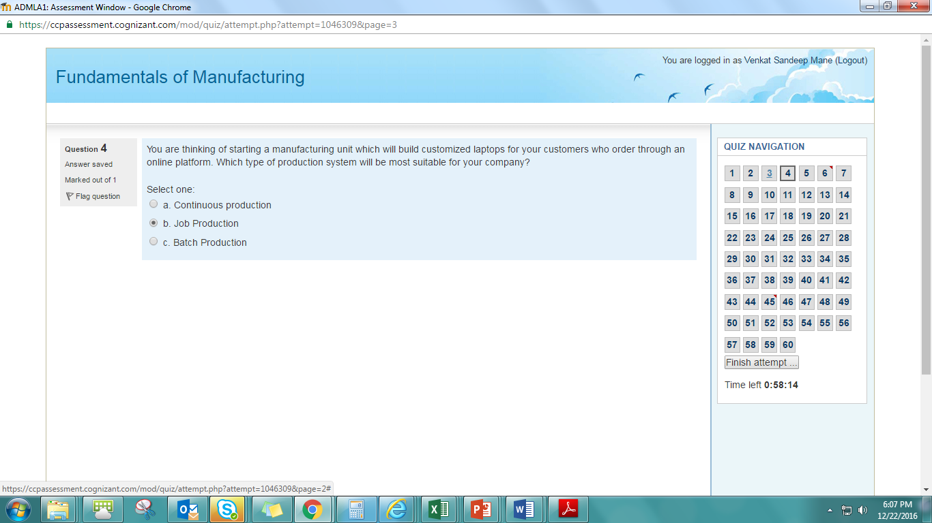
2. A milk run, in logistics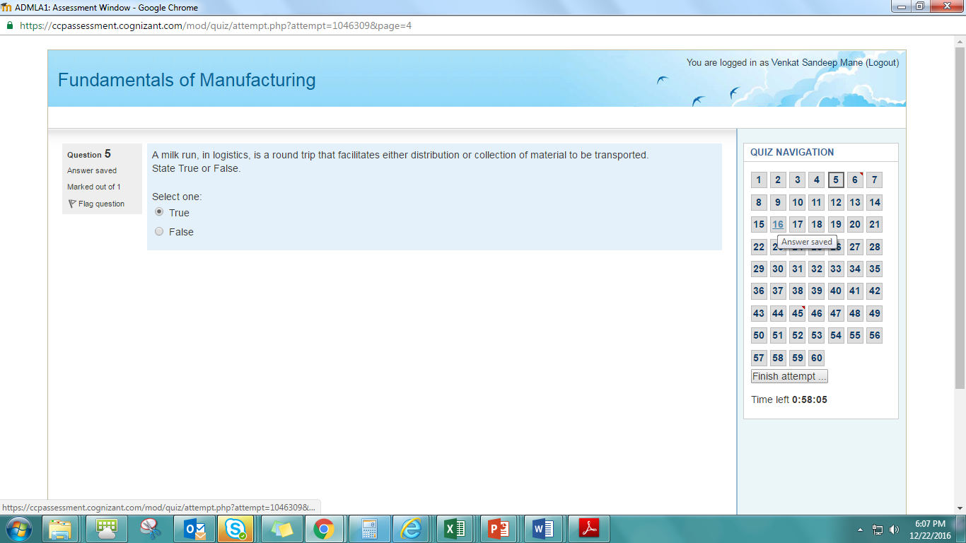
3. Postponement will help you

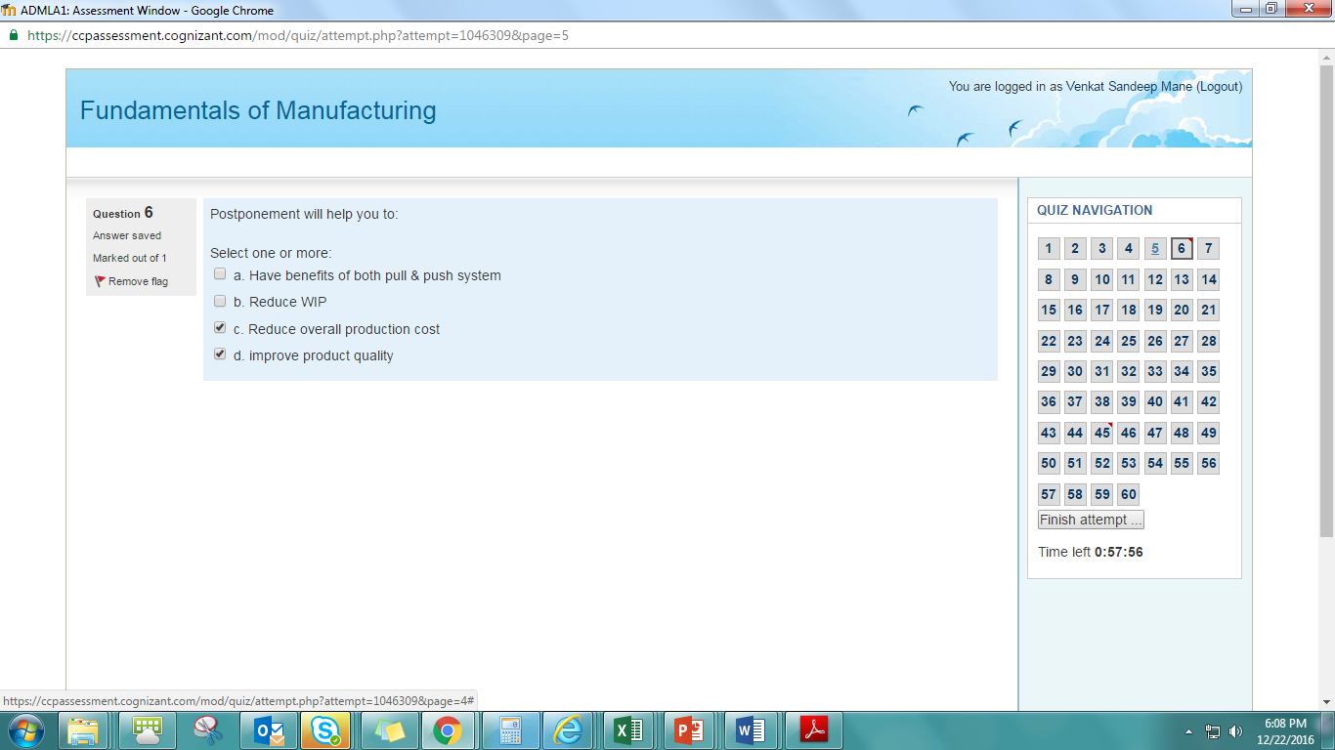

1. In a manufacturing system various components

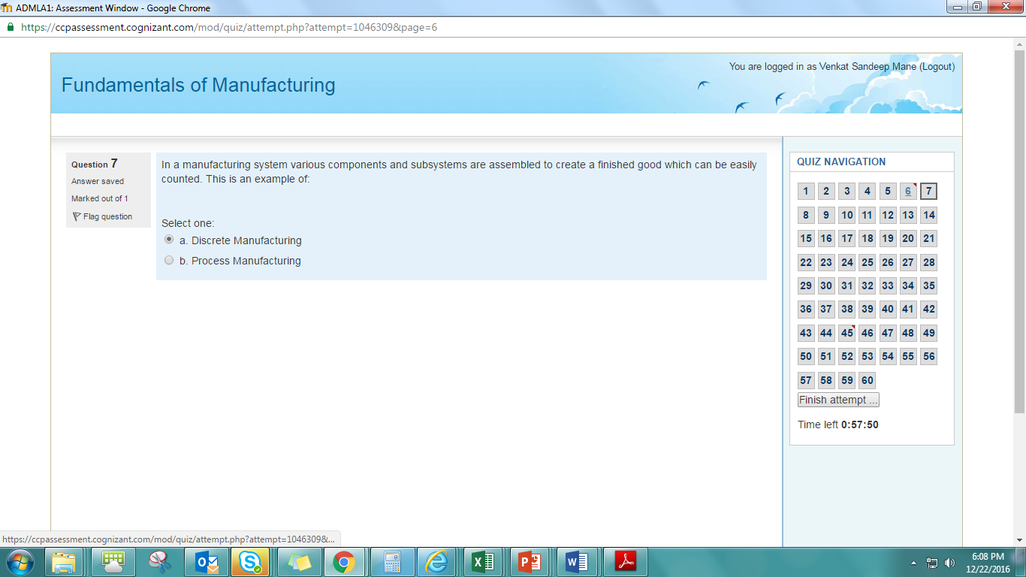

1. A manufacturing company executes

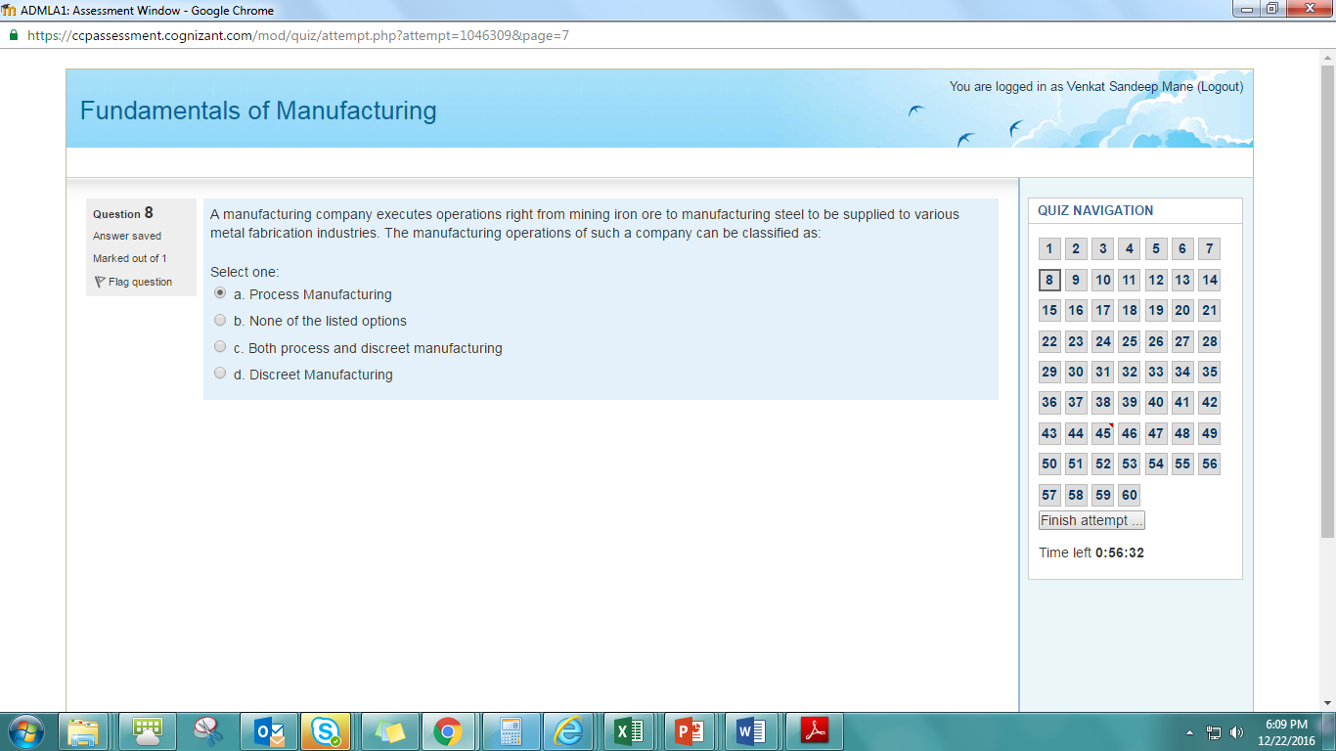

1. Aircraft manufacturing 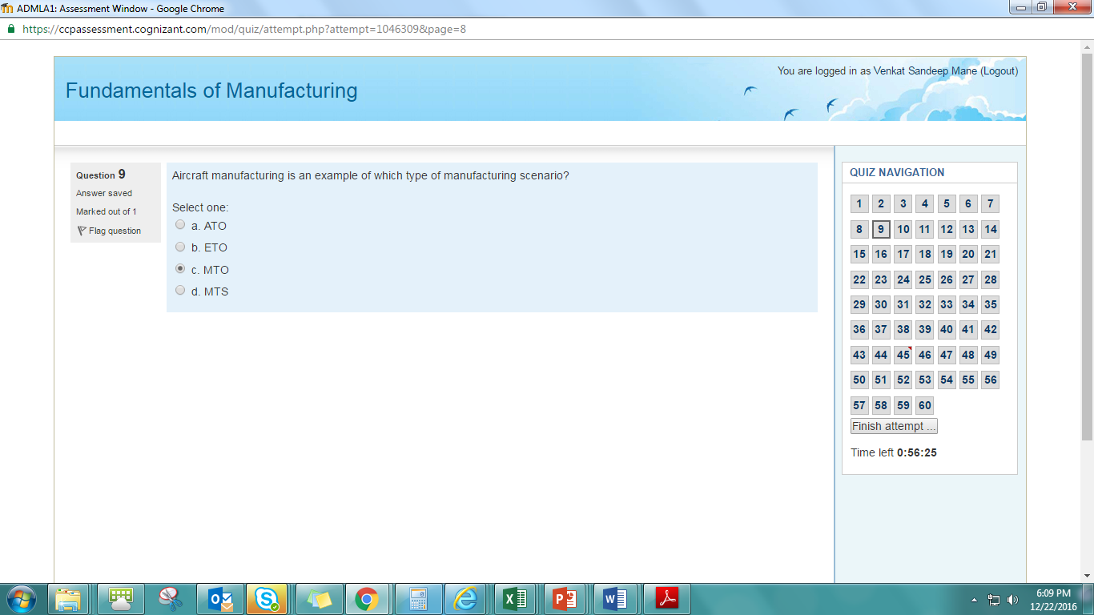
2. You want to order a laptop from Dell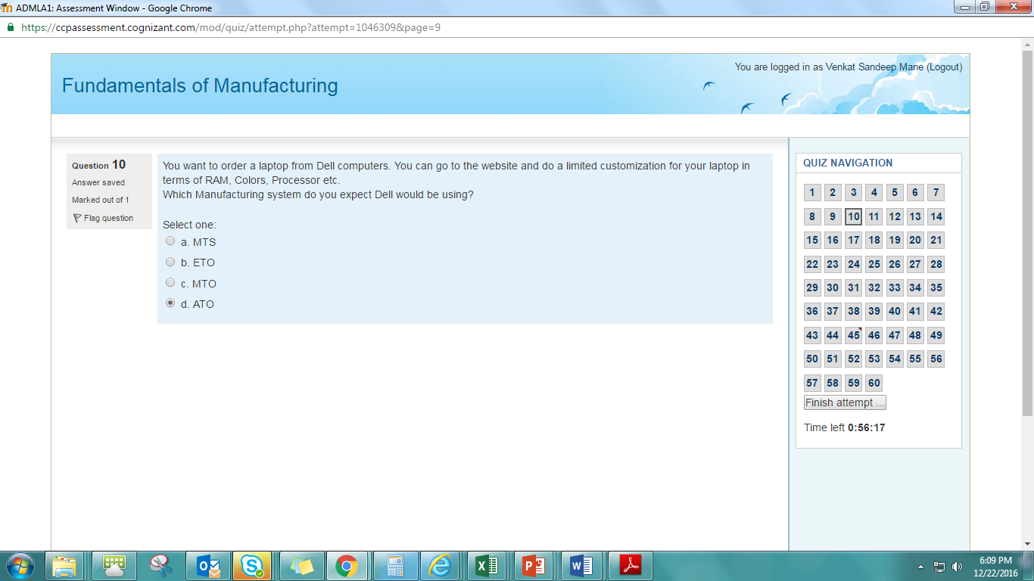
3. A company manufactures washing machines for the local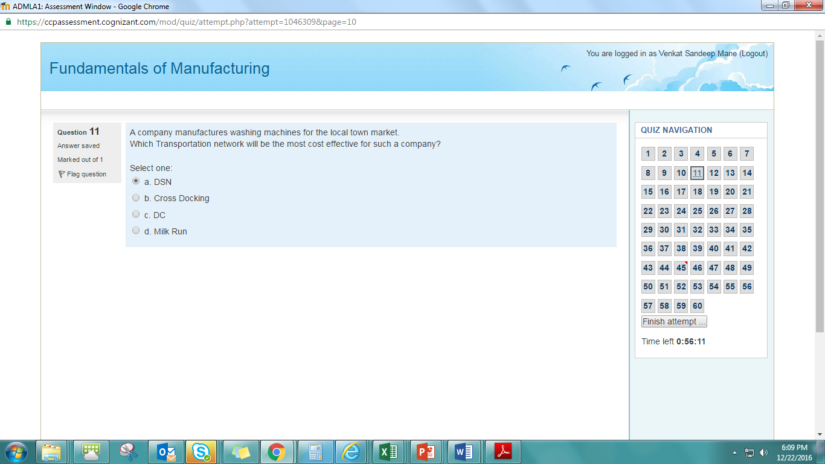
4. Quality assurance is a reactive approach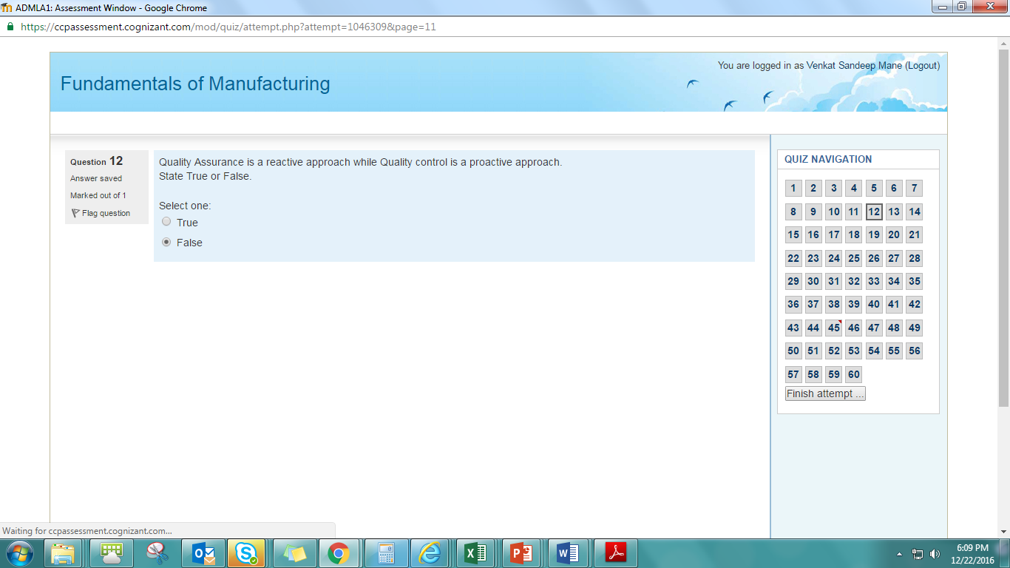
5. Line layout is used to manufacture 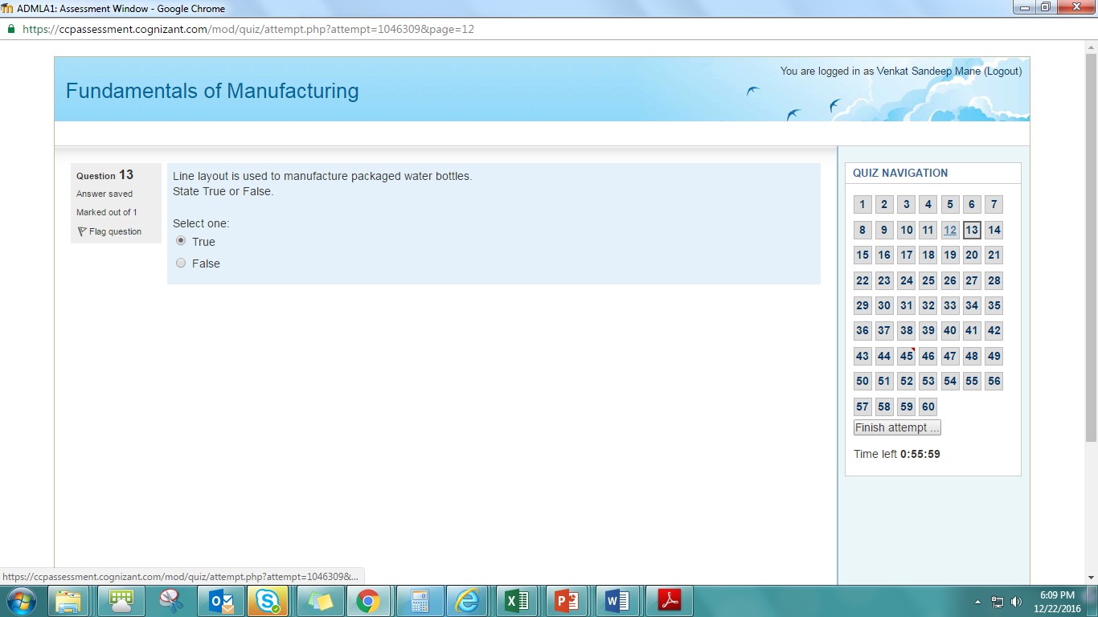
6. In which of the following scenario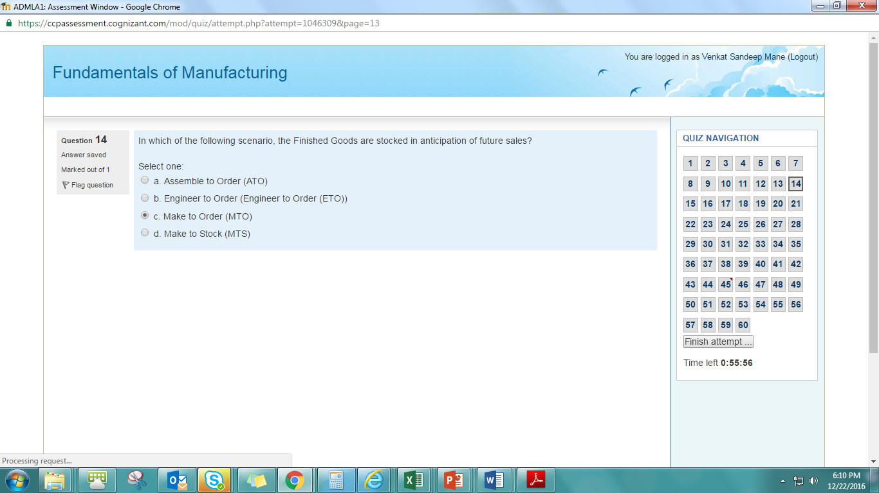
7. Carpenters contracted by 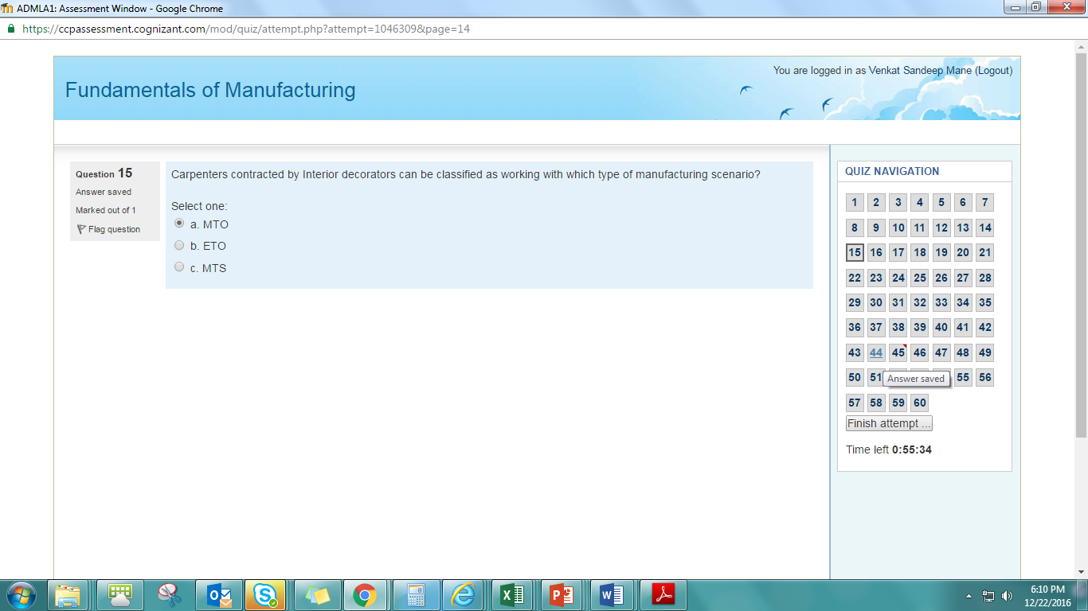
8. Based on product requirements 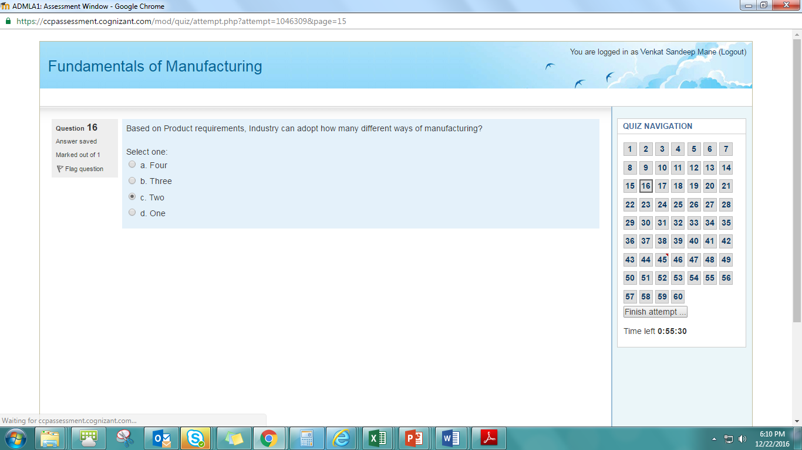
9. A chemical manufacturing company 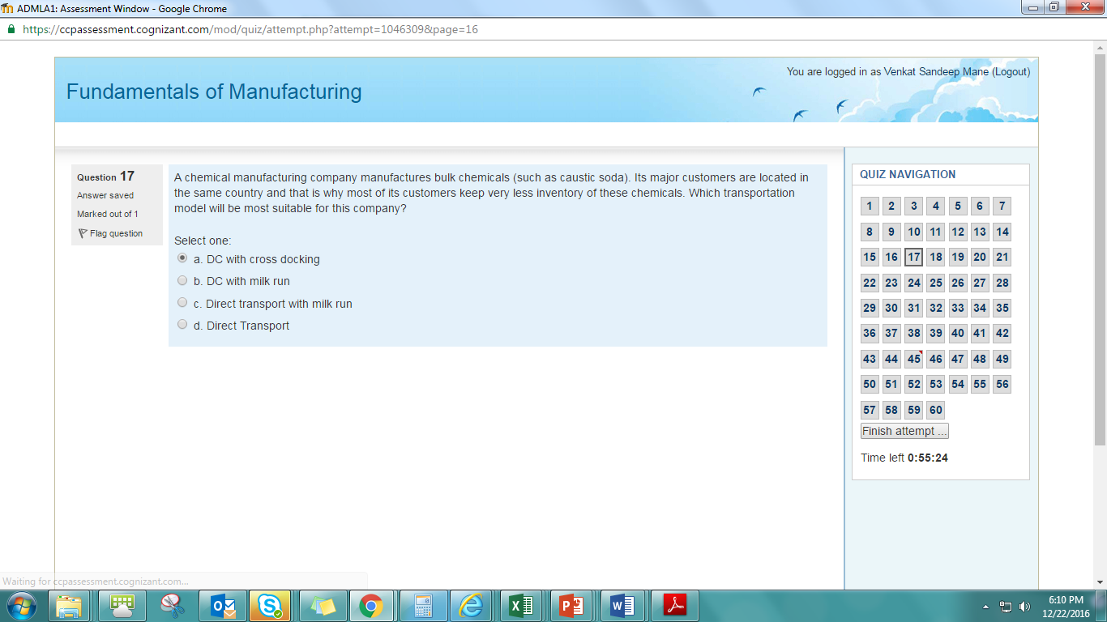
10. Raghav is a vendor who manufactures biscuits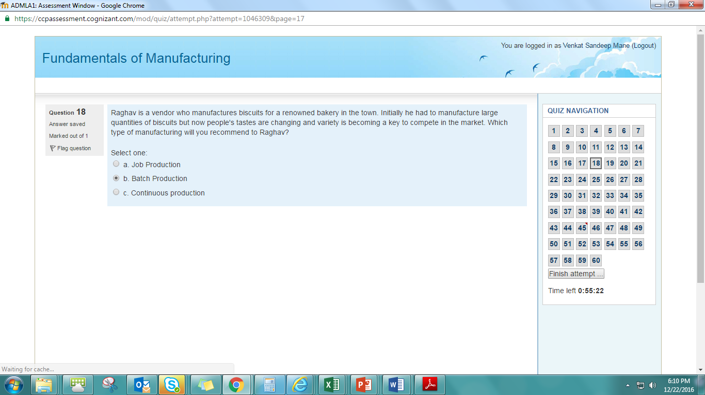
11. Which of the following are characteristics of job production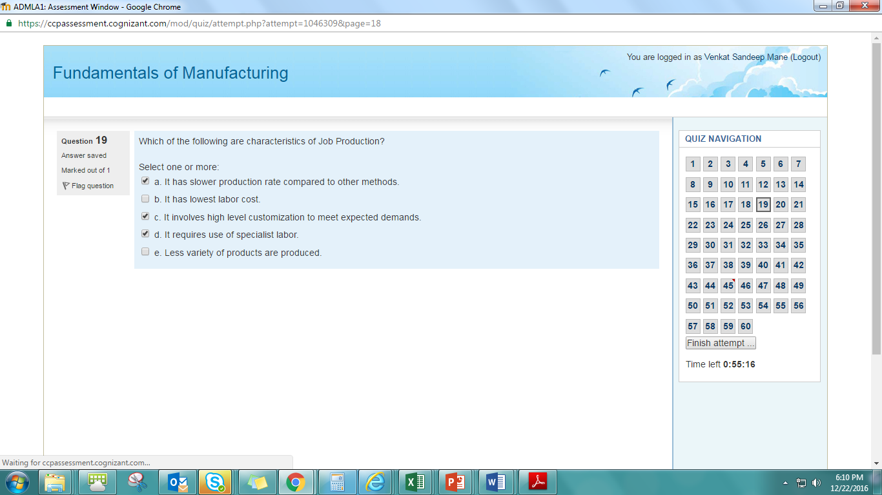
12. Is the task of buying goods of right 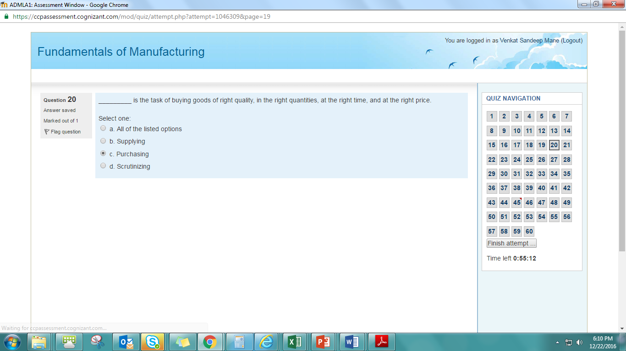
13. Which of the following are some of the examples of discrete manufacturing 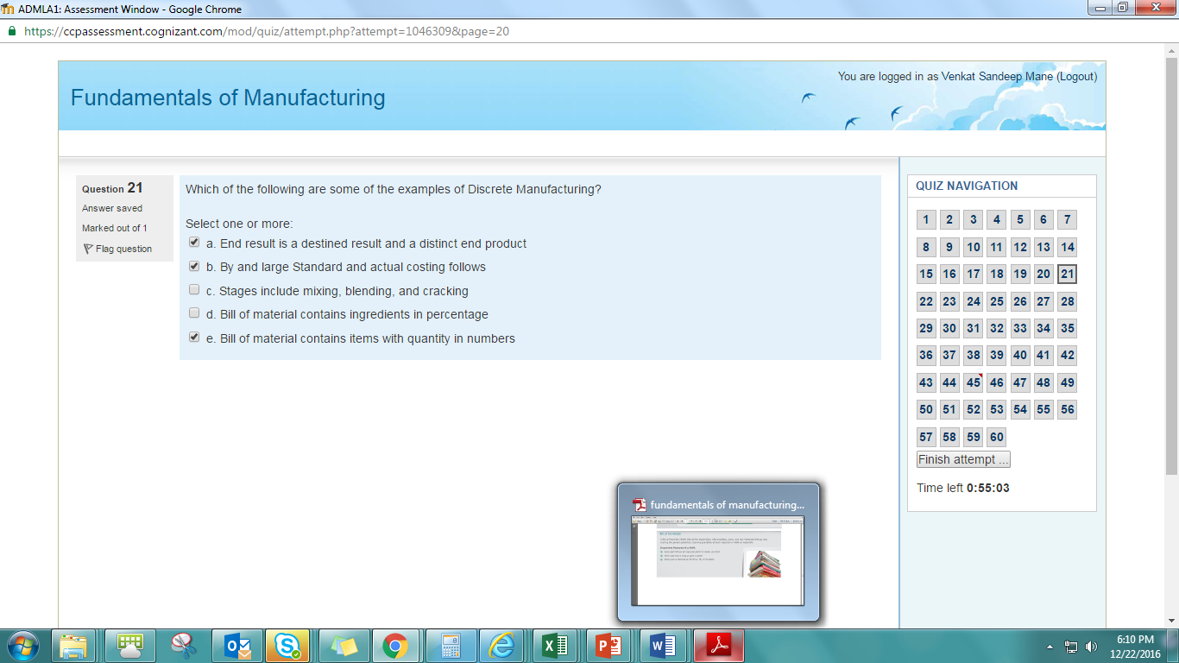
14. ABC is an online retailer. They want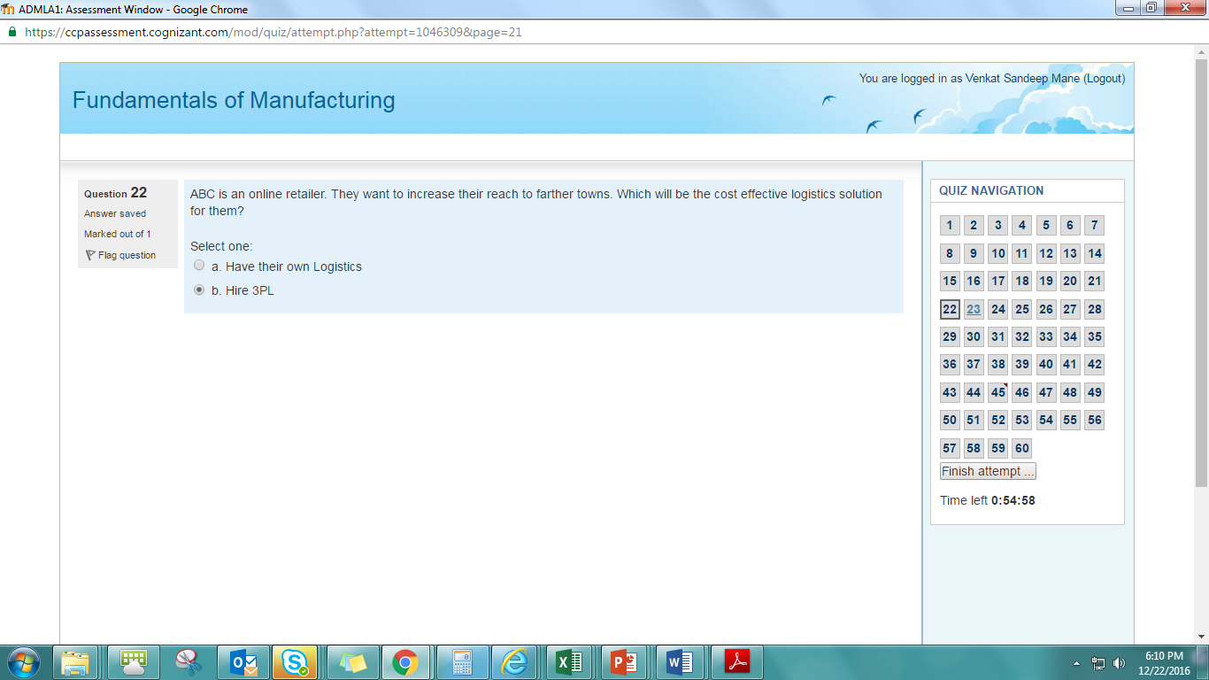
15. In which of the following layout is the production output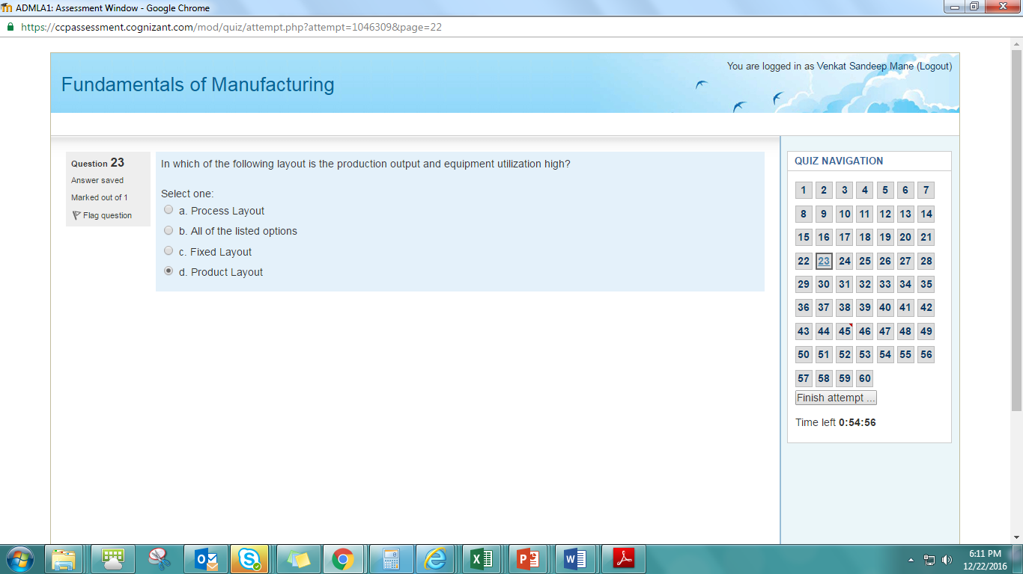
16. A niche drug manufacturer ships low volumes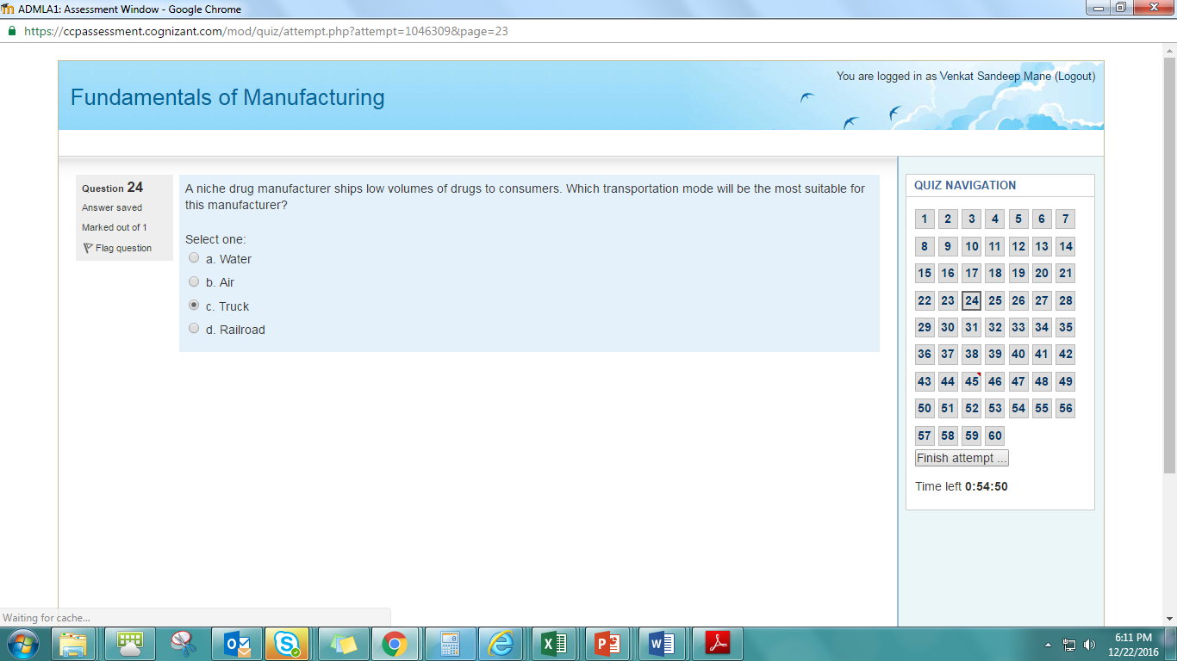
17. The activity of a cobbler mending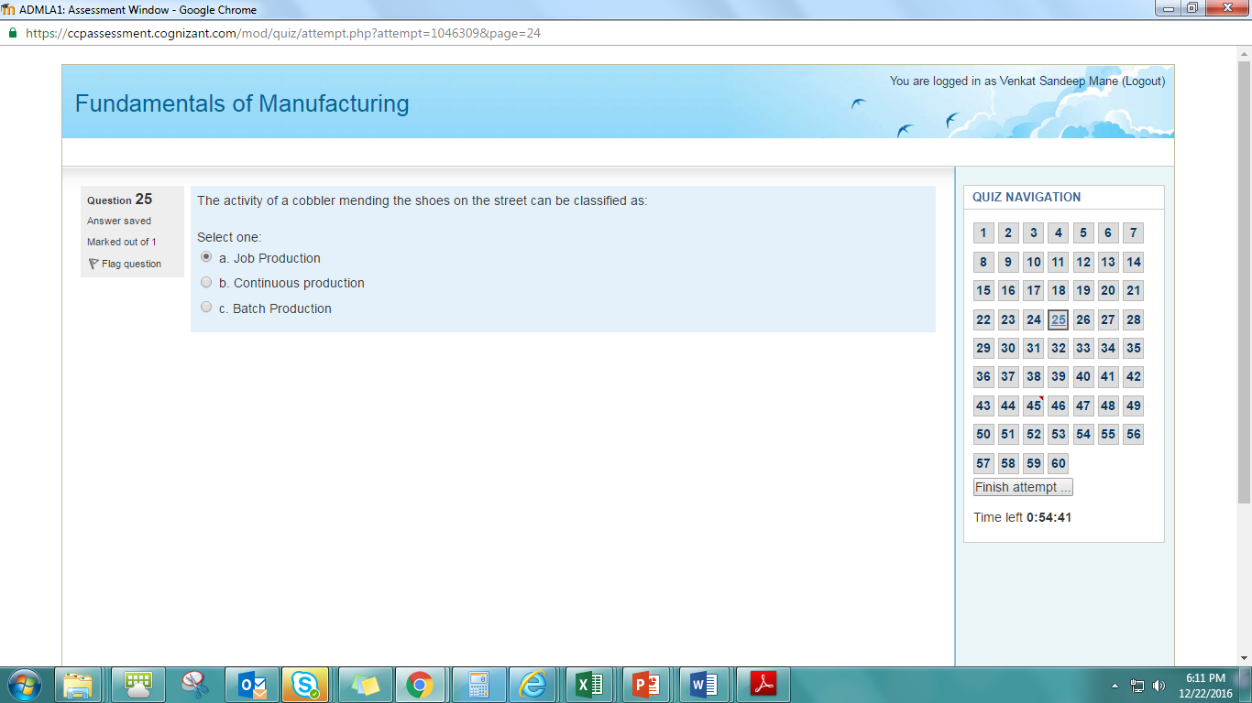
18. Manufacturing word comes from

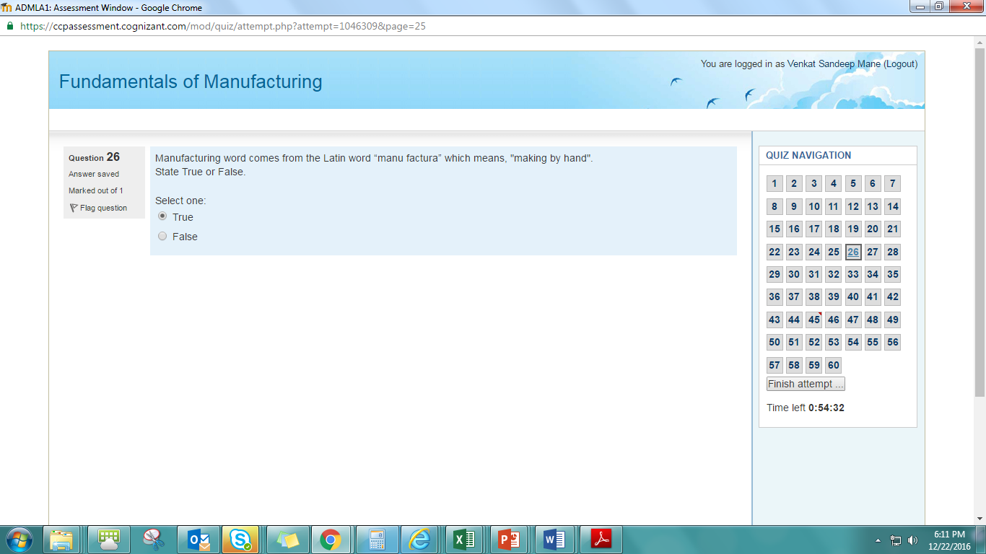

1. In which of the following scenario, the row material is stocked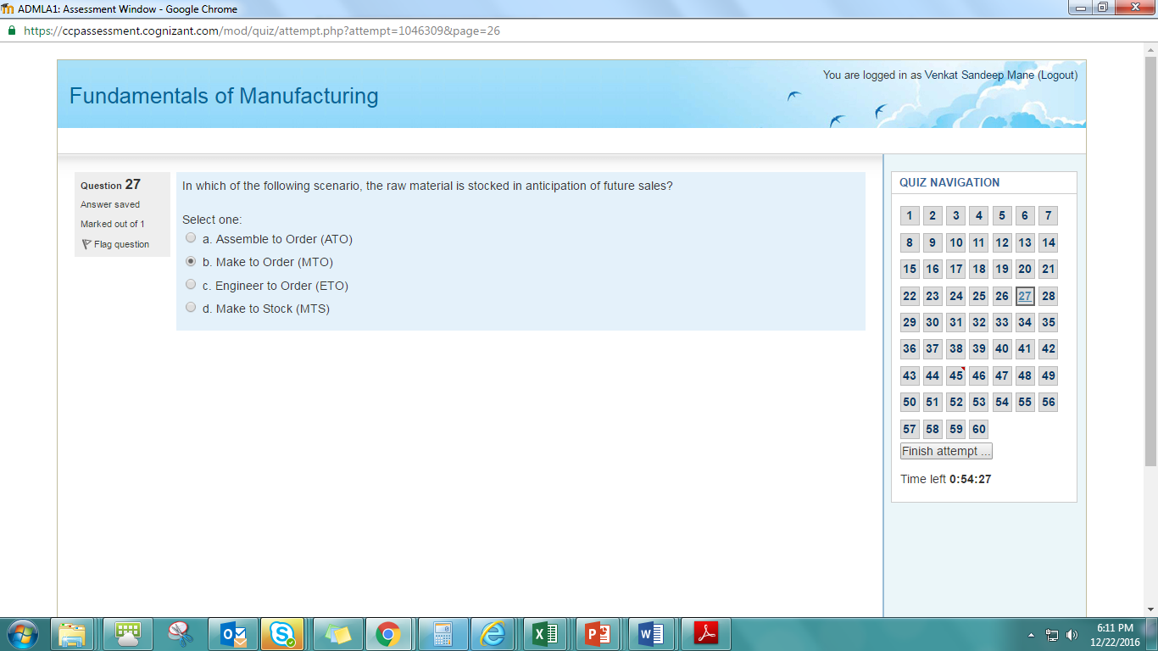
2. Warehouse is not a storage structure 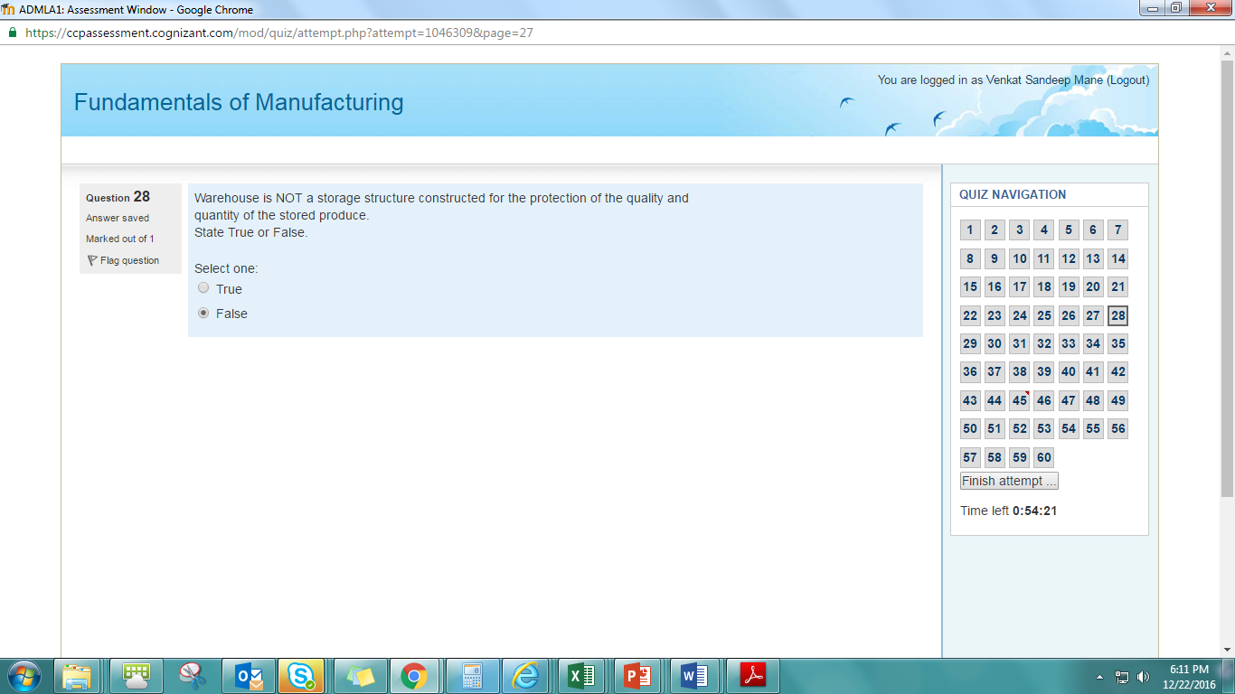
3. A company manufactures customized motor bikes for its customers.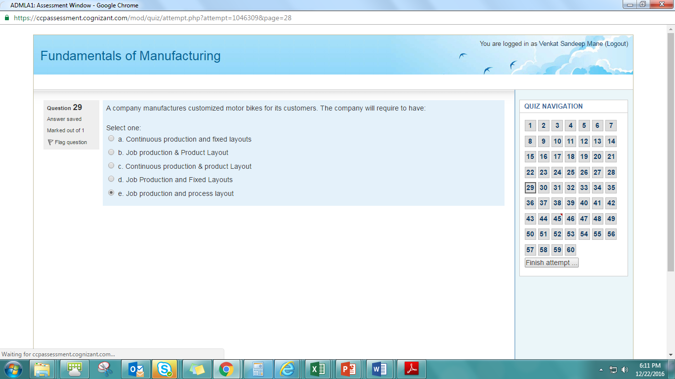
4. In which of the following manufacturing scenario, parts are organized into families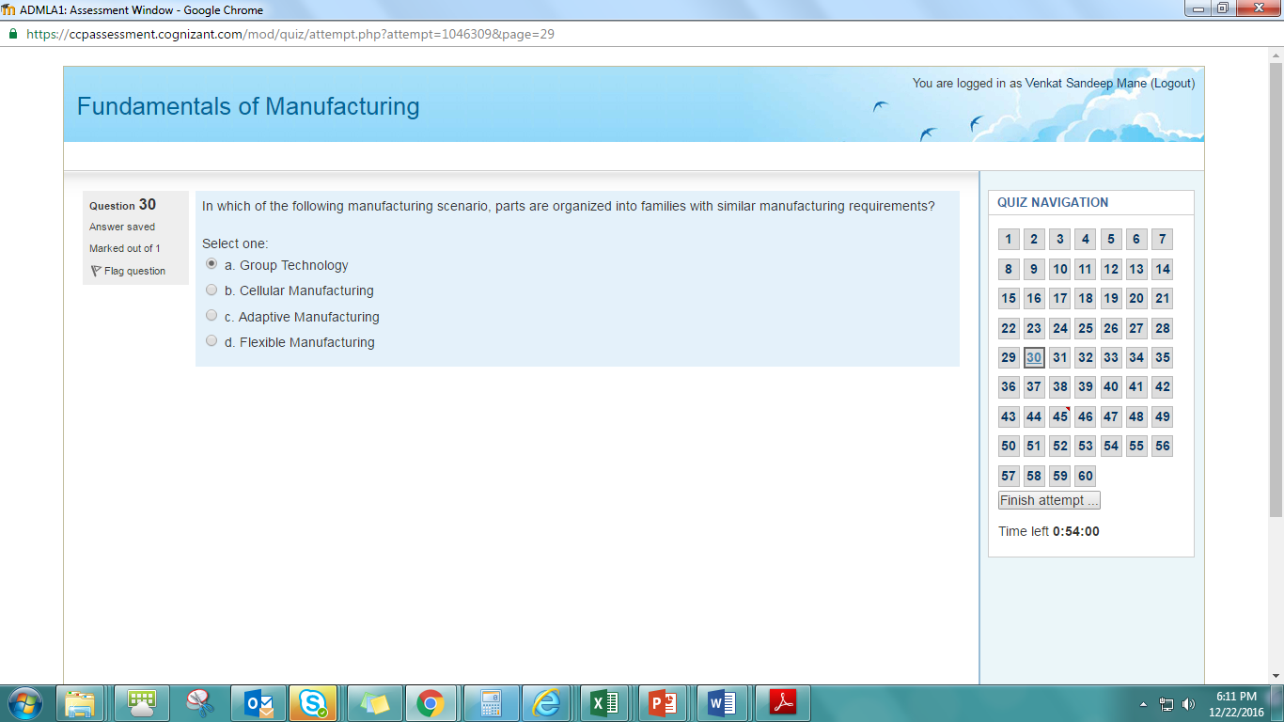
5. Co-ordination complexity will be highest

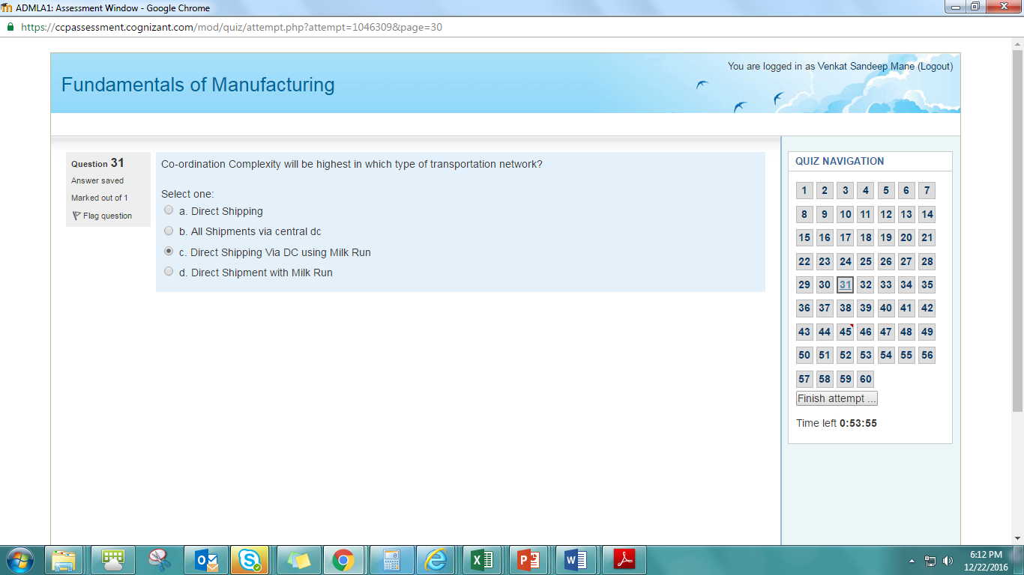

1. The growth of 3PL companies began in the 1980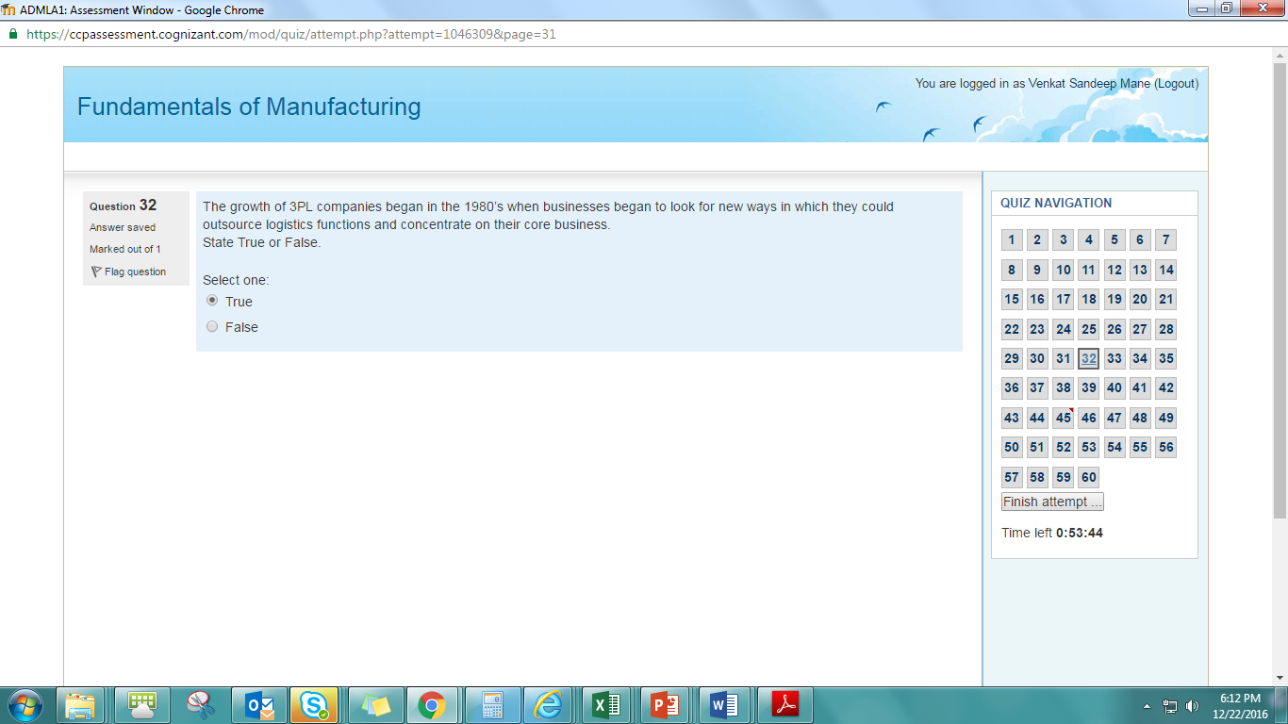
2. Period required to prepare a device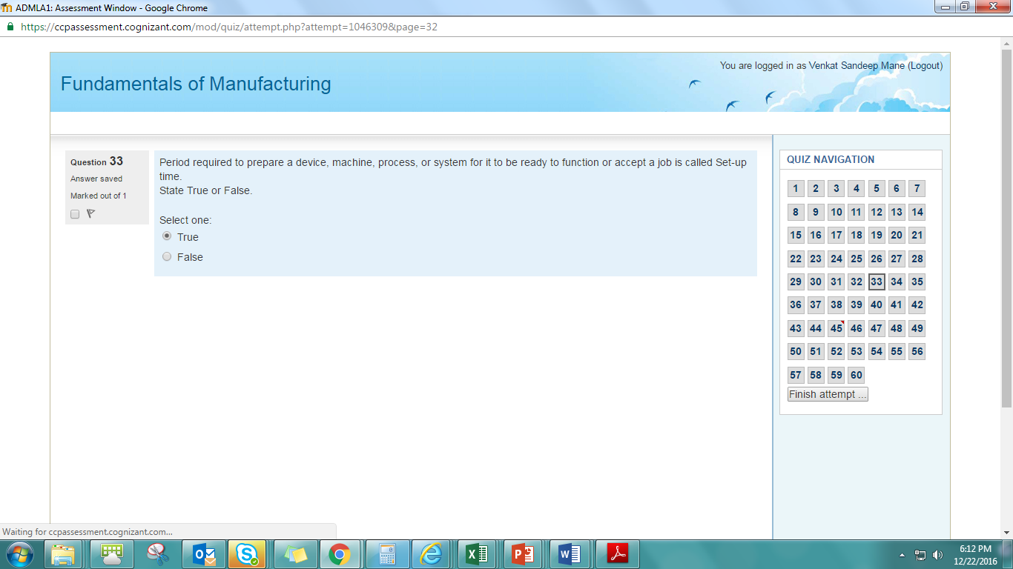
3. In batch production, the production line 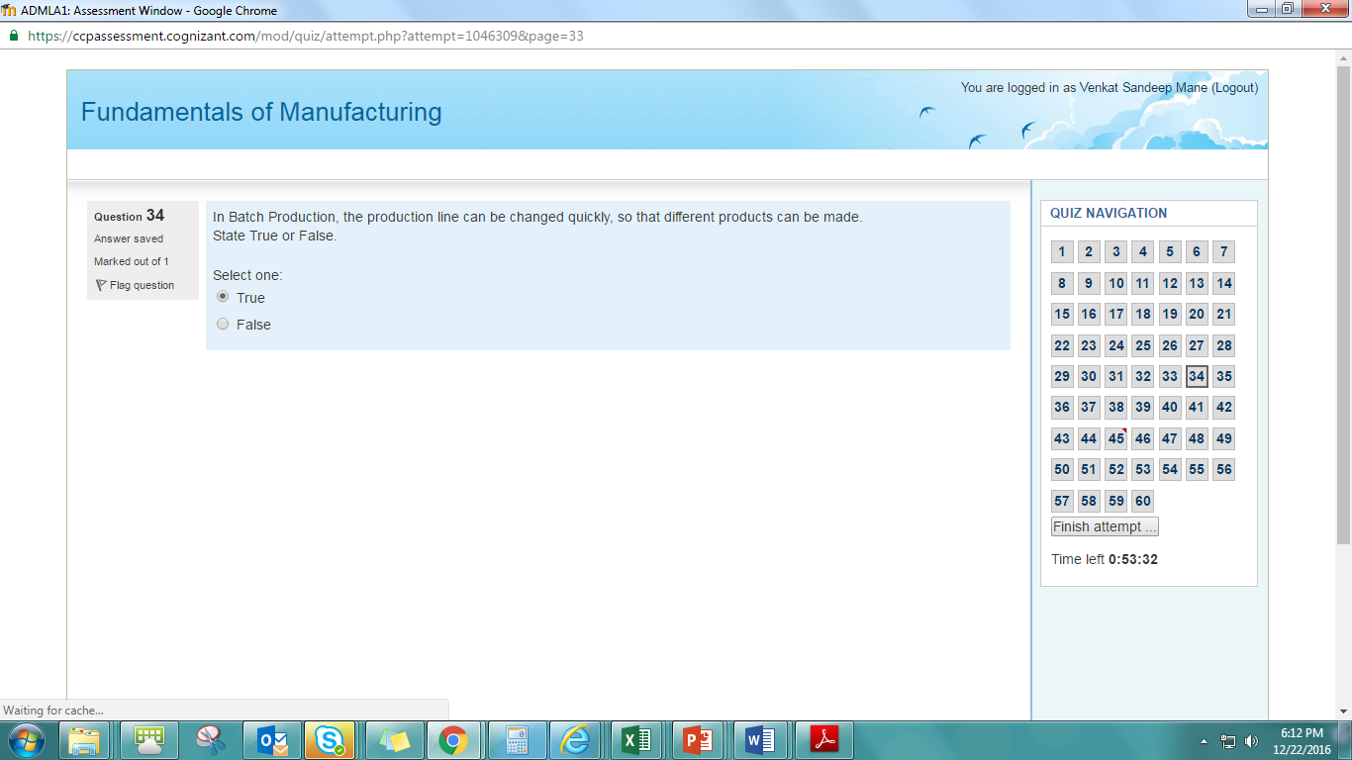
4. A bicycle or a car is a product of 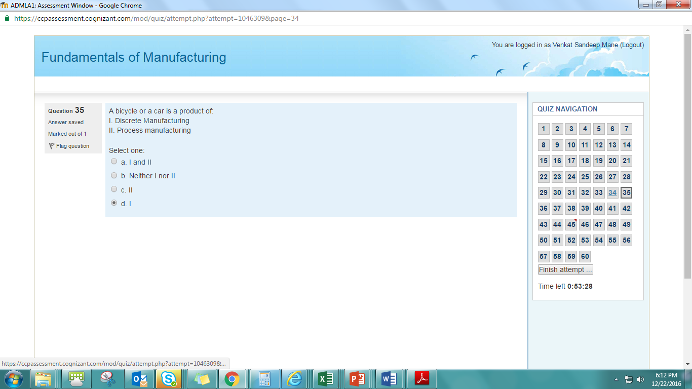
5. ABC is a distributor for a watch manufacturing company. It has a large 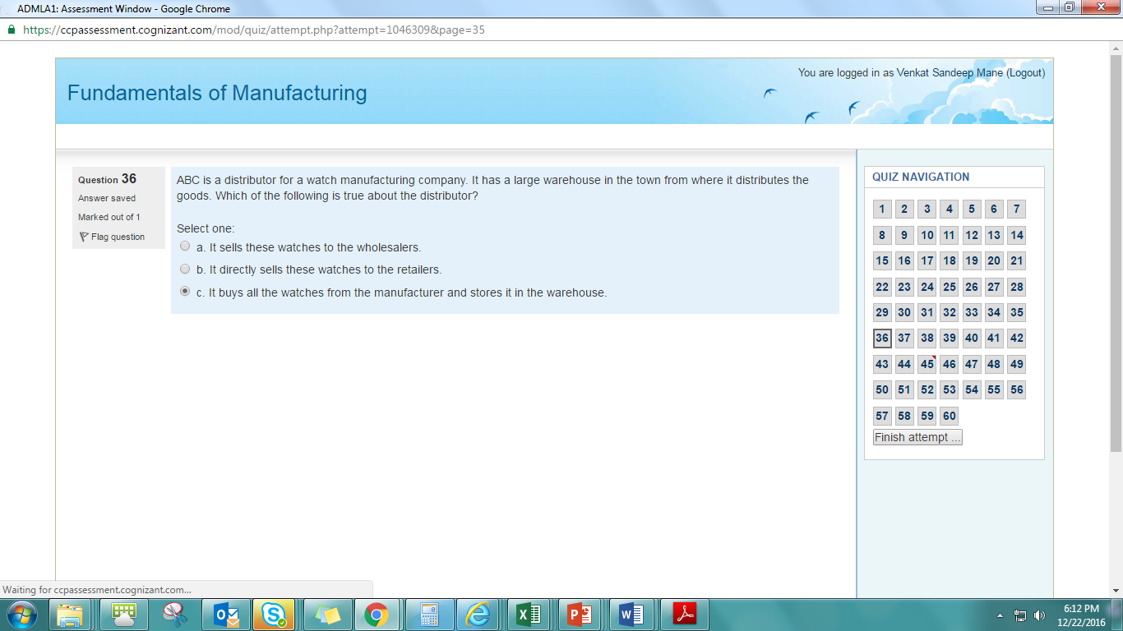
6. Decision between a product or a process layout 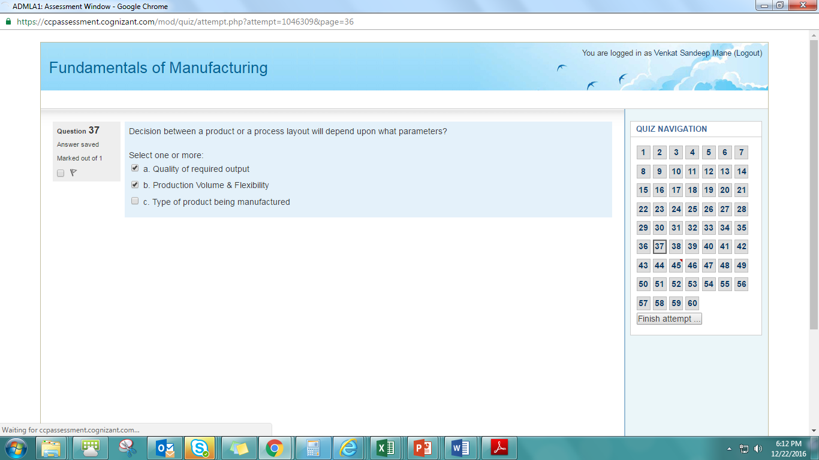
7. Continuous improvement in knowledge & high 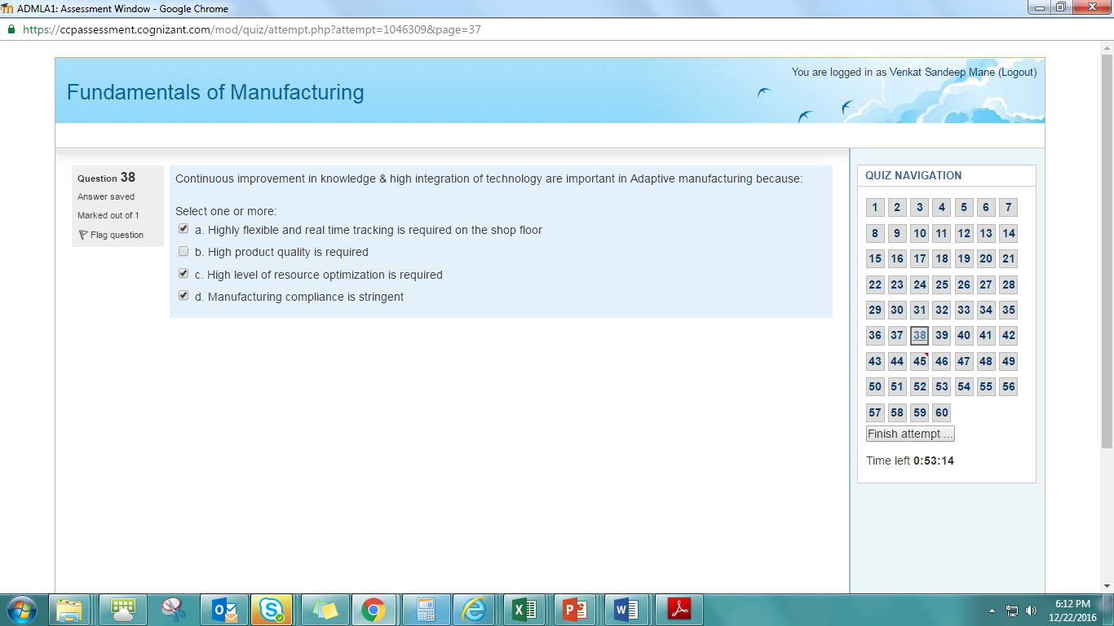
8. Sales forecasting is most critical in which if the 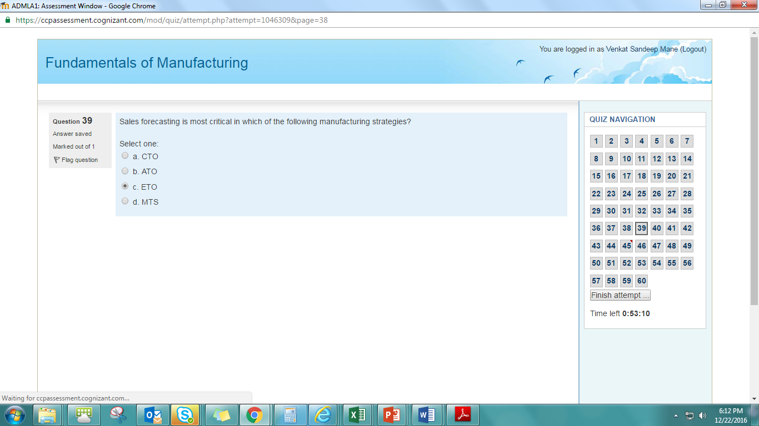
9. A fixed layout is applicable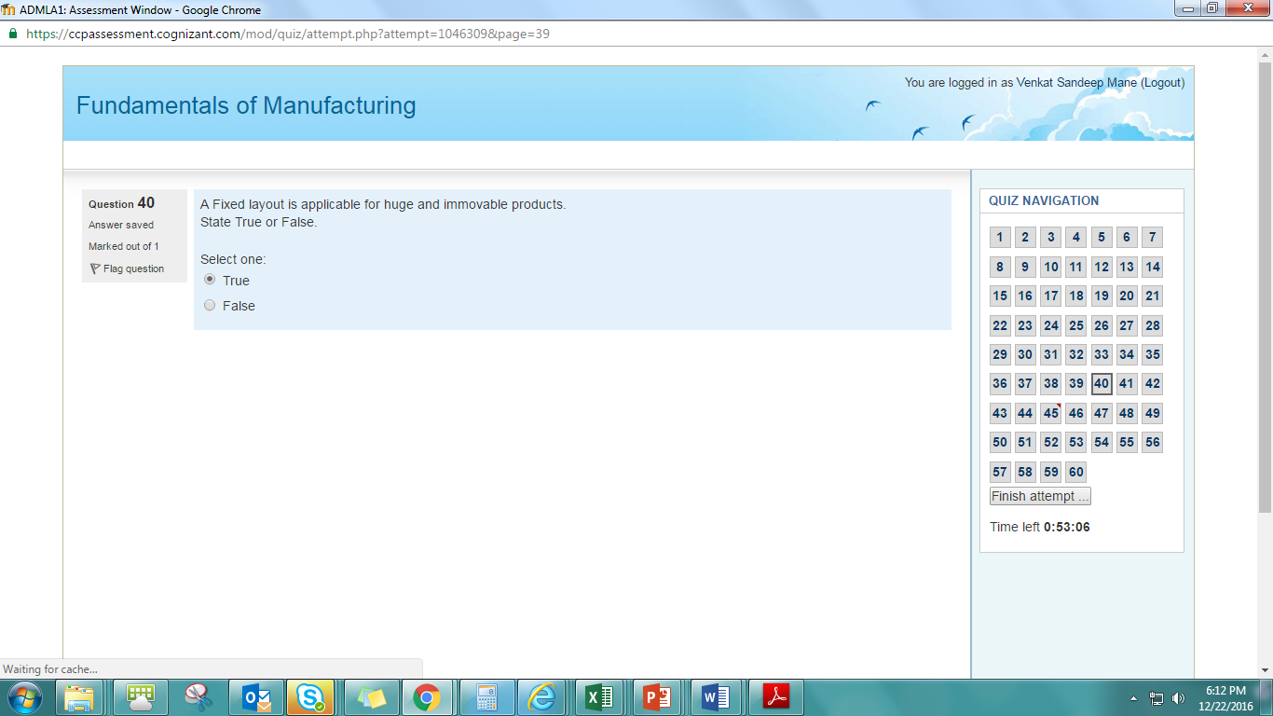
10. Manufacturing can be classified by which of the 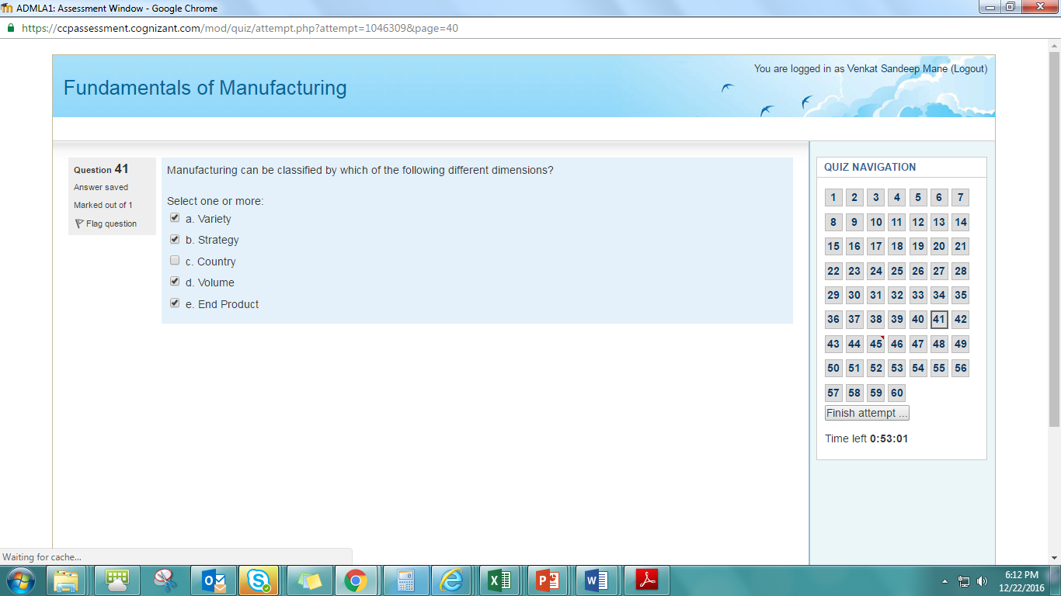
11. Reverse logistics is important 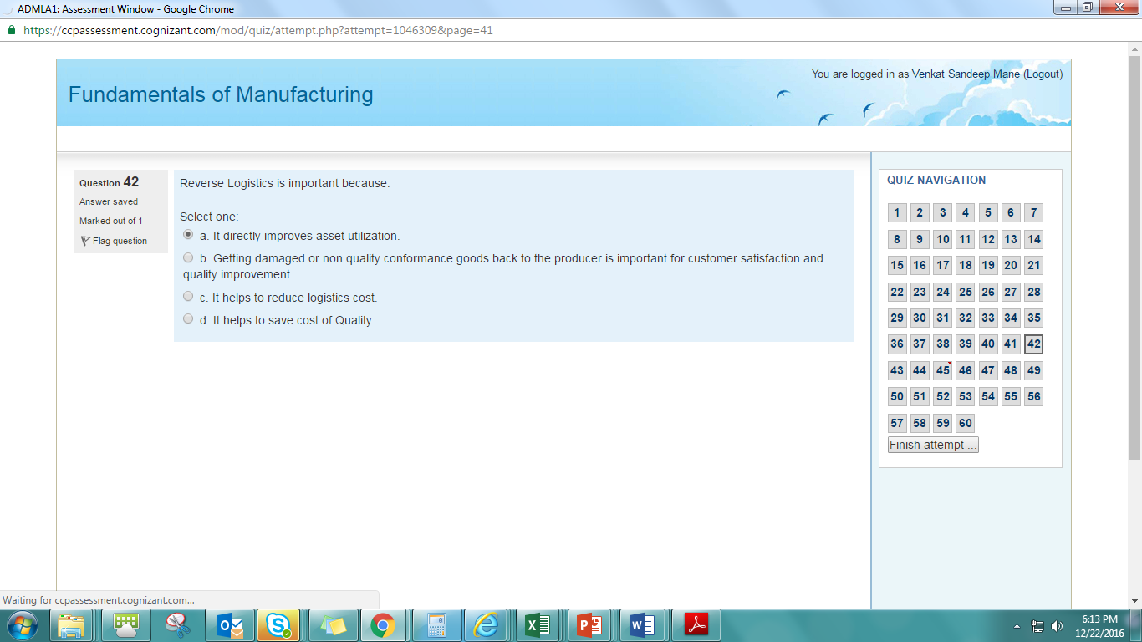
12. You are consulting for a cost reduction program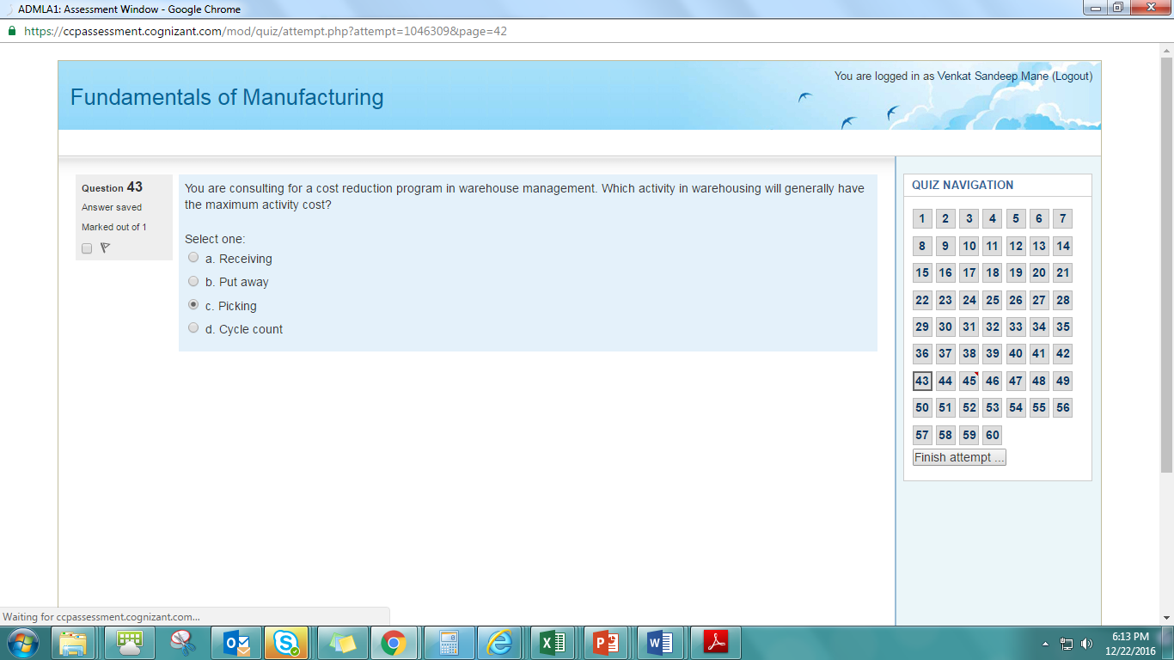

You are consulting for a cost reduction program in 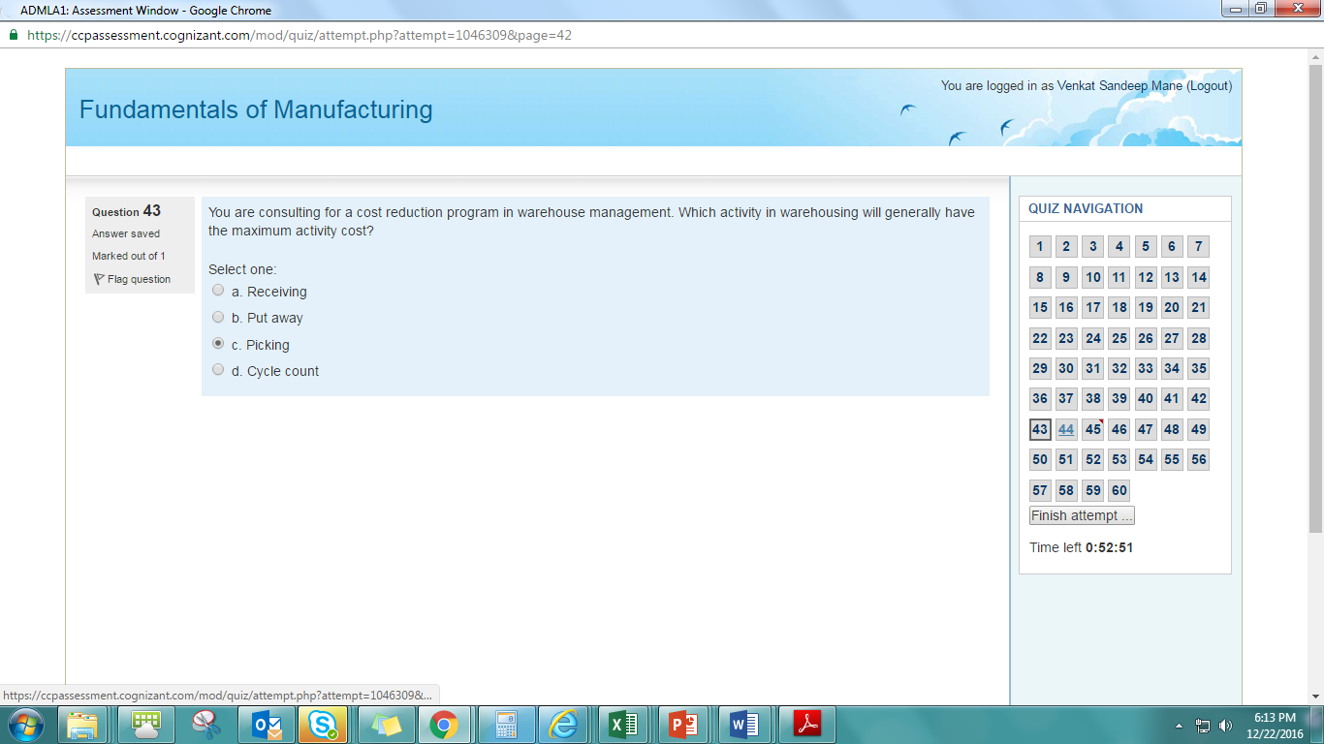

1. A large retail chain sells fresh pizzas 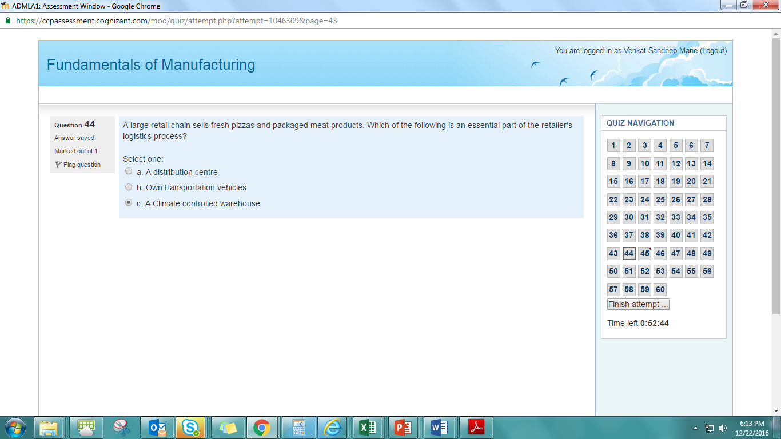
2. Includes design and administration of systems 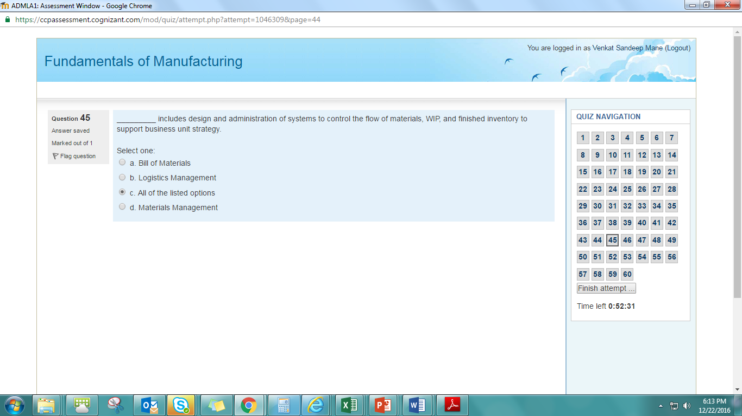
3. In which of the following manufacturing scenario 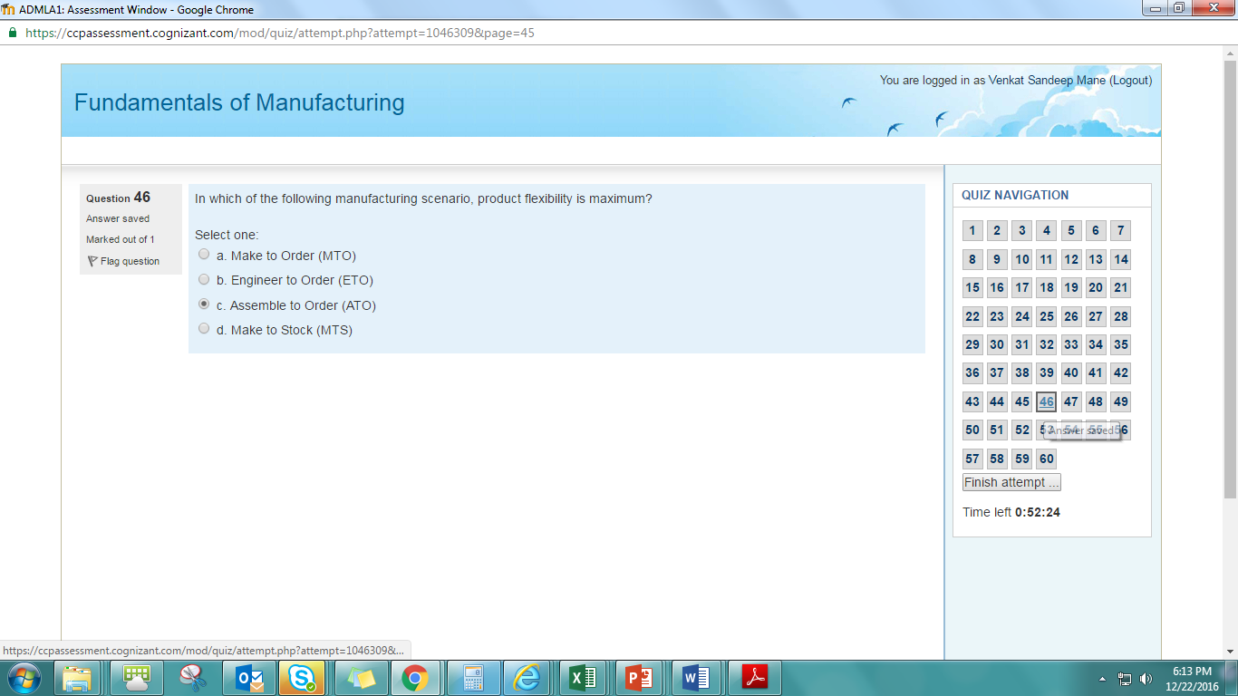
4. ABC manufactures standard FMCG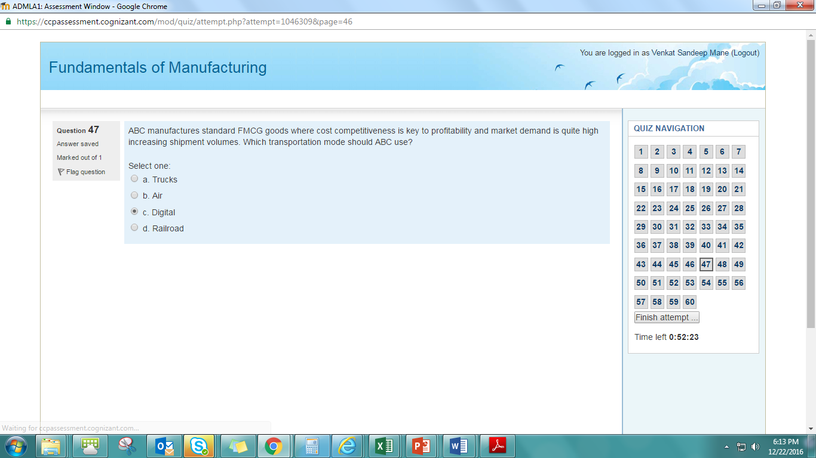
5. Which of the following happen during cross docking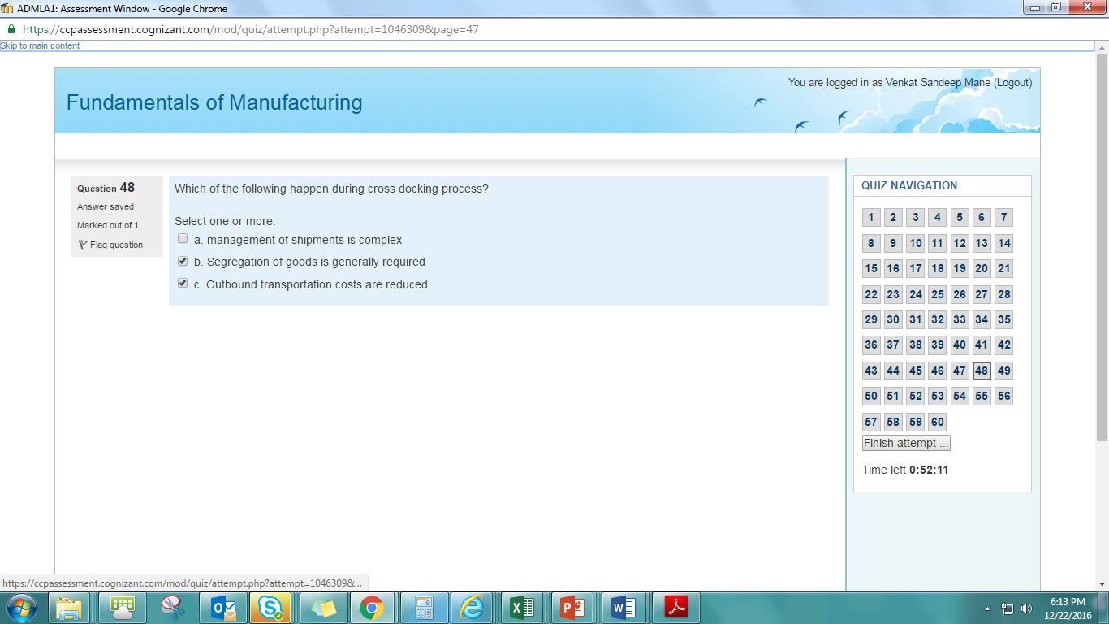
6. Food and beverage industry is an example 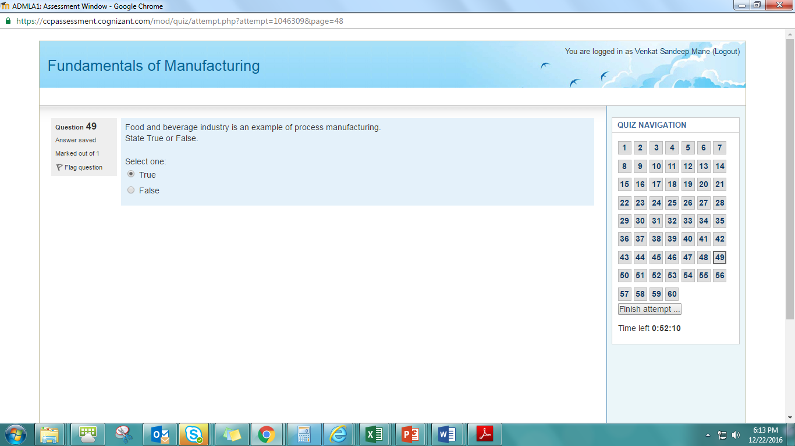
7. The typical characteristics of Make to Order are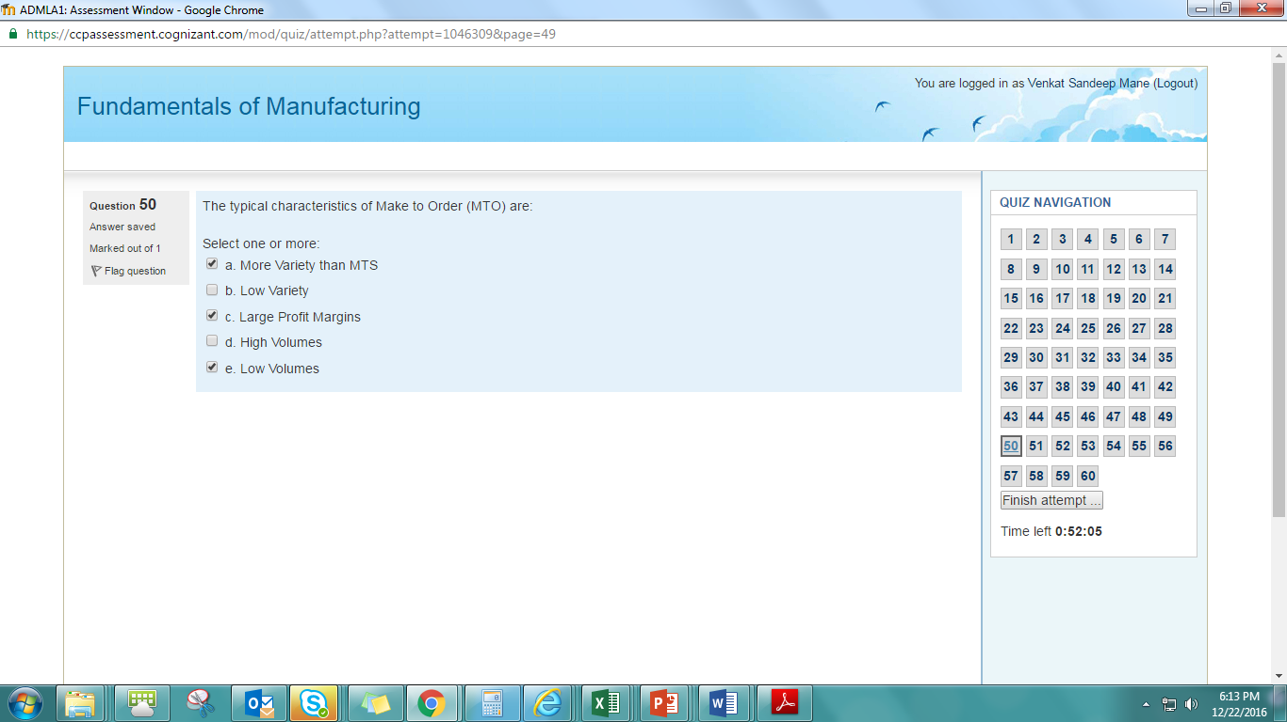
8. Two key issues in inspection are how much to inspect

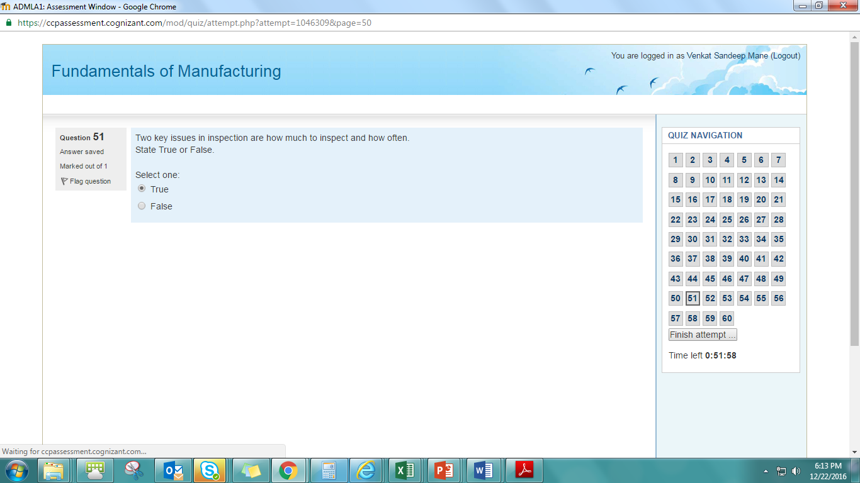

1. A warehouse management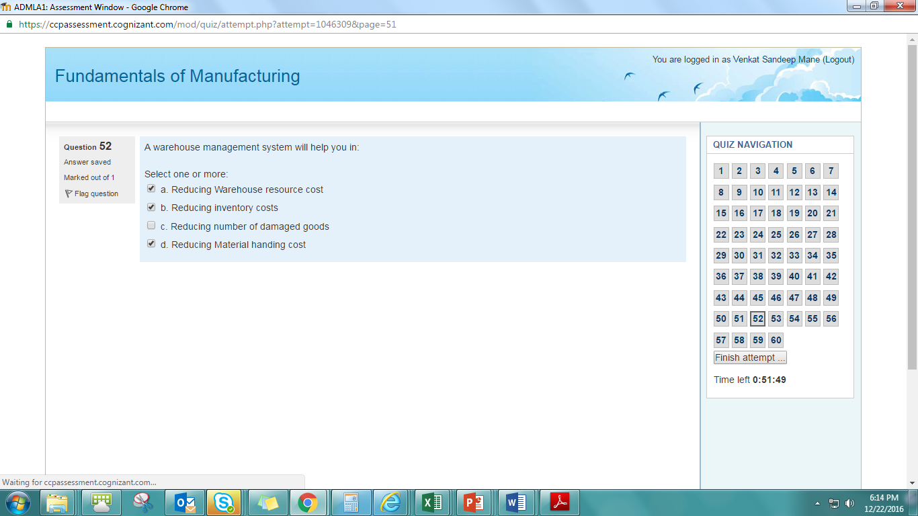
2. Profit margins

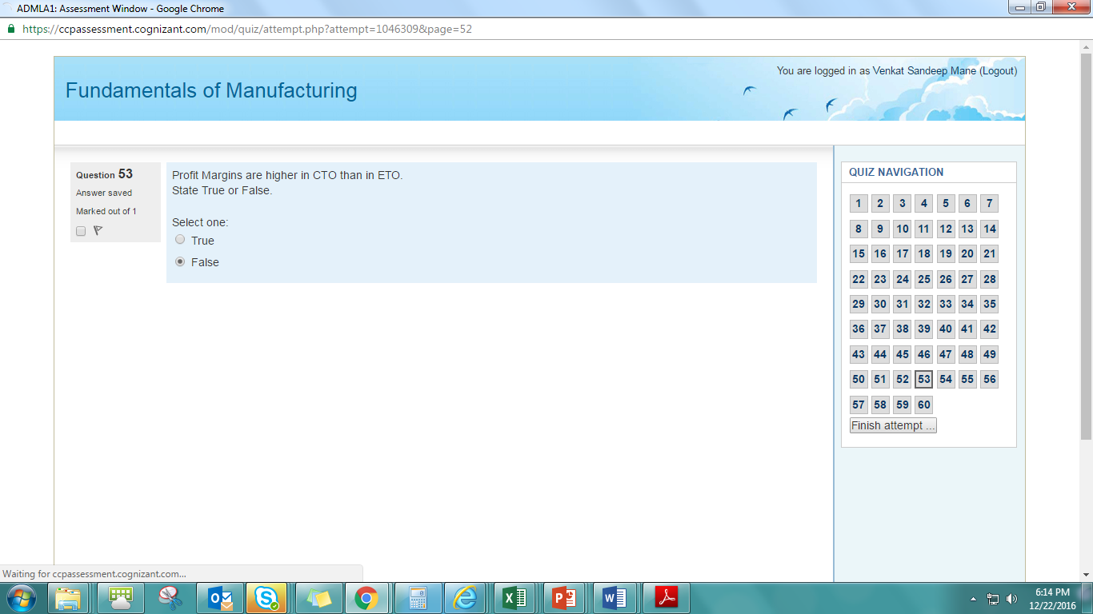

1. High cost of capital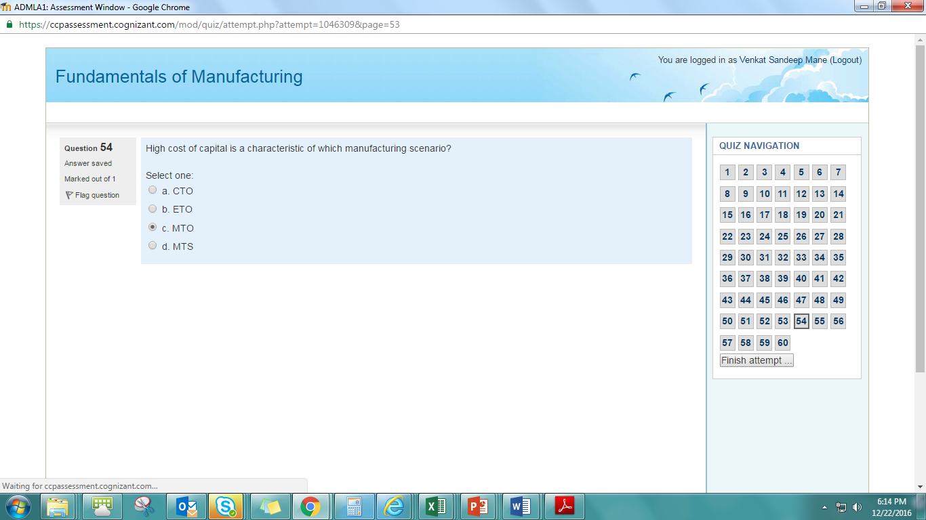
2. Unilever supplies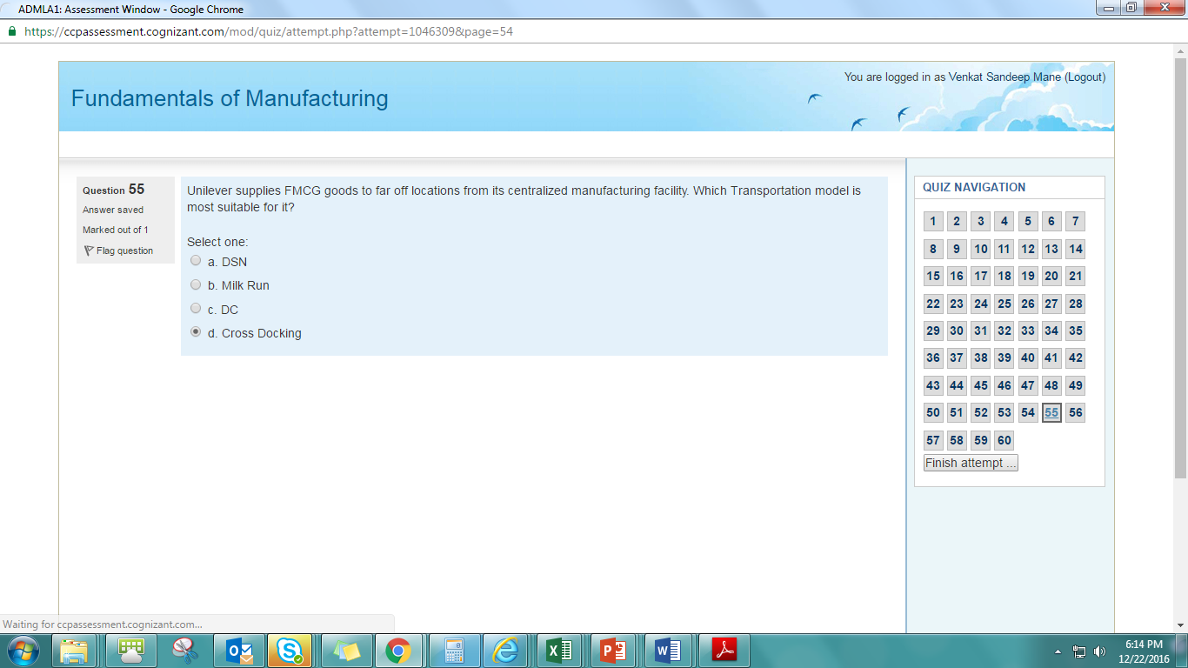
3. What are elements of logistic 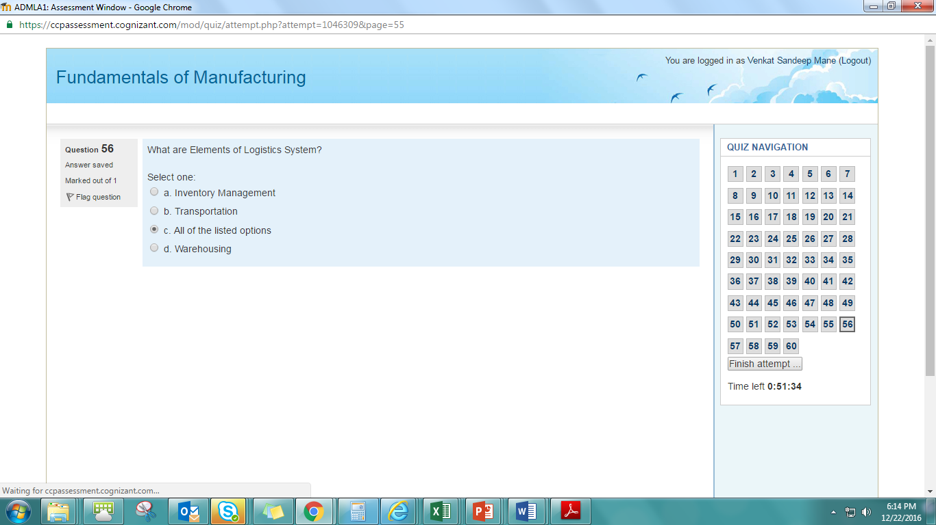
4. A quality assurance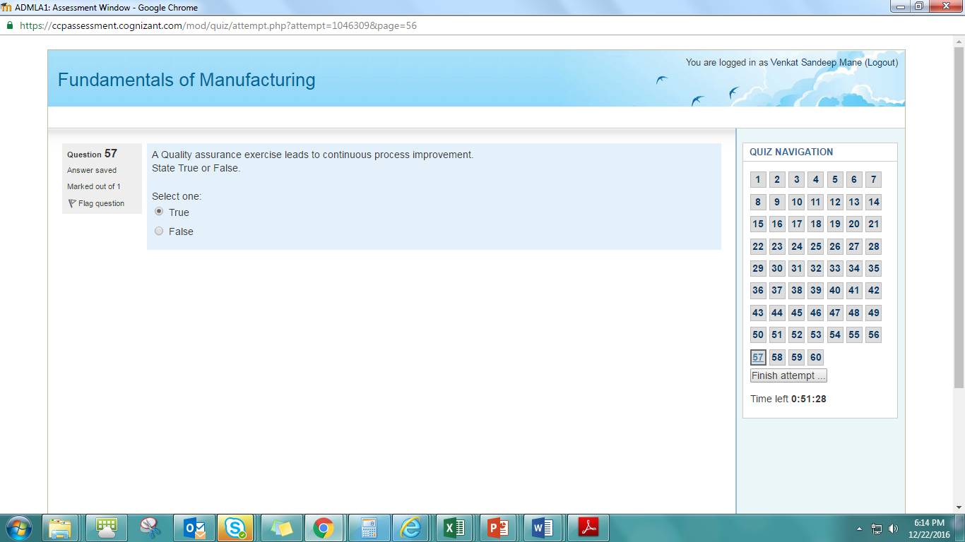
5. In case of continuous production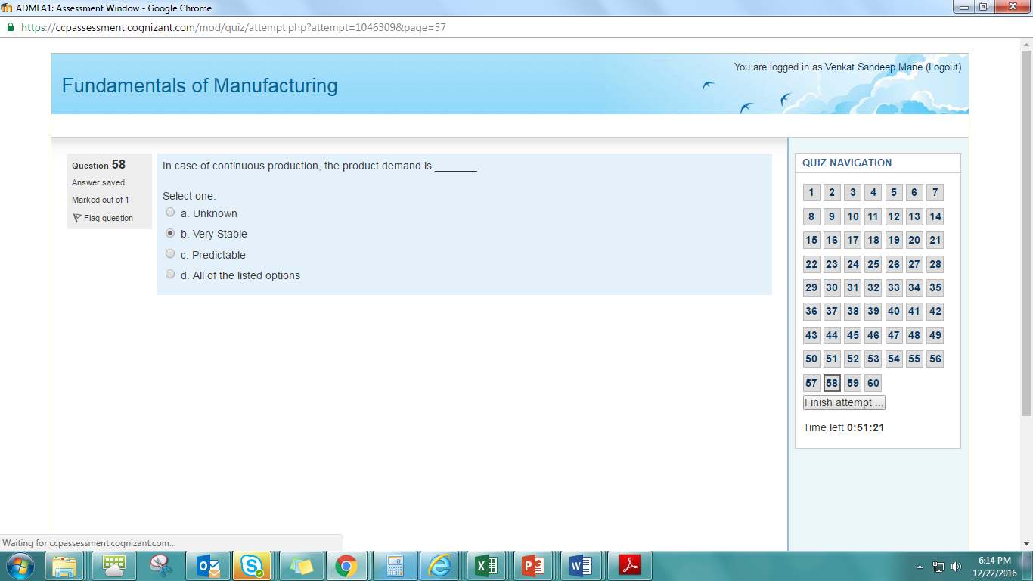
6. Suppose you want to manufacture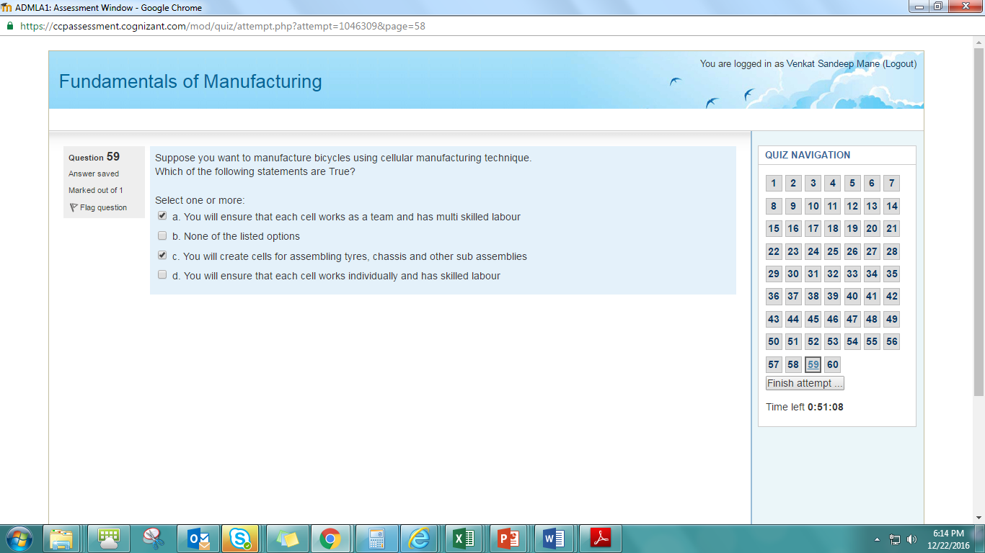
7. Which of the following manufacturing types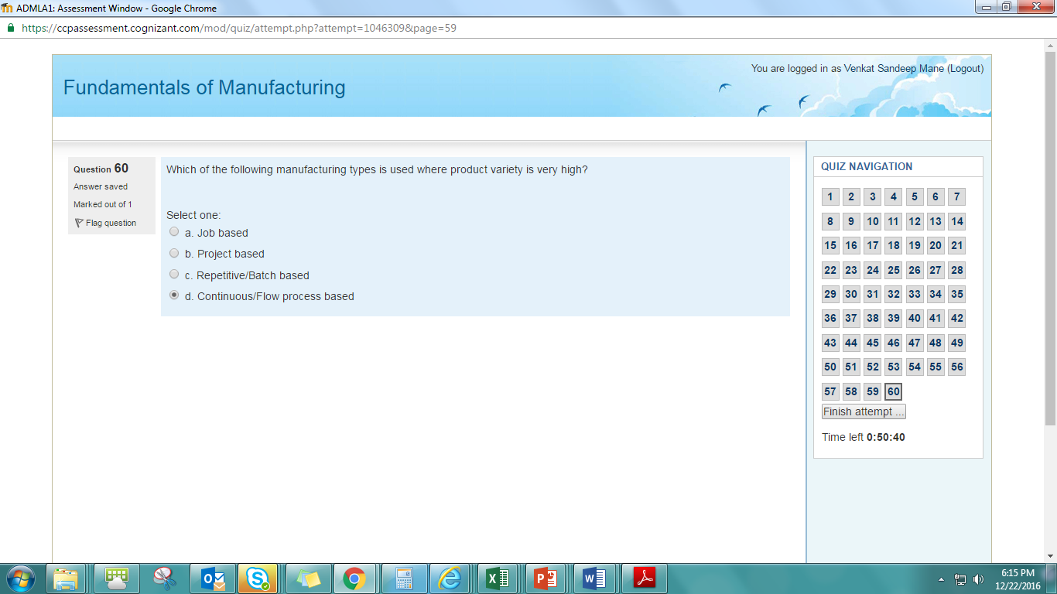

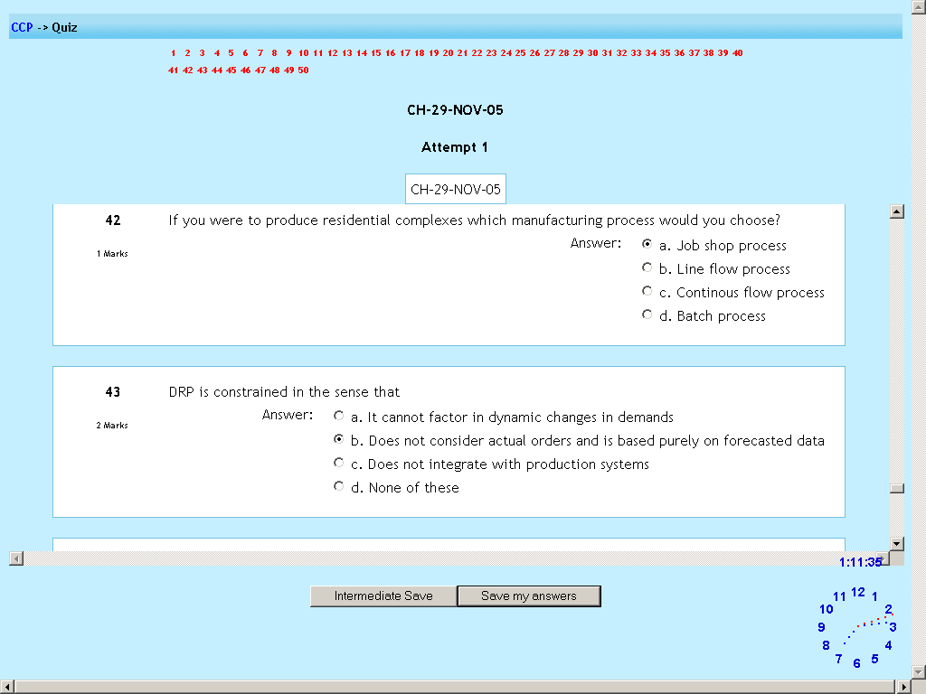

If you were to produce

DRP is constrained

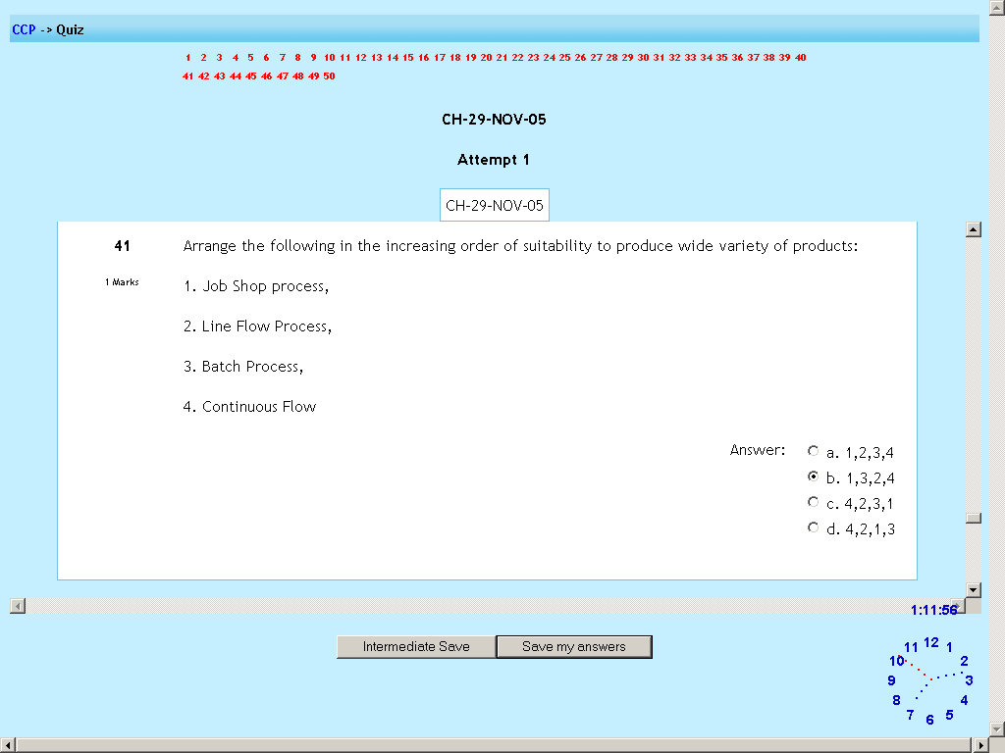

Arrange the following in increasing order

If the cost of the production

Arrange the following in increasing order

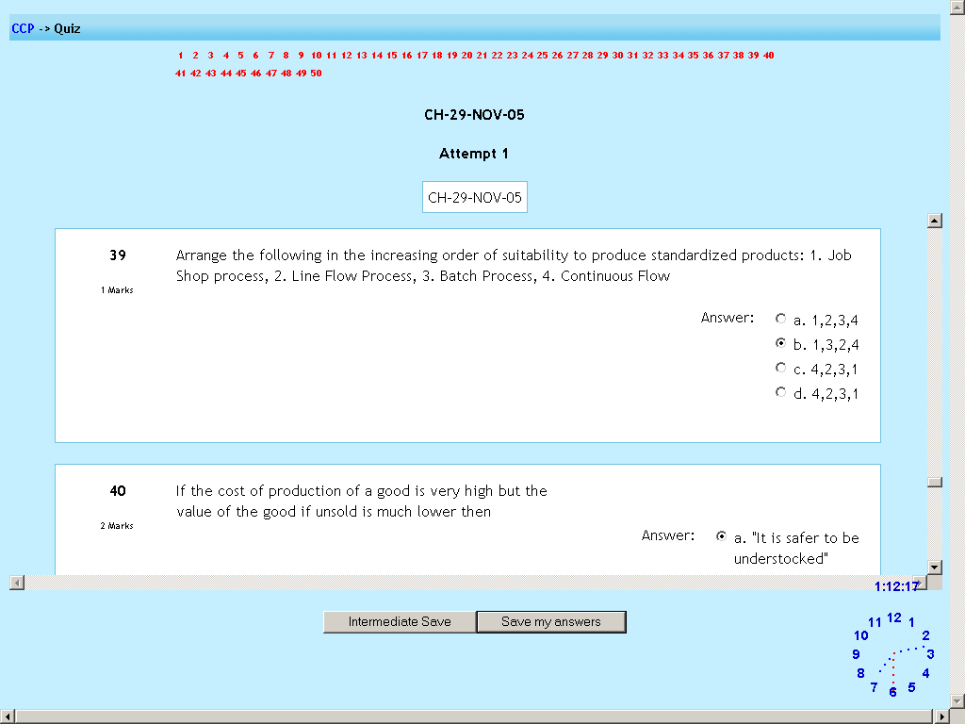

Which of the following are direct advantages

Changes in the marketing plan 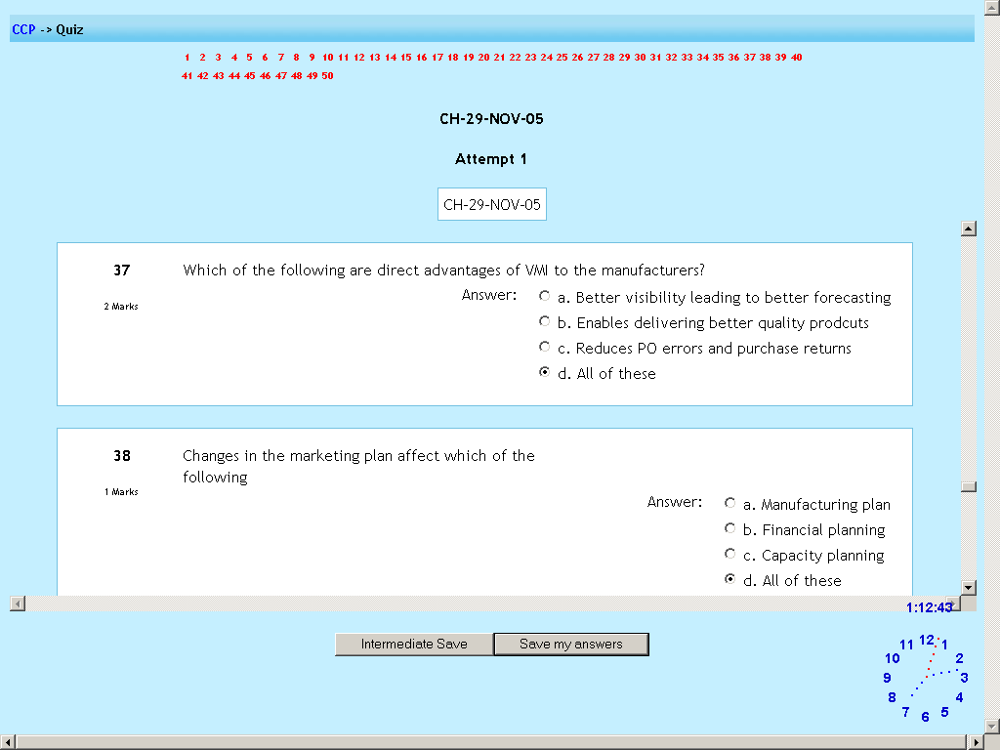

Which of the following are required

The utilization

u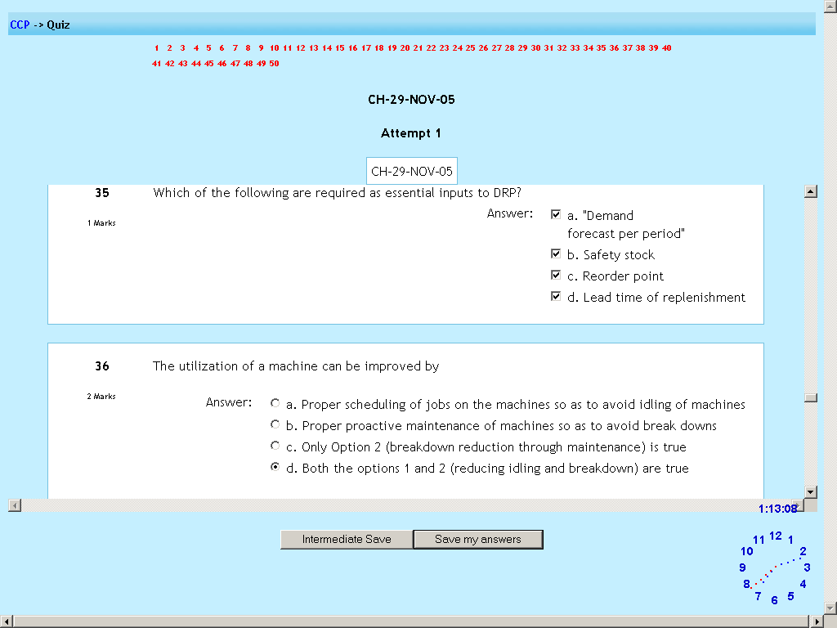

Bill of materials

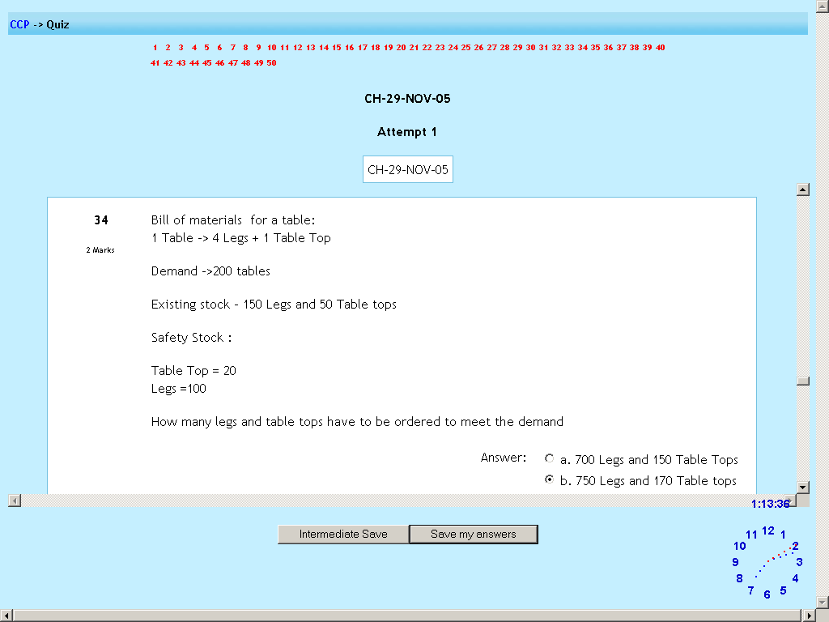

Which of the following is not a

The objective of DRP

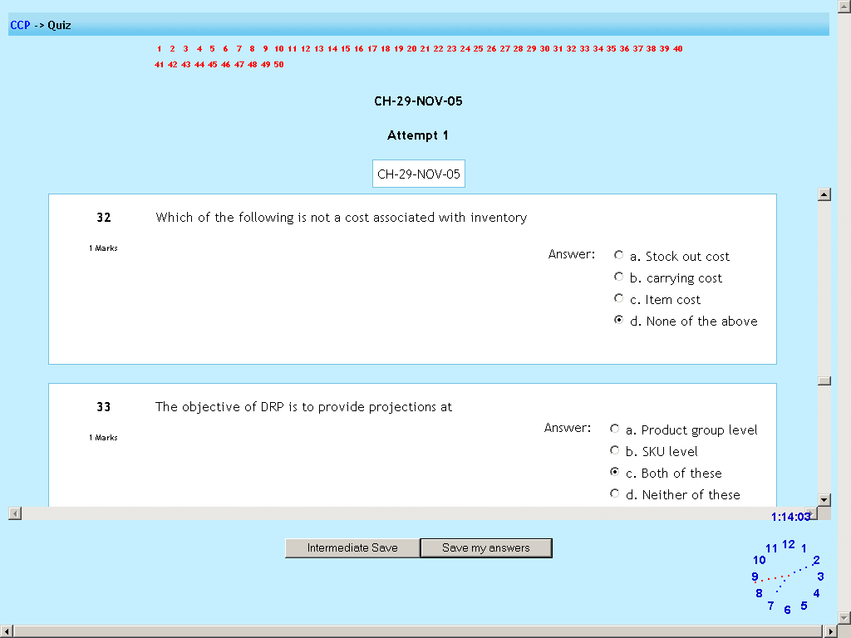

Typically in a

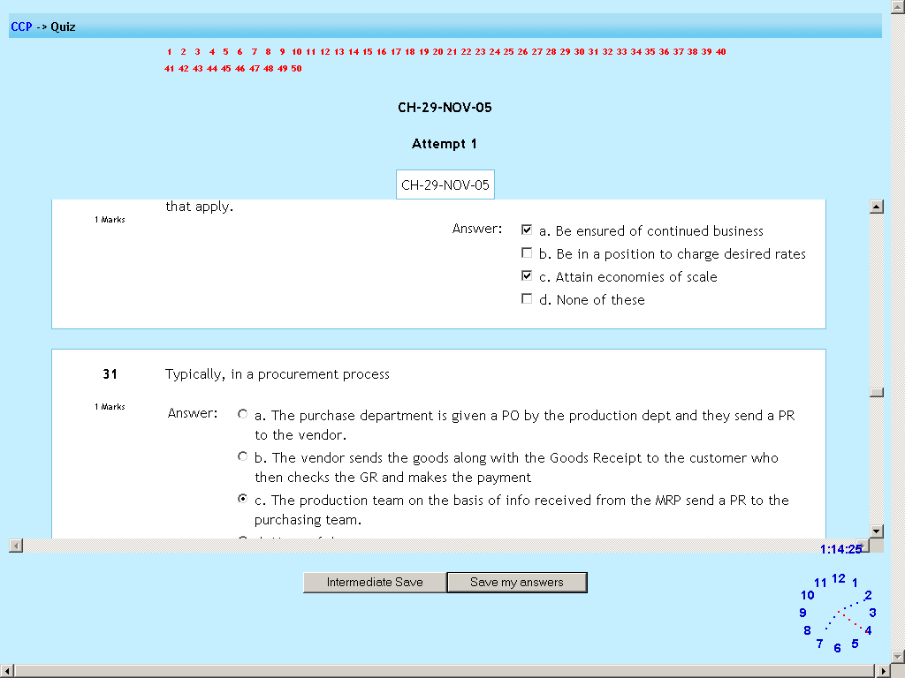

Which type of manufacturing

Why do vendors attempt

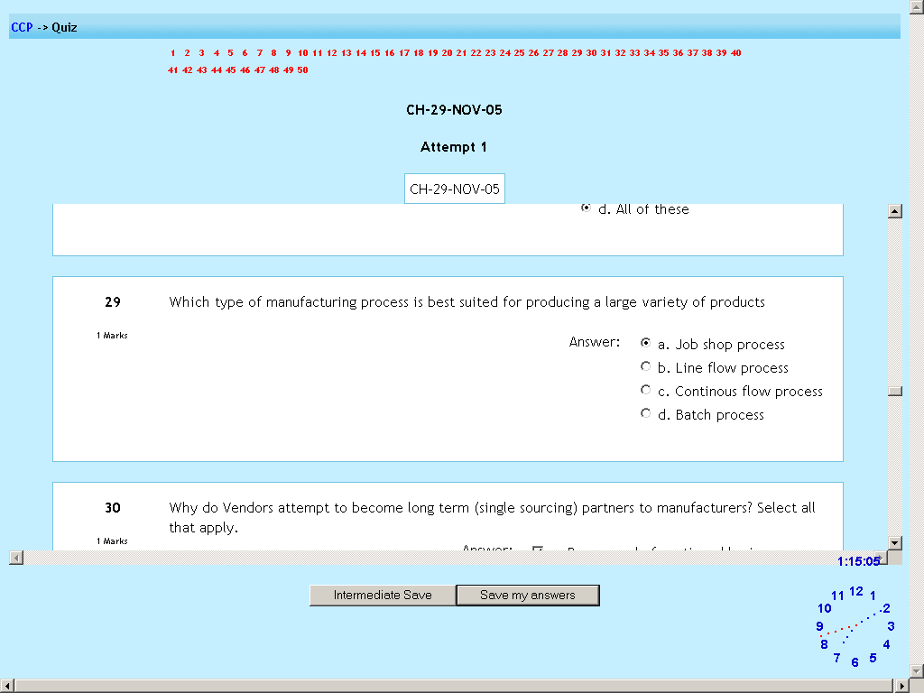

The actual product demands

Which of the following are parameters

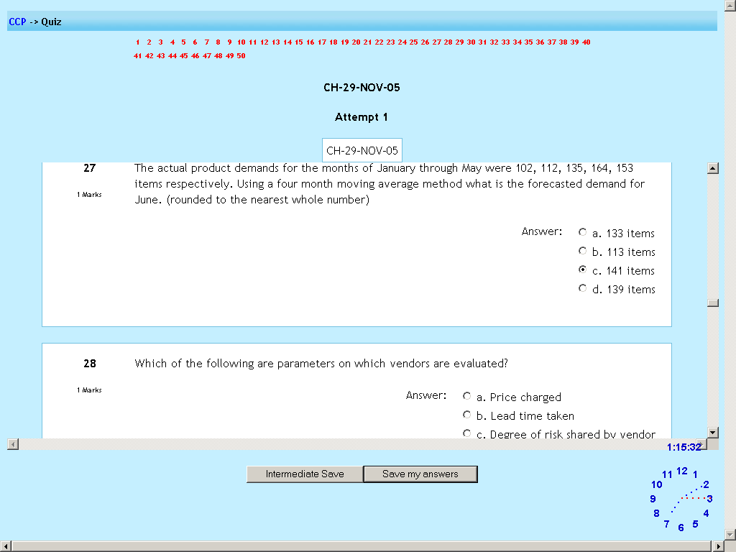

The demand patterns

After receipt of material

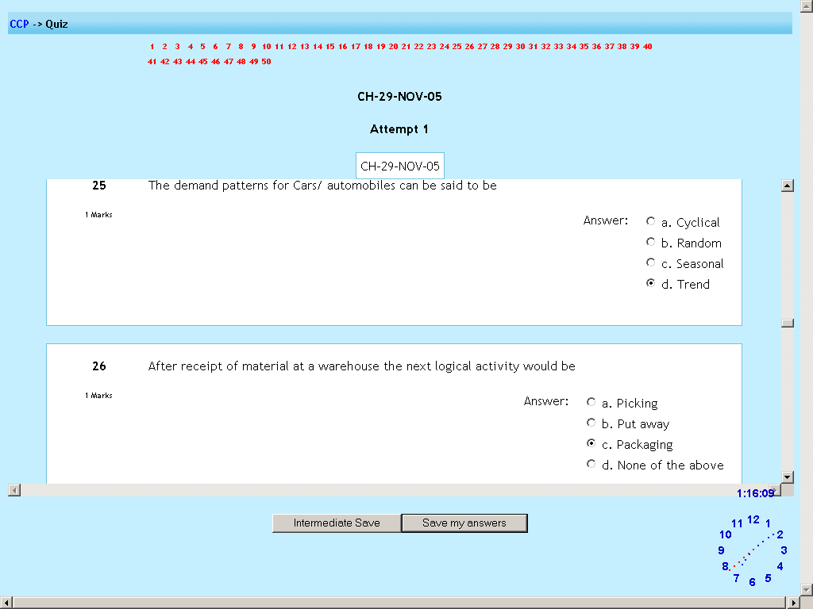

Excess production

Diseconomies

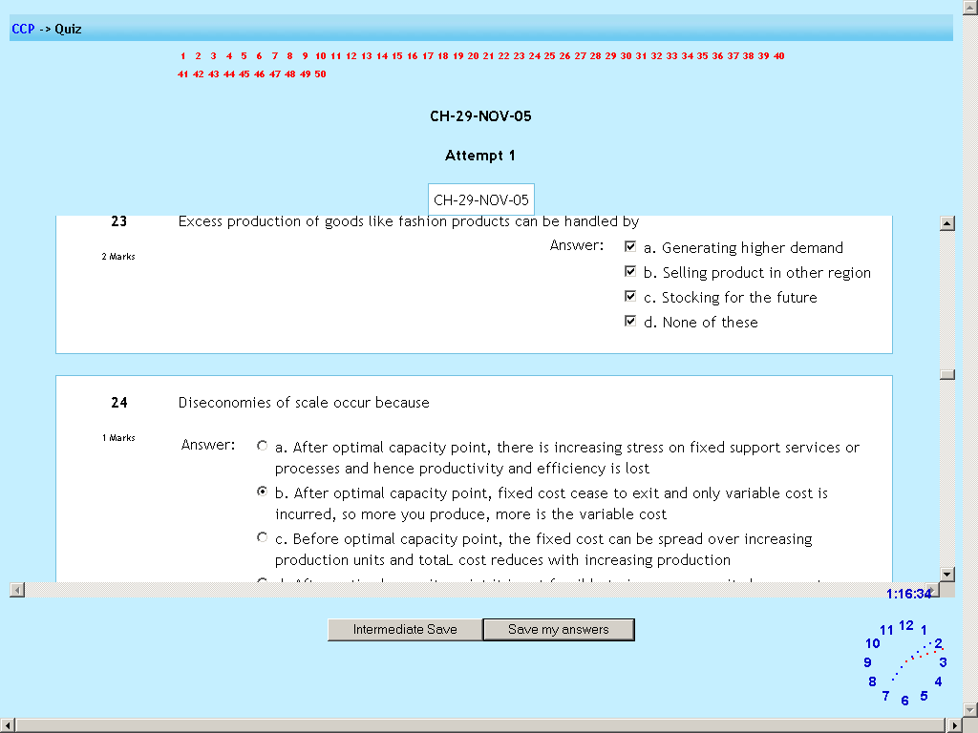

Implosion means

The demand patterns for steel

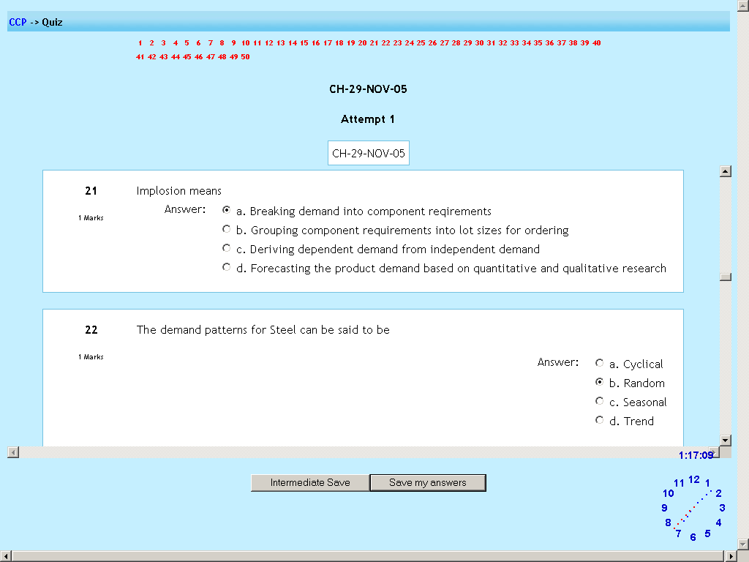

When idle capacity

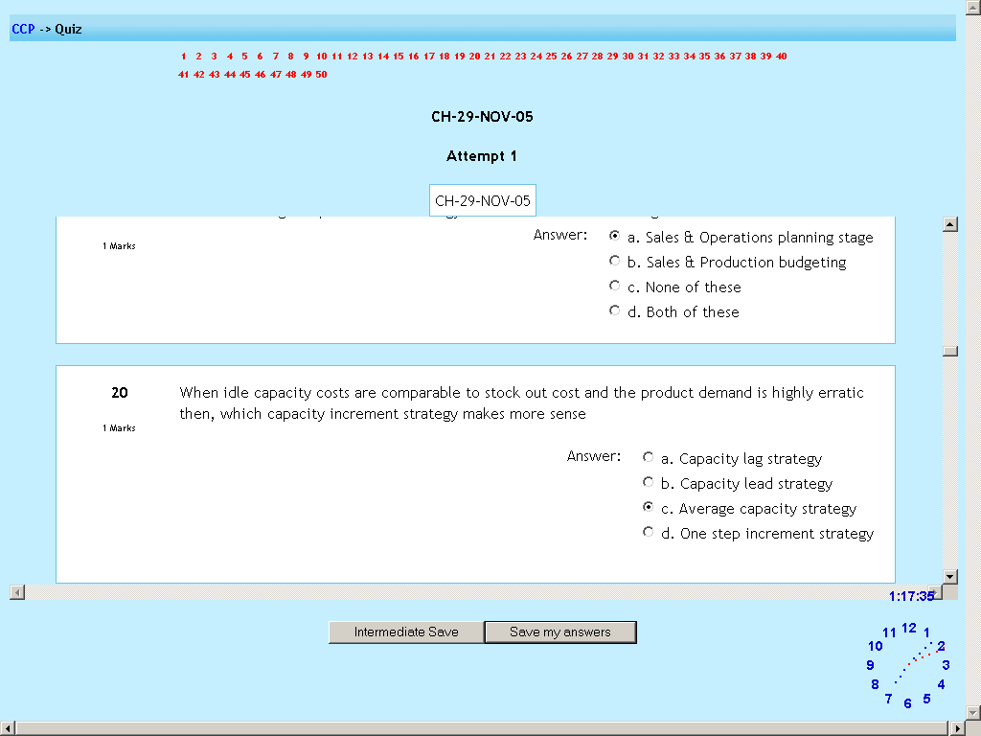

Office supplies

The advertising

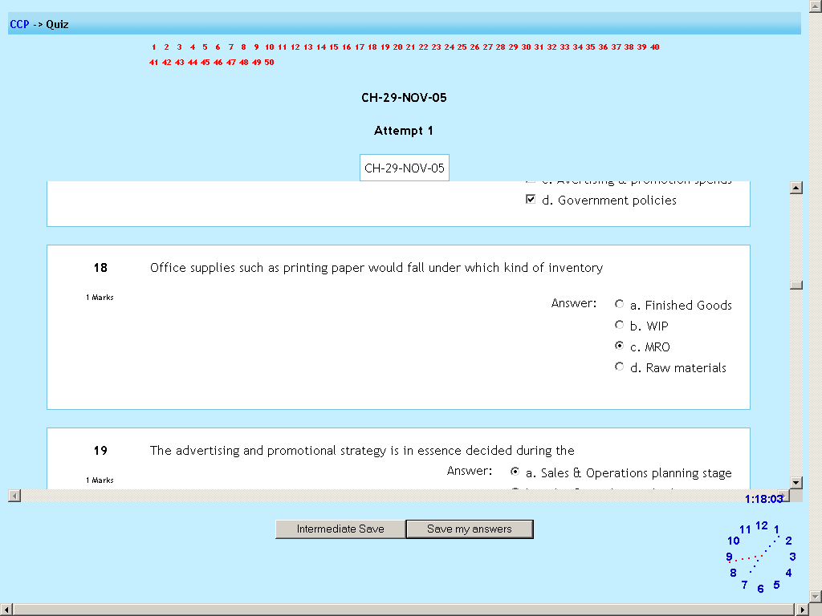

If in a growing market

Among the various factors

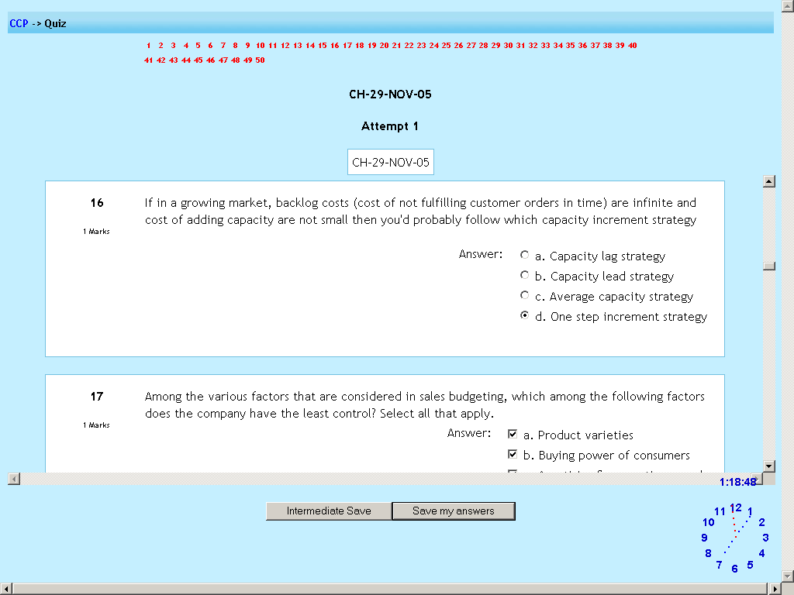

Production budgeting

Which among the following is not a

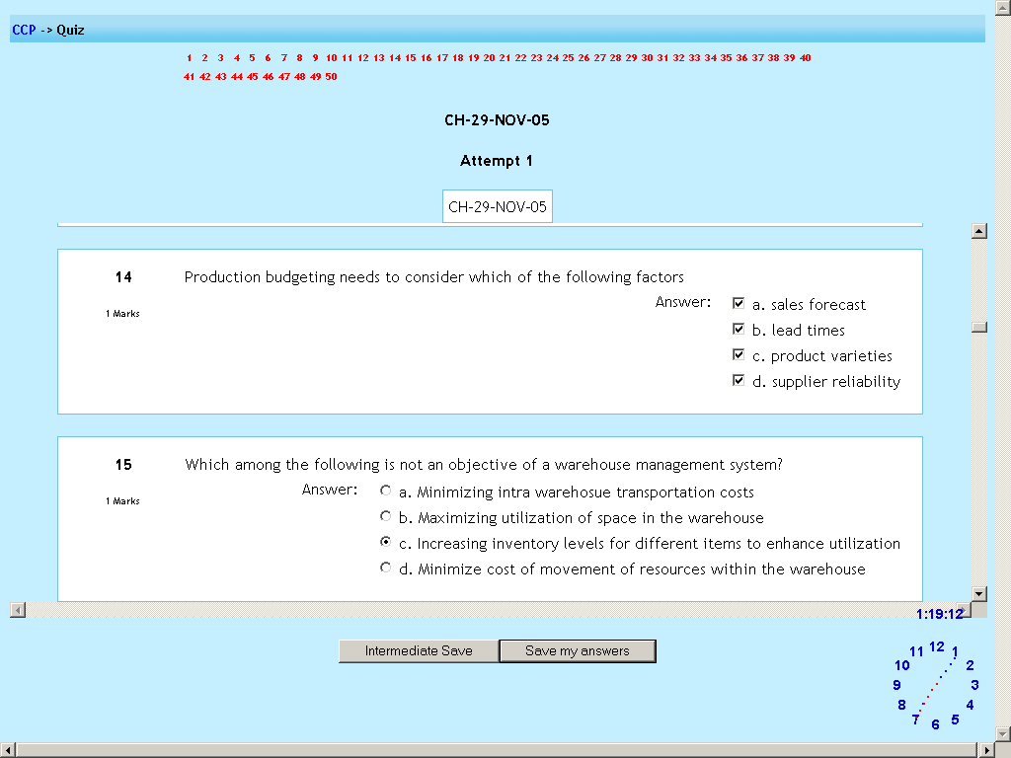

In manufacturing resources

How many intermed

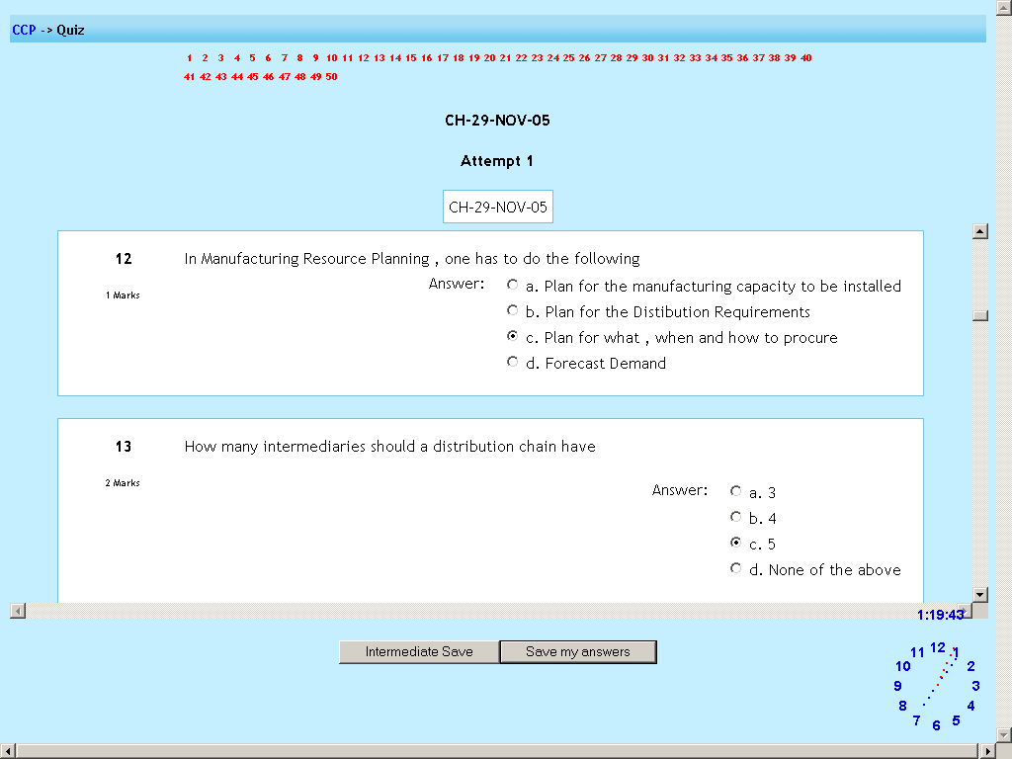

It is observed that

How do you define

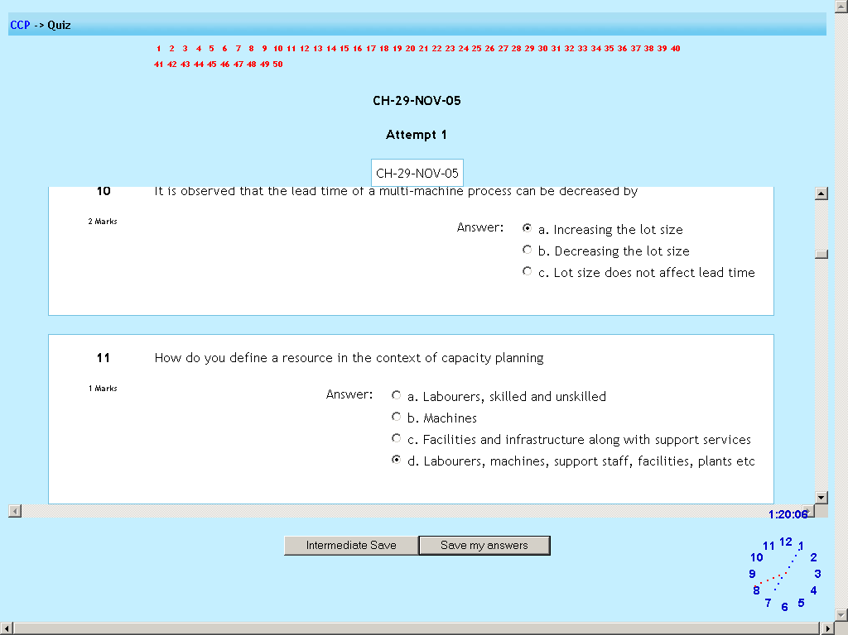

Which of the following need to be

Which among the following are

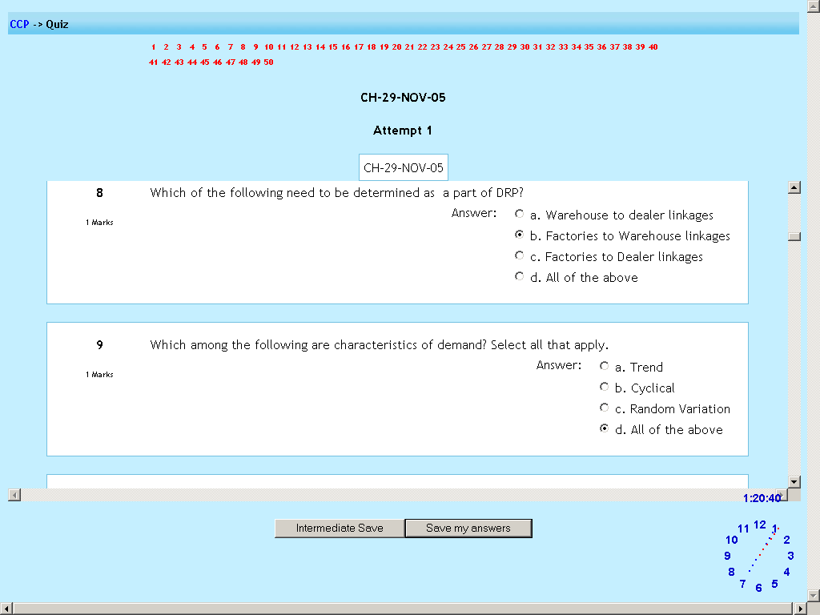

Automating a particular

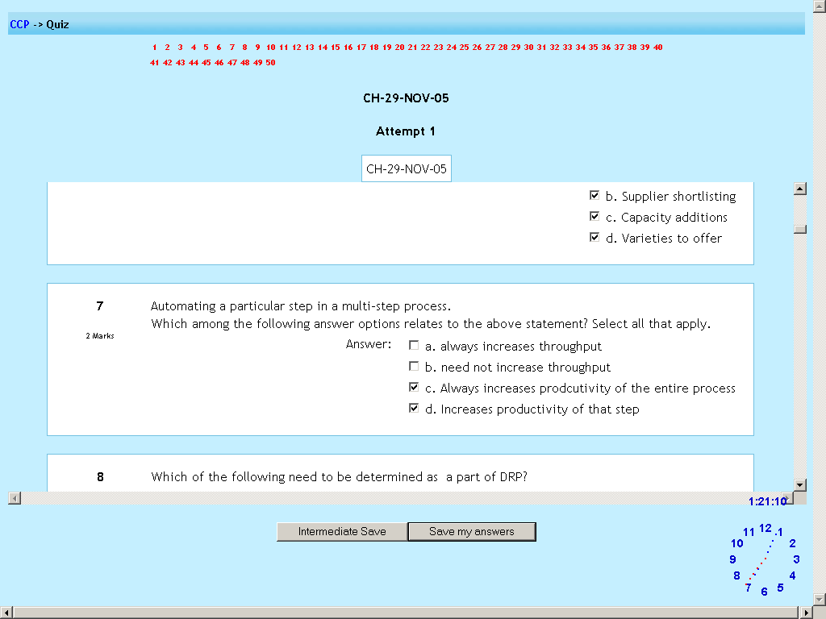

Which of the following affect the extent

Which of the following decisions

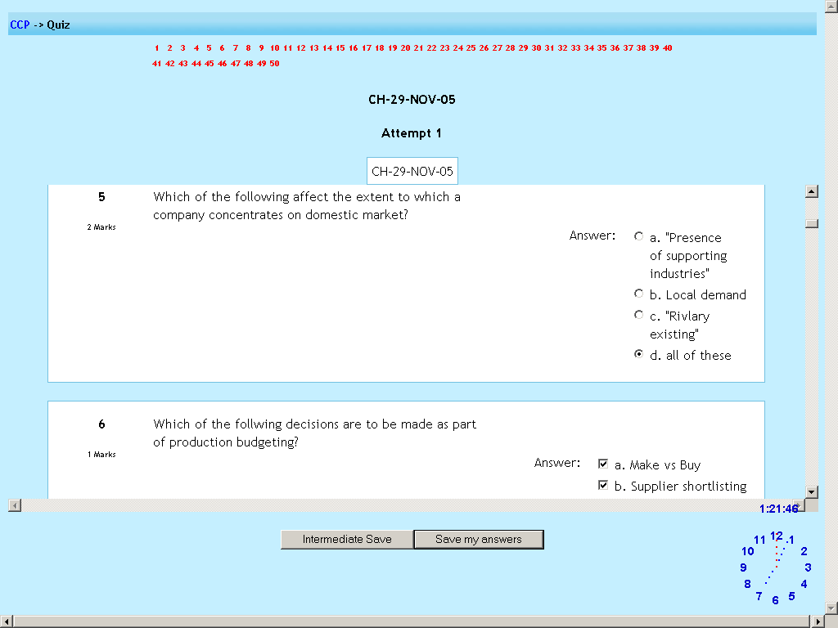

What is mean by term manufacturing

The output of a sales budgeting

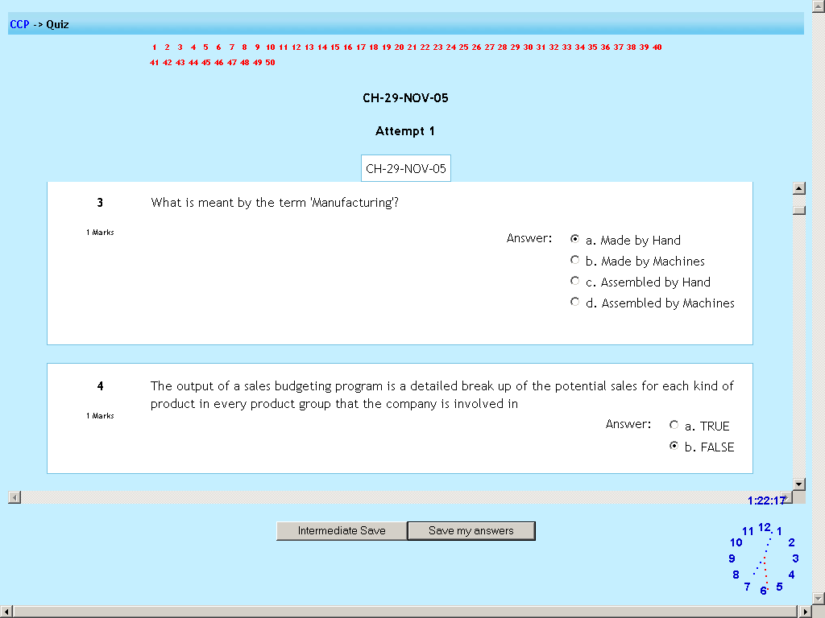

Which of the following is an incorrect statement

If a product takes 15

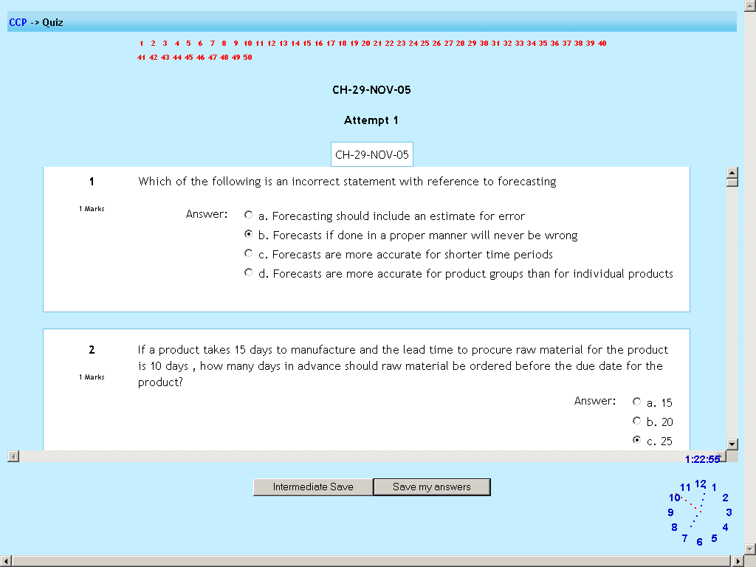

Sales and operational planning

Which of the following are reasonable

Advantage of multi-

Which of the following are not true about

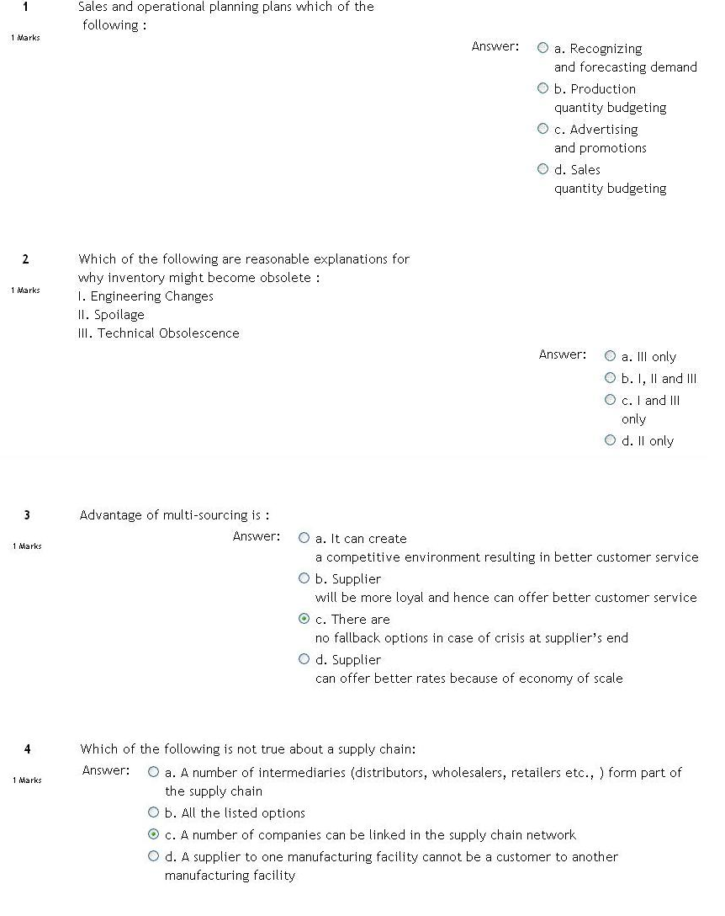

Each of the following is a

A work-center has 5 machines

The ABC classification

The manufacturing process

Purchasing commodities

If we have 30 tables

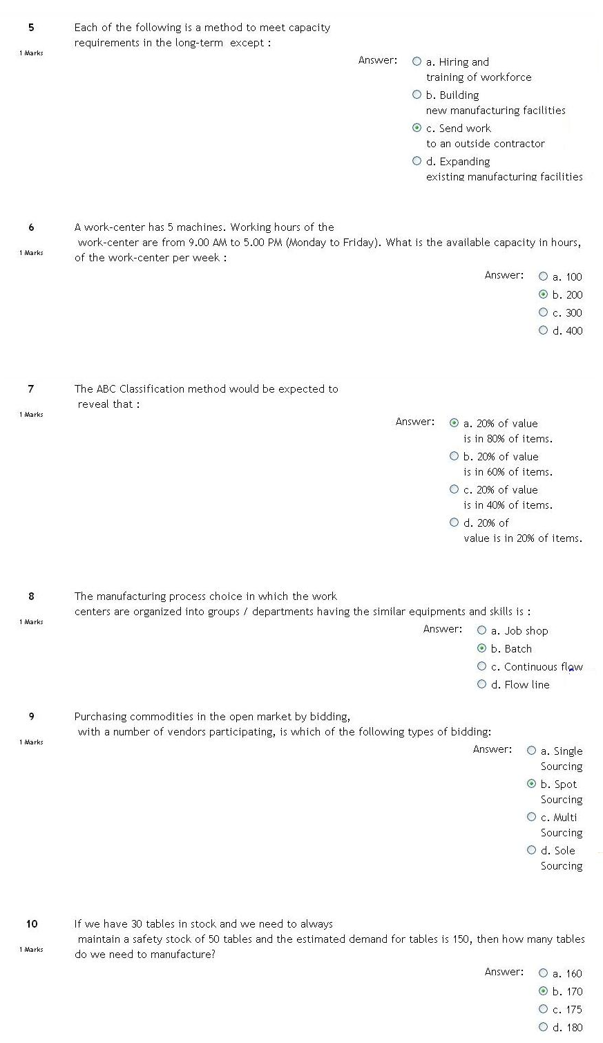

Which among the following

Dependent demand is not

Which of the following is not a

If in production scheduling

Correct sequence

A channel partner in the distribution

In which of the type of

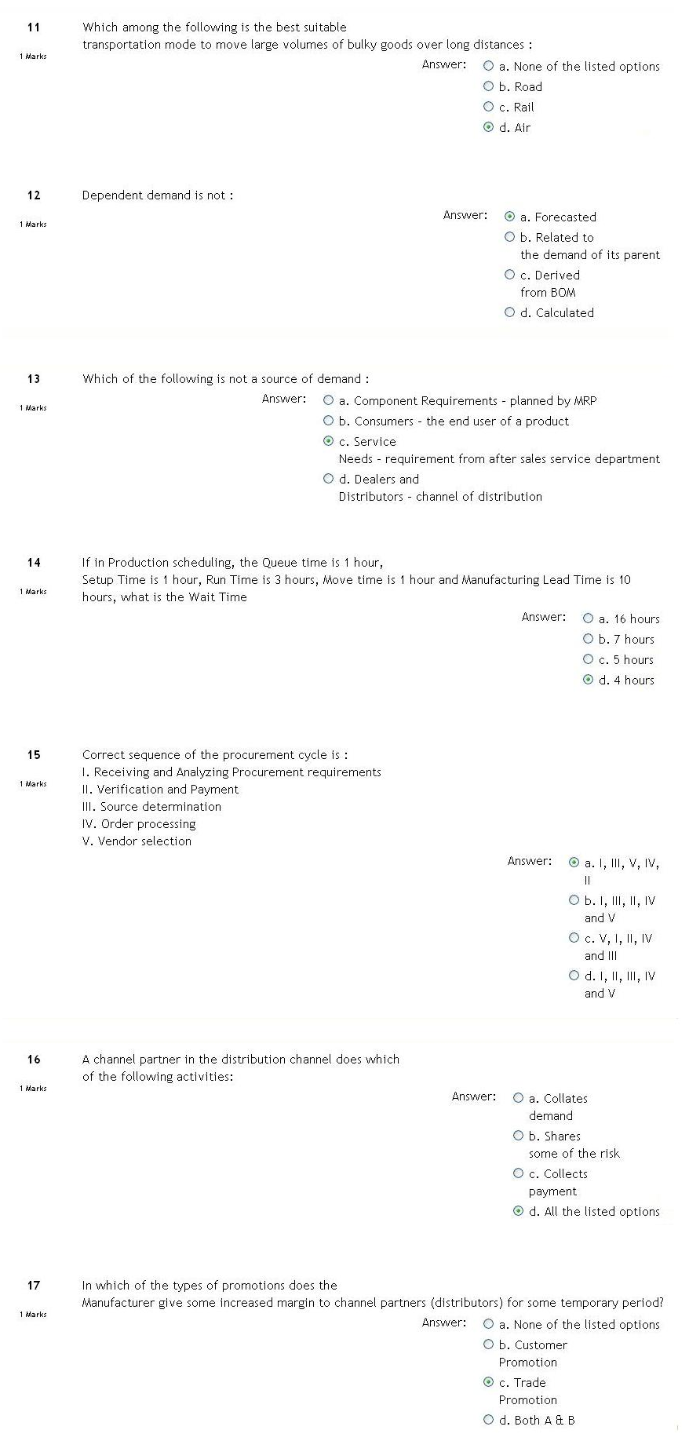

Objectives of procurement are

If the demand for a product is 400 units

Which of the following are motivations

Which of the following is a method to meet capacity

Which of the following cost are associated

